TechSavvySeniors

Accessibility Features Quick Reference Guide

What are accessibility features?
Accessibility features are options built into devices to make them easier for people to use. Generally, accessibility features are designed around the categories:
- Hearing
- Visual
- Mobility or dexterity
- Speech, and
- Cognitive.
Sometimes a feature offers benefits in more than one category.

How can I find accessibility features?
Most accessibility features can be found in a dedicated area of your phone’s settings.

This is the Settings symbol on your Android device [CHECK]

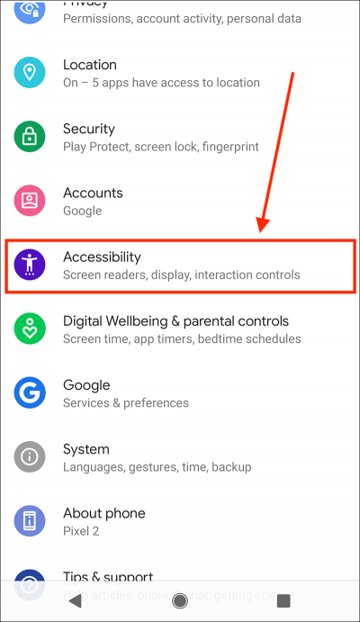
Tap on the Settings symbol, and then scroll down to “Accessibility”.

Hearing Features
Customise Alerts
Alerts usually involve audio, such as a ringtone for a call or another sound for an incoming text. However, you can customise your alerts with:
- a flashing light:

Settings > Accessibility > Advanced settings > Flash notification
Then turn on Flash Notification.

- a vibration alert:

Settings > Sounds and Vibration

Pair a Hearing Aid

Pairing your hearing aid with your mobile device will divert sound through your hearing aid so you can hear it better.

First check Bluetooth is on so your device is able to communicate with the hearing aid. Then find your hearing aid through your device:

Settings > Accessibility > Hearing Enhancements Bluetooth Hearing Aid …..Continue > Pair New Device
Choose your hearing aid from the list of available devices. Make sure your hearing aids are in pairing mode.
If you have more than one hearing aid, wait for the first hearing
aid to connect, then tap the other hearing aid in the list of available devices. After both are paired, the status displays a message like "Active, left and right."

Turn on subtitles and captions

Captions and subtitles allow you to follow audio content without sound.

Settings > Accessibility > Hearing enhancements > Subtitle settings > Show captions (toggle)

Optimise Sound

You can amplify soft sounds, reduce background noise, and adjust certain frequencies to suit your hearing.

Accessibility > Hearing Enhancements

Here you can adjust the sound balance using the slider bar or switch to mono audio so the same sound comes out of both speakers.
You can also select Amplify Ambient Sound. Tap Phone mic to adjust the settings:

- Reduce unwanted sounds: To reduce noise in the background, drag on the “Noise reduction” slider.

- Boost quiet sounds: To boost quiet sounds such as low speech sounds, drag the “Boost quiet sounds” slider to the right.

- Boost low frequency, high frequency: To boost high frequency sounds like bird sounds, drag the slider to the right. To boost low frequency sounds like deep voices, drag the slider to the left.

- Adjust ears separately: To apply sound and frequency settings to the left and right ears independently,
tap Adjust ears separately.

Vision Features
Adjust Screen Display Settings

Edit your device’s screen display settings to make your screen easier to view - use larger fonts, contrast, magnification, and other options.

To make your font size smaller or larger:

Settings > Accessibility > Visibility Enhancements > Font size and style
Then move the slider left or right for larger/smaller font.

You can also use this route to:
- Turn bold on and off
- Increase contrast
- Highlight buttons
- Add a colour filter
For colourblindness, you can compensate with Color correction and grayscale settings:

Accessibility > Visual Enhancements > Colour Adjustment
Then toggle on/off and choose a correction mode. You can also make the mouse pointer larger:
Accessibility > Visual Enhancements > Large Mouse pointer.

Other Features
Voice Control

You can use voice commands to tap, swipe, type and more, instead of physically performing these gestures yourself.

Check that your device is Android version 5.0 or later (Settings > About) and use the same language for Voice Access as the device and Google Assistant.

Download Google app from Google Play. Also download Voice Access.

Open Settings > Accessibility > Voice Access.

Tap Use Voice Access.

Start Voice Access in one of these ways:

- If "Hey Google" detection is on, you can say "Hey Google, Voice Access."
- Open your notifications and tap Touch to start [CHECK].
- On your Home screen, tap the Voice Access app .
- Tap the Voice Access activation button . (You can set up the activation button in Settings

Accessibility > Voice Access > Settings
  - Activation.)
- Say a command, such as "Open Gmail."

Using Google Assistant
Adjust Screen Display Settings

Most tablets and phones have in-built personal assistants. The Android assistant is known as “Google Assistant”.

While Google Assistant is not technically regarded as an accessibility feature, this function can be particularly useful for people with visual or motor impairments where reading or typing may be challenging.

Google Assistant allows you to leverage the technology of your phone orally. For example, you can ask Google Assistant to set a timer, provide a weather forecast, write reminders, and search the internet, all without typing into or needing to read your phone.

You can also use Google Assistant to open apps and turn accessibility features on or off.

First check that Google Assistant is activated on your phone:

If Google Assistant is not activated on your Android device, you will get a message when you say “Hey Google”. Follow the instructions to activate.
Alternatively, open the Google Assistant app on your Android device . If Google Assistant is off, you’ll get the option to turn it on at the bottom. Tap Turn on.

You can now call on Google Assistant as needed, simply by holding down the home button.

More Information

This Quick Reference Guide discusses just some of the many accessibility features available. You can explore more at:

Settings > Accessibility

The best way to familiarise yourself with available settings is to test them out.

Telstra has a dedicated team of experts who conduct phone- based support to help you learn new skills. You don’t have to be a Telstra customer to access this support.

You can access skills support by completing the form on Telstra’s website - https://www.telstra.com.au/forms/request-a-skill- building-session

