Tech Savvy Seniors
Module 9
Apps that make life easier
Session plan

Table of contents
Session overview 3
Learning architecture 3
Learning outcomes 3
Resources checklist 4
Session summary 5
Session plan 7
1. Welcome (10 min) 7
2. What are apps and where do you find them? (20 min) 9
Option 1: Opal (15 min) 11
Option 2: Transit (10 min) 12
Option 3. Service NSW App (15 min) 13
Option 4. myGov app (10 min) 14
Option 5. My Telstra app (10 min) 16
Option 6. Hazards Near Me NSW app (10 min) 18
Option 7. my health app (10 min) 19
Option 7. Get ePrepared (website) (15 min) 20
8. Built in flexibility (20 min) 21
9. Wrap up (20 min) 24

Session overview
This hands-on 2–2.5-hour session helps older Australians become more confident with smartphone apps. It introduces what an app is, where to find and download them, and how apps can simplify everyday activities such as checking travel cards, managing phone bills, and accessing government services. Learners will explore useful apps, learn how to manage app settings, and practise using real-life apps to build independence and digital confidence.

Learning architecture
This module forms part of a 12-module series.
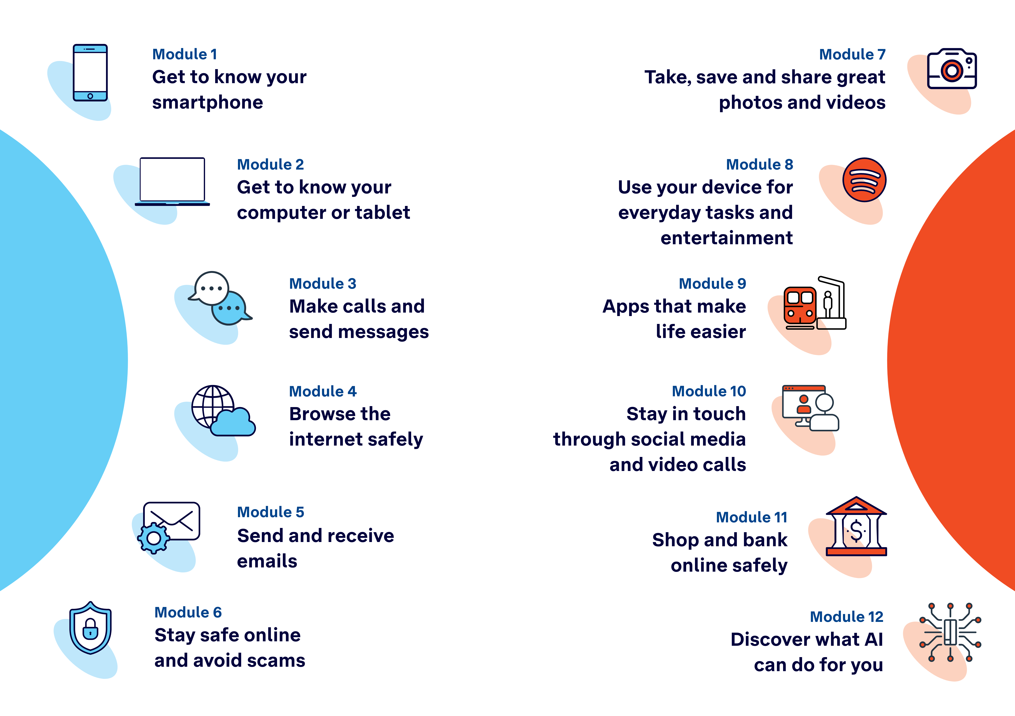

Learning outcomes
At the end of this session, learners will be able to:
- Explain what an app is and the different types of apps available.
- Search for and download apps.
- Use apps to access services and manage accounts.
- Manage app settings such as updates, permissions, and notifications.
- Organise and delete apps.

Resources checklist
This session requires the following resources:
☐ | Session plan (this document)
☐ | PowerPoint presentation
☐ | Learning Canvas - printed (one per learner)
☐ | Pens for learners (one per learner)
☐ | Butchers paper/markers or a whiteboard/markers may be useful to assist with capturing ‘learning goals’ which will be touched on throughout the session
☐ | Library’s Wi-Fi password
☐ | Tech Savvy Seniors program schedule - printed (one per learner)
☐ | Learners’ own device (smartphone or tablet)
☐ | Internet-connected smartphones and tablets (as available)
☐ | Facilitator’s smartphone for demonstrations
☐ | Facilitator’s computer for presentation (optional)
☐ | Projector and screen (optional)

Session summary
This session summary provides an overview of topics, the activities relevant to each topic and the duration.
Note: There are 10-15 minute sessions design for the following apps:
- Opal  - Transit  - Service NSW App  - MyGov App | - My Telstra App (or your phone provider’s app)  - Hazards Near Me  - my health  - Get ePrepared (website - not an app)
Choose the five most appropriate apps for your audience (the duration of each app and useful links are provided on the following page). You could also explore a sixth app during the built in flexibility section.

Duration | Topic | Useful links
10 min | 1. Welcome
20 min | 2. What are apps and where do you find them?
15 min | 3. App 1
10 min | 4. App 2
10 min | Break
15 min | 5. App 3
10 min | 6. App 4
10 min | 7. App 5
10 min | Break
20 min | 8. Built in flexibility  (Option to explore App 6) | Digital legacy:  - eSafety: What happens to your digital accounts after you die  - Service NSW: Get started making a will
20 min | 9. Wrap up | - iPhone: Scan a QR code with your iPhone or iPad  - Android: How do you scan QR codes on Android?
Total duration: 2.5 hours

Duration | Topic | Useful links
25 min | Opal | Overview: https://transportnsw.info/apps/opal-travel  Apple App Store: https://apps.apple.com/au/app/opal-travel/id941006607  Google Play: https://play.google.com/store/apps/details?id=au.com.opal.travel&hl=en  Learn more: https://transportnsw.info/plan/instructions-planning-guides/opal-travel-app-help-centre
25 min | Transit | Overview: https://transportnsw.info/apps/transit  Learn more: https://help.transitapp.com/
15 min | Service NSW App | Learn more: https://www.service.nsw.gov.au/campaign/service-nsw-mobile-app
10 min | MyGov App | Learn more: https://my.gov.au/en/about/help/mygov-app
10 min | My Telstra App | Learn more: https://www.telstra.com.au/my-t-app-s
10 min | Hazards Near Me NSW App | Learn more:  - https://www.nsw.gov.au/emergency/hazards-near-me-app  - https://hazardsnear.me/  Watch: Hazards Near Me: Watch Zones
10 min | my health App | Learn more: https://www.digitalhealth.gov.au/myhealth  Watch: my health app - how to set up
10 min | Get ePrepared website | Learn more: https://prepare.apps.justiceconnect.org.au/

Session plan

1. Welcome (10 min)
Overview
Purpose:
- Introduce Module 9: Apps that make life easier, including the flow (short demos + practice)
- Set a safe, calm tone; reduce anxiety about ‘pressing the wrong thing’
- Introduce the Learning Canvas as a personal guide they can use during the session and take home
- Gather learner goals to tailor the ‘Built‑in flexibility’ section later
Timing breakdown | Content
Session overview  10 min  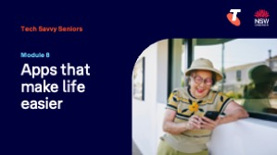  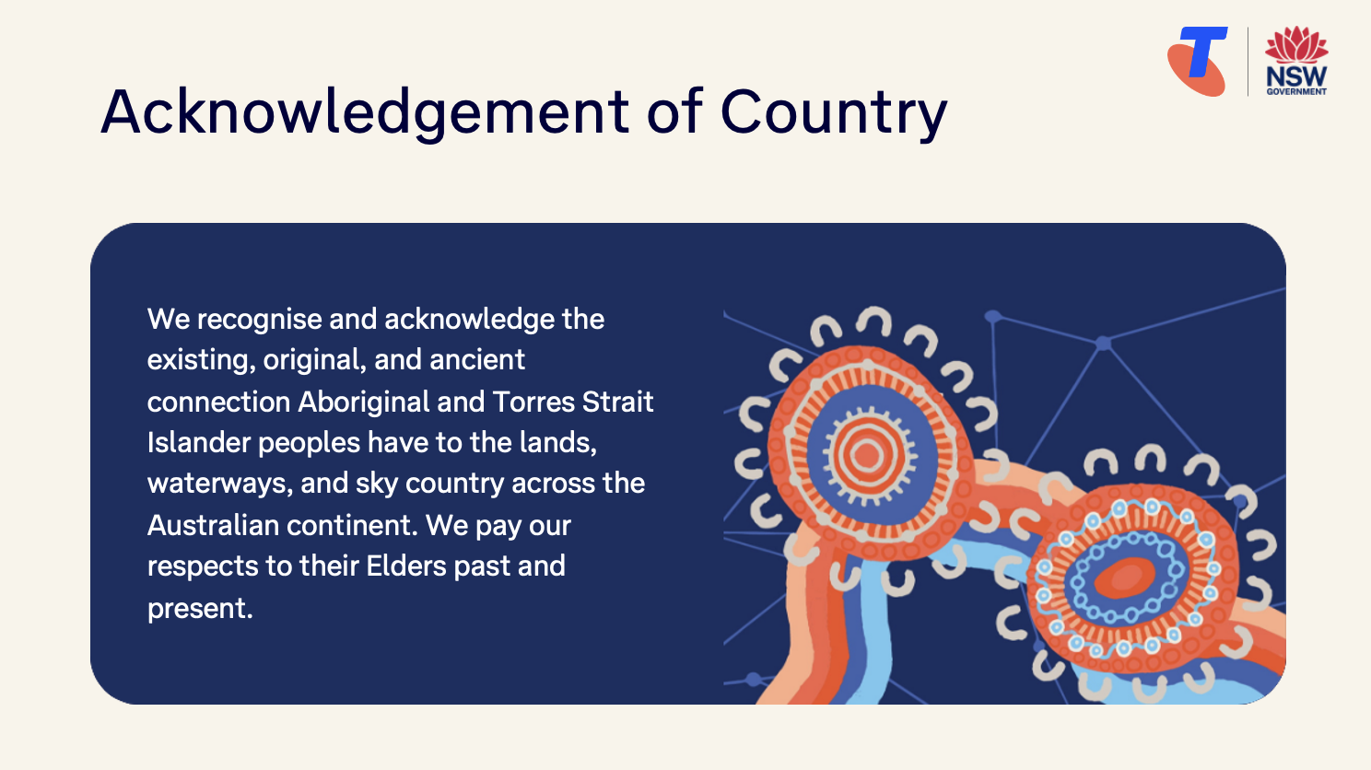  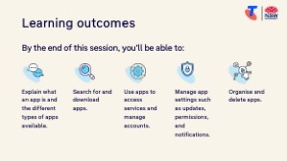 | On arrival, ensure each learner has a device, printed Learning Canvas and pen. Group learners by device so they can support each other.  Deliver: An Acknowledgement of Country.  Say:  - Welcome! Today we’ll explore some helpful tools on your phone called apps, short for applications. These are programs that can help with all sorts of everyday tasks, like paying bills, managing your MyGov account, and looking up transport timetables.  - Some apps are already installed on your device, such as the Weather, Calendar, or Calculator. Others you can choose to download.  - Today we’ll download and use some helpful apps (choose the five most appropriate apps for your audience):  - Travel Apps: Opal and Transit – for planning public transport and checking travel cards  - Service NSW App – for accessing licences, rebates, and more  - MyGov App – for Medicare, Centrelink and other services  - My Telstra App (or your phone provider’s app) – for managing your phone or internet account  - Hazards Near Me NSW - for emergency warnings and incident information in NSW  - my health - to access My Health Record  - Get ePrepared - to help you prepare electronic copies of your essential documents in case of an emergency  - Note: some apps require a particular operating system to work - we’ll check capability in the App Store/Google Play Store.  - Before we touch anything, let’s agree: it’s fine to make mistakes. That’s how we learn.  - By the end of this session, you’ll be able to:  - Explain what an app is and the different types of apps available.  - Search for and download apps.  - Use apps to access services and manage accounts.  - Manage app settings such as updates, permissions, and notifications.  - Organise and delete apps.

Timing breakdown | Content
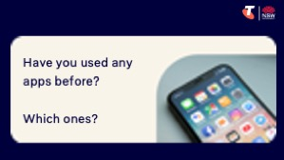  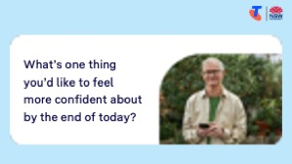 | Introduce Learning Canvas:  - Use your printed Learning Canvas to write notes in your own words, tick off skills as you learn them, and highlight what feels most useful to you. Writing things down helps you remember and understand them better, and makes it easier to recall later. Take your Canvas home to keep practising. On the back, you’ll find extra tips and trusted links if you want to explore more.  Ask:  - Have you used any apps before? Which ones?  - What’s one thing you’d like to feel more confident about by the end of today?  (Write answers on a whiteboard or butchers paper. These will help shape the ‘Built-in Flexibility’ section later in the session.)  Confirm everyone has a device; pair anyone without.  Transition:  - Let’s start by learning how to find apps on your phone and where to go if you want to download a new one.

2. What are apps and where do you find them? (20 min)
Overview
Purpose:
- Build understanding of what an app is.
- Show where to find apps on your device.
- Introduce the App Store and Play Store.
Timing breakdown | Content
What are apps and where do you find them?  5 min  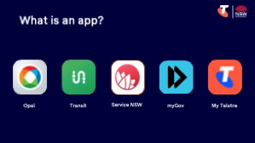 | Say:  - Before we try some specific apps today, let’s talk about what an app actually is, and how you can find and install new ones.  - An app is a small program or tool on your phone or tablet.  - Some apps come already installed (like the Weather, Calendar, or Clock).  - Others can be downloaded when needed.  - Apps can be free or paid. Today we’ll focus on free, trusted apps.  Explain how to find apps already on your phone:  - Apple: Swipe left from the home screen or swipe down and type in the app name to search.  - Android: Swipe up from the bottom of the home screen to view all apps, or use the search bar at the top.  Try it:  - Ask learners to look through their home screen or app drawer.  - Find common apps (e.g. Weather, Notes, or Calculator).  - Show how to tap to open and swipe up or press home to close.
Downloading apps  5 min  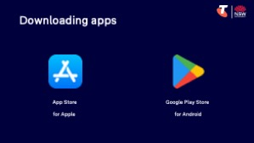 | Explain where to download apps:  - App Store (Apple)  - Google Play Store (Android)  Demonstrate how to search for an app:  - Open the App Store (Apple) or Play Store (Android)  - Tap the search bar and type in a name  - Look at the list – point out icons, ratings, and reviews  - Point out the ‘Get’ or ‘Install’ buttons  Try it:  - Guide learners to open the relevant store and search for the Opal Travel App.  Ask:  - Have you ever looked for or downloaded an app before?  - What types of apps do you think would be most useful to you?

Timing breakdown | Content
Updates and permissions  5 min | Explain updates and permissions:  - Apps often update automatically to fix issues or improve features.  - When installing or using an app for the first time, it may ask for permissions (e.g. access to your camera, location, contacts).  - If unsure, you can tap “Don’t Allow” or “Ask Next Time”.  - You can always change permissions later – they are not locked in.  Demonstrate how to review and change permissions later:  - Apple: Go to Settings > scroll to the app name > adjust permissions (e.g. Location, Camera, Notifications)  - Android: Go to Settings > Apps > choose the app > tap Permissions > allow or deny specific items  Try it:  - Guide learners to review app permissions.
Organise or delete apps  5 min | Say:  - Moving, organising and deleting apps is easy.  Demonstrate how to organise and delete apps:  - Apple: Tap and hold an app icon > Choose “Remove App” or drag to rearrange  - Android: Tap and hold > Drag to “Uninstall” or choose “Remove”  Try it:  - Guide learners to practice organising and seeing how to delete apps.  Transition:  - Now that we’ve learned how to find and explore apps, let’s look at some examples.

Option 1: Opal (15 min)
Overview
Purpose:
- Introduce the Opal Travel App that supports independent travel.
- Explore key features for planning trips and checking transport details.
- Practise opening, searching and navigating using the Opal Travel App.
Timing breakdown | Content
Opal Travel App  15 min  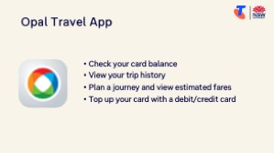 | Say:  - Let’s now explore two apps that are really useful if you take public transport. One is for checking your Opal card and planning trips, and the other helps you look up timetables for services in your area.  Explain the Opal Travel App:  - The Opal Travel App is used by NSW public transport users with an Opal card.  - It helps you:  - Check your card balance  - View your trip history  - Plan a journey and view estimated fares  - Top up your card with a debit/credit card  Demonstrate how to download and use the Opal Travel App:  - Open the App Store (Apple) or Play Store (Android)  - Search for “Opal Travel” and download  - Once installed, open the app and:  - Show how to log in or create an account if needed  - Explain that users need their Opal card number to link their account  - Navigate to Balance, Trip History and Trip Planner sections  Try it:  - Guide learners to complete tasks.  Learn more:  - Opal app guide: https://transportnsw.info/plan/instructions-planning-guides/opal-travel-app-help-centre
  Extension activities:
  - Order an Opal card online from https://transportnsw.info/tickets-fares/opal/get-opal-card (Check eligibility of Gold Senior/Pensioner Opal cards and Free travel Opal cards.)

Option 2: Transit (10 min)
Overview
Purpose:
- Introduce the Transit App that support independent travel.
- Explore key features for planning trips and checking transport details.
- Practise opening, searching and navigating using the Transit App.
Timing breakdown | Content
Transit App  10 min  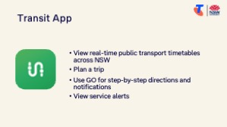  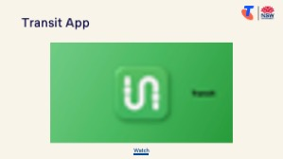 | Explain:  - The Transit App provides real-time public transport timetables across NSW and is free to download and use.  - It shows buses, trains, ferries, light rail and more — including service alerts and arrival countdowns.  Watch:  - The Transit transport app video on https://transportnsw.info/apps/transit  Demonstrate how to download and use the Transit App:  - Search for “Transit” and download from the App Store or Play Store  - Open the app and show:  - How to plan a trip (tap the search bar > enter destination > tap search)  - How to use GO for step-by-step directions and notifications (after tapping your preferred search result, tap GO. (You can only start GO for trips that leave in the next 60 minutes. GO is not supported on multimodal trips.))  - How to view service alerts (When there is an active alert, you'll see a little triangle next to the line name or number. Tap the line to get more information.)  Try it:  - Guide learners to complete tasks.  Learn more:  - https://help.transitapp.com/  Ask:  - Do you catch the bus, train or ferry regularly?  - Can you see how these apps might make your trip easier?
  Extension activities:
  - Check nearby departures & track your ride
  - Get step-by-step directions with GO
  - Pin most used lines & add favourite locations
  - Adjust GO settings, including walking speed

Option 3. Service NSW App (15 min)
Overview
Purpose:
- Introduce learners to a central app for accessing NSW Government services.
- Show how to download and log in to the app.
- Explore key features including digital licences, notifications, and service requests.
Timing breakdown | Content
Service NSW app  15 min  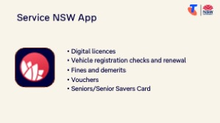 | Say:  - The Service NSW app provides access to a range of NSW Government services. It’s especially handy for things like your driver licence, vehicle registration, rebates, and more.  Demonstrate how to download and use the Service NSW app:  - Open the App Store or Play Store  - Search for and download “Service NSW”  - Open the app and show:  - Log in screen – requires a MyServiceNSW account:  - Select the Settings icon in the top right of the screen  - Select the Log in button  - Enter your MyServiceNSW email address and password and press Log in  - How to create an account if learner doesn’t have one  - Tour of the home screen: Digital Wallet, Vouchers, Services, Settings  Try it:  - Guide learners to complete tasks.  Learn more:  - https://www.service.nsw.gov.au/campaign/service-nsw-mobile-app
  Extension activities:
  - Add a digital licence or credential to the Service NSW app
  Select 'Wallet' from the homescreen > Select the 'Add' button> Follow the prompts,
  - Mange personal details
  Select the profile or 'person' icon > Select 'Personal details' > Select the details you’d like to add or update.

Option 4. myGov app (10 min)
Overview
Purpose:
- Introduce learners to the myGov app as a secure access point for federal government services.
- Demonstrate how to download, log in, and explore key linked services such as Medicare and Centrelink.
- Build confidence in using the app to check information and receive notifications.
Timing breakdown | Content
myGov app  10 min  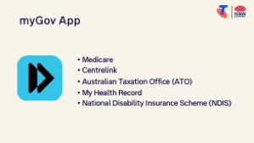  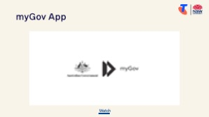 | Say:  - The MyGov app allows you to access many federal government services. Instead of logging in through the website every time, this app keeps things simple and secure.  - The MyGov app connects you to:  - Medicare (claims, immunisation history, Medicare card)  - Centrelink (payments, documents)  - Australian Taxation Office (income statements, super)  - My Health Record and more  - It uses a PIN or face recognition to log in securely.  - You can get notifications and messages from services in one place.  Watch:  - The myGov app video on https://my.gov.au/en/about/help/mygov-app  Demonstrate how to download and use the Service NSW app:  - Open the App Store or Play Store  - Search for and download “myGov” (not the myGovID app)  - Open the app and show:  - Log in screen – learners must already have a MyGov account  - How to enter a PIN, or create one if setting up for the first time  - Overview of the dashboard (Medicare, Centrelink, Inbox)  - Where to see linked services  Try it:  - Guide learners to complete tasks.  - Reinforce the importance of protecting personal information and using strong PINs.  - If learners have forgotten their pin:  - Select Forgot PIN on the sign in screen.  - Sign in to your myGov account using either:  - your myGov sign in details (username and password and a myGov sign in code or answer a secret question)  - your myID Digital ID, if you’ve connected it  - your passkey.  - Set a new 6 digit myGov app PIN.  Learn more: https://my.gov.au/en/about/help/mygov-app

Timing breakdown | Content
Extension activities:
- Link services
- Select Services from your home screen
- Select the Link icon (Android) or Plus symbol (Apple) next to the service you want to link
- Select the service you would like to link and follow the prompts
- Manage notifications:
- Turn on notifications:
Open your device Settings, then Notifications and select myGov from the list then:
- on your Apple device, switch Allow Notifications to On
- on your Android device, switch Show notifications to On.
- Turn off notifications:
Open your device Settings, then Notifications and select myGov from the list then:
- on your Apple device, switch Allow Notifications to Off
- on your Android device, switch Show notifications to Off.

Option 5. My Telstra app (10 min)
Overview
Purpose:
- Introduce learners to apps provided by phone and internet companies.
- Demonstrate how to use the My Telstra app to manage services and accounts.
- Allow learners to explore the app relevant to their own provider.
Timing breakdown | Content
My Telstra App  10 min  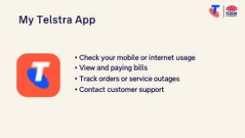 | Say:  - Most phone and internet companies have an app that makes it easier to manage your account. Today we’ll use the My Telstra app as an example, but if you’re with another provider, you’re welcome to explore their app instead.  - These apps are useful for:  - Checking your mobile or internet usage  - Viewing and paying bills  - Tracking orders or service outages  - Contacting customer support  - They’re designed to save time and reduce the need to call customer service or login via their websites.  Demonstrate how to download and use the My Telstra app:  - Open the App Store or Play Store  - Search for and download “My Telstra”  - Login  - Navigating to sections like Billing, Services, or Support  - Highlight tools like data usage tracking and outage updates  Try it:  - Guide learners to download their phone provider’s app and explore features.  For those with Telstra accounts, explain what a Telstra ID is:  - A Telstra ID is the username and password you use to access and manage your Telstra services online. If you’ve used the My Telstra app, or have managed your services in My Telstra, you may already have a Telstra ID. Don't worry if you've forgotten your Telstra ID, you can easily recover it.  Demonstrate how to:  - Register with a Telstra ID (video)  Open the My Telstra app > Select Create a new Telstra ID and Let's get started > Enter your details and follow the prompts.  - Reset your Telstra IS password (video)  Tap Sign in or register >Tap Reset password > Enter your username and tap Send email > You’ll receive an email with further instructions.  Try it:  - Guide learners to complete tasks.  Learn more: https://www.telstra.com.au/my-t-app-s

Timing breakdown | Content
Extension activities:
- Pay a bill (video)
Choose the bill you want to pay > Tap Pay now > Enter the bill amount > Choose your payment method.
- Request a payment extension (video)
Choose the bill you want to pay > select Pay now > Select Request payment extension > Tap accept.
- Set up direct debit (video)
Select Payments > Select your latest bill > Choose your direct debit payment method and enter your details > Follow the prompts.
- Check contract details (video)
Select the service you want to check > Take a look at the Your plan section. Tap Manage and follow the prompts.
- Recharge PrePaid (video)
Open the Service tab and choose your Pre-paid service > Select Recharge now and follow the prompts.
- Check for outages (video)
Select Get Help and Check for outages in your area.

Option 6. Hazards Near Me NSW app (10 min)
Overview
Purpose:
- Introduce learners to the Hazards Near Me NSW app as an official source for bushfire and other emergency warnings.
- Build confidence in using the app to view incidents, set watch zones, and receive timely alerts.
Timing breakdown | Content
Hazards Near Me NSW app  10 min  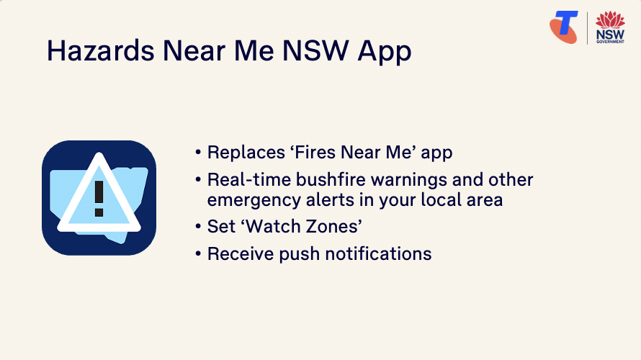 | Say:  - In February 2023 the NSW Rural Fire Service app Fires Near Me NSW was updated to include additional information about other emergencies from the NSW State Emergency Service. Fires Near Me is now called Hazards Near Me.  - Hazards Near Me NSW is the official app for emergency warnings and incident information in NSW. It’s free, easy to use, and provides real-time alerts about bushfires and other hazards, helping you make safe decisions wherever you are.  Explain:  - The app is developed by the NSW Government and NSW Rural Fire Service.  - It provides real-time bushfire warnings and other emergency alerts in your local area.  - You can use your phone’s GPS or enter locations manually to set ‘Watch Zones’ — such as your home, family members’ homes, or a holiday area.  - You can choose to receive push notifications for your current location or any Watch Zones.  - You don’t need to create an account — just download and get started.  - Over time, more types of hazards and emergencies will be added to the app.  Demonstrate how to download and use the Hazards Near Me NSW app:  - Open the App Store or Play Store  - Search for and download “Hazards Near Me NSW”  - Open the app and walk through:  - Home screen and map view  - Tap to view an alert, and explain colour-coded alert levels:  - Advice (yellow)  - Watch and Act (orange)  - Emergency Warning (red)  Watch NSWRFS’s Hazards Near Me - Watch Zones (or demonstrate using a device).  Try it:  - Guide learners to download the app, add a watch zone and explore features.  Learn more:  - https://www.nsw.gov.au/emergency/hazards-near-me-app  - https://hazardsnear.me/

Option 7. my health app (10 min)
Overview
Purpose:
- Introduce the my health app as a secure way to access and manage your health information.
- Support learners to check their My Health Record and understand how to use it.
Timing breakdown | Content
my health app  10 min  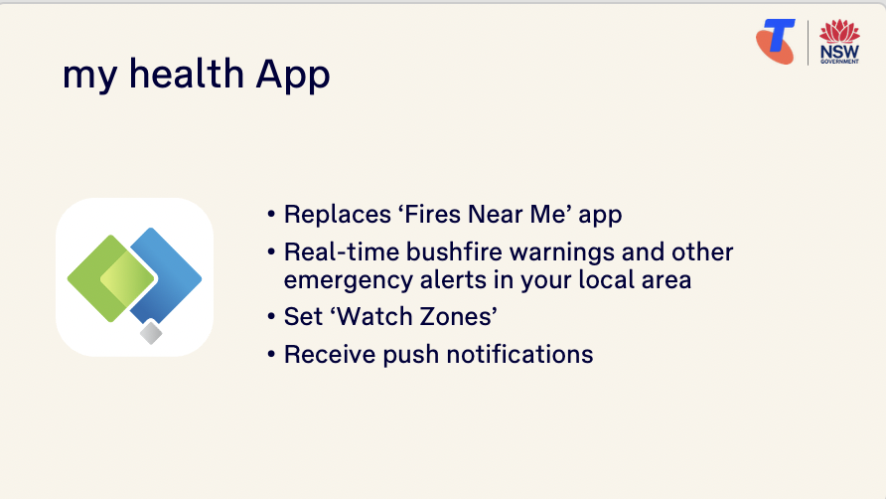 | Say:  - The my health app gives you easy access to your My Health Record — a secure summary of your health information that you and your healthcare providers can use when needed. It can save time, reduce paperwork, and help you stay informed about your health.  Explain:  - The my health app is provided by the Australian Government and connects directly to your My Health Record  - It helps you view:  - Medications and prescriptions  - Immunisations (including COVID-19)  - Pathology and imaging results  - Hospital discharge summaries  - Allergies and adverse reactions  - You can also add your emergency contact, personal health notes and key documents  - You need a myGov account linked to My Health Record to log in  Watch AuDigitalHealth’s my health app - how to set up (or demonstrate using a device).  Demonstrate how to download and use the my health app:  - Open the App Store or Play Store  - Search and download “my health gov” (by Australian Digital Health Agency)  - Open the app and follow the prompts  Try it:  - Guide learners to download the app add explore its features.  Learn more:  - https://www.digitalhealth.gov.au/myhealth

Option 7. Get ePrepared (website) (15 min)
Overview
Purpose:
- Introduce learners to the Get ePrepared website as a simple way to make a digital emergency and life admin plan.
- Show how to create a personalised plan online using checklists, contacts and storage prompts.
Timing breakdown | Content
Get ePrepared (website)  15 min  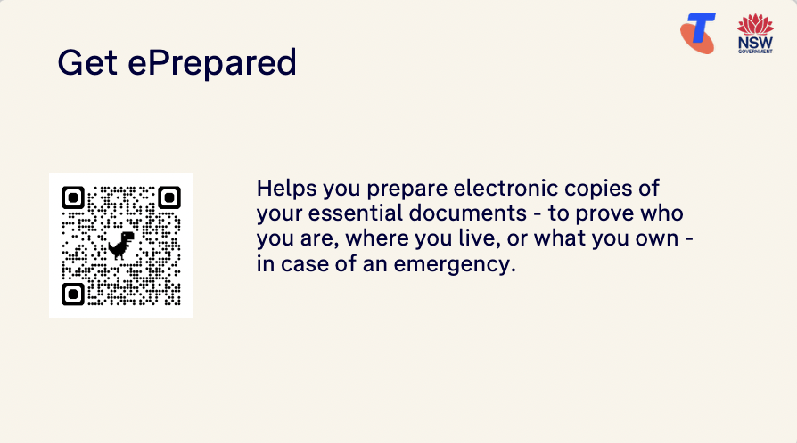 | Say:  - Get ePrepared is a free and easy website that helps you organise important information in one place — like your support network, contacts, medications, documents and more. It’s especially helpful if you want to feel more prepared and in control.  Explain:  - Developed by Justice Connect to help Australians plan for challenging life events  - Helps you prepare electronic copies of your essential documents - to prove who you are, where you live, or what you own - in case of an emergency  - You can complete it at your own pace and save or print your plan  Demonstrate how to explore the website:  - Go to https://prepare.apps.justiceconnect.org.au/  - Scroll down to ‘How can we help you today?’ and show the three topics:  - Learn which documents to store (create a checklist of essential documents)  - Learn where to store documents (pros and cons of storage solutions to decide where to store electronic copies of essential documents)  - Learn how to store documents (Sandra, Jay, Jack, and the Nguyens describe their approach to safely storing electronic copies of their documents)  - Select ‘Get Started’ or ‘Go to the checklist’ and follow the prompts to create a checklist  Try it:  - Guide learners to scan the Get ePrepared QR code on the Learning canvas or PowerPoint Presentation, and explore the three topics.  Learn more:  - https://prepare.apps.justiceconnect.org.au/

8. Built in flexibility (20 min)
Overview
Purpose:
- To address the questions and skills learners were hoping this session covers
- To practice skills
- If time and learner confidence allow, introduce one or more extension activities from earlier sections
Timing breakdown | Content
Digital legacy (optional) | Facilitator note: This is an optional extension activity available across several modules. Before delivering it, check whether learners have already covered it in a previous session.  Say:  - Let’s take a moment to think about something important but often overlooked: what happens to your digital accounts and files when you pass away?  - Many of us have online accounts — like email, photos, social media, or even digital bank records. These are called your digital assets. Your digital accounts don’t automatically close when you die — someone needs to manage them.  - Some people choose to include instructions for these in their will, or appoint a trusted person to help manage things like:  - Deleting or memorialising social media accounts  - Accessing online photo albums or email accounts  - Closing down subscriptions or accounts  Explain how to prepare:  - You can prepare by:  - Making a list of your key digital accounts (and how to access them)  - Thinking about what you’d like to happen to them and including these wishes in your will  - Most online platforms (like Google, Facebook, Apple) have their own settings to manage accounts after death. For example:  - Google has an “Inactive Account Manager” where you can choose what happens and who is notified  - Facebook lets you appoint a “Legacy Contact” or request your account be memorialised  Explain how to start a will:  - In Australia, making a will is the best way to say who gets your belongings and digital assets.  - You can:  - Make a will through a solicitor, trustee service, or using an online will kit  - Visit Service NSW: Get started making a will for a step-by-step guide to get started (QR code on Learning Canvas)  Try it:  - If desired, support learners to visit Service NSW to start a will, or add a legacy contact/Inactive Account Manager to Facebook/Google.  - Learn more: eSafety: What happens to your digital accounts after you die

Timing breakdown | Content
Flexible time  20 min   | Facilitator note:  - If learners identified additional questions or topics in the Welcome section:  - Refer to the list you captured  - Say: “Let’s go through the things you said you most wanted to learn today. I’ll demonstrate each one, and then you’ll have a go.”  - If some learners would prefer to focus on practicing instead, divide the group accordingly  - If there are no further learner questions, recap key skills or explore a sixth app  - If time and learner confidence allow, introduce extension activities covered earlier in the session  Transition:  - Let’s wrap up by reflecting on what you’ve learned today and planning your next steps.
  Extension activities:
  Opal Travel App
  - Order an Opal card online from https://transportnsw.info/tickets-fares/opal/get-opal-card (Check eligibility of Gold Senior/Pensioner Opal cards and Free travel Opal cards.)
  Transit App
  - Check nearby departures & track your ride
  - Plan your trip
  - Get step-by-step directions with GO
  - Pin most used lines & add favourite locations
  Service NSW App
  - Add a digital licence or credential to the Service NSW app
  Select 'Wallet' from the homescreen > Select the 'Add' button> Follow the prompts,
  - Manage personal details
  Select the profile or 'person' icon > Select 'Personal details' > Select the details you’d like to add or update.
  myGov App:
  - Link services
  - Select Services from your home screen
  - Select the Link icon (Android) or Plus symbol (Apple) next to the service you want to link
  - Select the service you would like to link and follow the prompts
  - Manage notifications:
  - Turn on notifications:
  Open your device Settings, then Notifications and select myGov from the list then:
  - on your Apple device, switch Allow Notifications to On
  - on your Android device, switch Show notifications to On.
  - Turn off notifications:
  Open your device Settings, then Notifications and select myGov from the list then:
  - on your Apple device, switch Allow Notifications to Off
  - on your Android device, switch Show notifications to Off.
  My Telstra App:
  - Pay a bill (video)
  Choose the bill you want to pay > Tap Pay now > Enter the bill amount > Choose your payment method.
  - Request a payment extension (video)
  Choose the bill you want to pay > select Pay now > Select Request payment extension > Tap accept.
  - Set up direct debit (video)
  Select Payments > Select your latest bill > Choose your direct debit payment method and enter your details > Follow the prompts.
  - Check contract details (video)
  Select the service you want to check > Take a look at the Your plan section. Tap Manage and follow the prompts.
  - Recharge PrePaid (video)
  Open the Service tab and choose your Pre-paid service > Select Recharge now and follow the prompts.
  - Check for outages (video)
  Select Get Help and Check for outages in your area.

9. Wrap up (20 min)
Overview
Purpose:
- Consolidate learning and celebrate progress.
- Demonstrate scanning QR codes on the Learning Canvas for trusted follow‑up resources.
- Set a simple action for the week and signpost support.
Timing breakdown | Content
Reflection  10 min  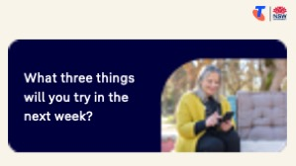  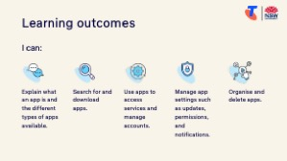  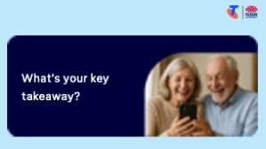 | Say:  - We’ve covered some key information and skills in installing and using apps. Let’s take a moment to celebrate what you’ve learned and record it so you can refer back to it later.  Say:  - Let’s revisit your Learning Canvas - tick the skills you can do.  Ask:  - What’s your key takeaway from today’s session?  Learners note reflections on their Learning Canvas. Invite responses.  - What three things will you try in the next week?  E.g. share what you learned with someone, top up your Opal card, plan a trip using the Transit app, add your digital licence to Service NSW app.  Learners note actions on their Learning Canvas. Invite responses.
Support  10 min   | Say:  - There are QR codes on the back of your Learning Canvas that provides more information online.  - There’s a lot of information online, so don't feel you need to access it. We’ll cover lots more in our Tech Savvy Seniors program.  - But being able to scan a QR code is a handy skill. A QR code is a visual link to a website. It saves you from needing to type the URL/web address into your browser. So, let’s practice today’s final skill!  Demonstrate how to:  - Scan QR code (Open the Camera > point at QR code on Canvas > tap the link)  Try it:  - Guide learners to scan the QR codes on the back of the Learning Canvas.  Explain:  - Where learners can go for support (e.g. 1:1 help at the library, tech groups, or other programs).  Learners note support on Learning Canvas.  - Show Tech Savvy Seniors program and provide the schedule for upcoming sessions.  Say:  - Well done! You’ve all achieved something new today. Keep practising little and often. We look forward to seeing you at another session.

