Tech Savvy Seniors
Module 8
Use your device for everyday tasks and entertainment
Session plan

Table of contents
Session overview 3
Learning architecture 3
Learning outcomes 3
Resources checklist 4
Session summary 5
Session plan 6
1. Welcome (10 min) 6
2. What is an app? (10 min) 8
3. Tools for everyday use (30 min) 9
4. Maps and directions (20 min) 12
5. Entertainment on your device (20 min) 14
6. Built in flexibility (20 min) 16
7. Wrap up (20 min) 19

Session overview
This 2–2.5-hour session helps older Australians explore fun and practical ways to use their smartphone or tablet. From setting reminders to finding your way, and discovering how to enjoy music, videos, podcasts or games, learners will build confidence using everyday apps. They’ll also practise switching between apps and closing them when not needed.
This session is a hands-on exploration, tailored to learners’ interests. It aims to show that digital devices aren’t just for communication or information — they can make daily life easier and more enjoyable.

Learning architecture
This module forms part of a 12-module series.
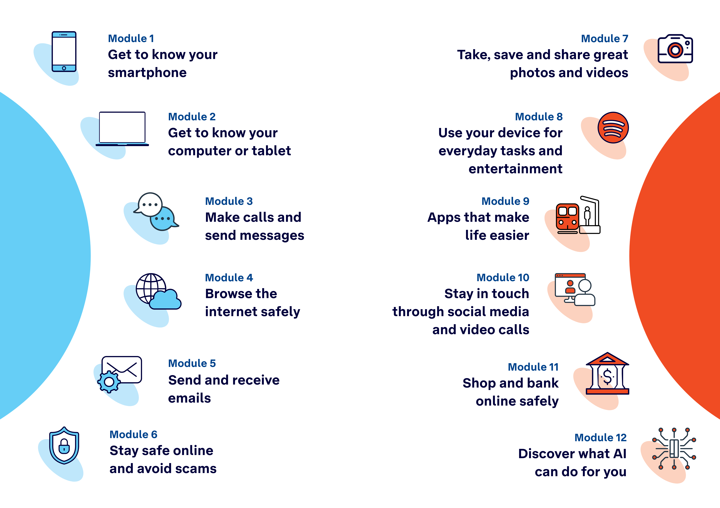

Learning outcomes
At the end of this session, learners will be able to:
- Download, open and close apps.
- Use a navigation app to find a location and get directions.
- Set an alarm, timer, reminder or calendar event.
- Use a calculator, write a note and check the weather.
- Try a video, music, podcast or game app.

Resources checklist
This session requires the following resources:
☐ | Session plan (this document)
☐ | PowerPoint presentation
☐ | Learning Canvas - printed (one per learner)
☐ | Pens for learners (one per learner)
☐ | Butchers paper/markers or a whiteboard/markers may be useful to assist with capturing ‘learning goals’ which will be touched on throughout the session
☐ | Library’s Wi-Fi password
☐ | Tech Savvy Seniors program schedule - printed (one per learner)
☐ | Learners’ own device (smartphone, tablet or computer)
☐ | Internet-connected smartphones, tablets or computers (as available)
☐ | Facilitator’s computer for demonstrations
☐ | Projector and screen (optional)

Session summary
This session summary provides an overview of topics, the activities relevant to each topic and the duration.

Duration | Topic | Useful links
10 min | 1. Welcome
10 min | 2. What is an app?
30 min | 3. Tools for everyday use | - Clock app: iPhone  - Reminder app: iPhone and Android (Google Calendar or Google Tasks)  - Calendar app: iPhone and Android (Google Calendar)  - Notes app: Notes (Apple) or Google Keep (Android)  - Weather: iPhone and Samsung  - Convert units: iPhone and Samsung  - Organise notes: iPhone and Android
10 min | Break
20 min | 4. Maps and directions | - Google Maps
20 min | 5. Entertainment on your device
10 min | Break
20 min | 6. Built in flexibility
20 min | 7. Wrap up | - iPhone: Scan a QR code with your iPhone or iPad  - Android: How do you scan QR codes on Android?
Total duration: 2.5 hours

Session plan

1. Welcome (10 min)
Overview
Purpose:
- Introduce Module 8: Use your device for entertainment, including the flow (short demos + practice)
- Set a safe, calm tone; reduce anxiety about ‘pressing the wrong thing’
- Introduce the Learning Canvas as a personal guide they can use during the session and take home
- Gather learner goals to tailor the ‘Built‑in flexibility’ section later
Timing breakdown | Content
Session overview  10 min    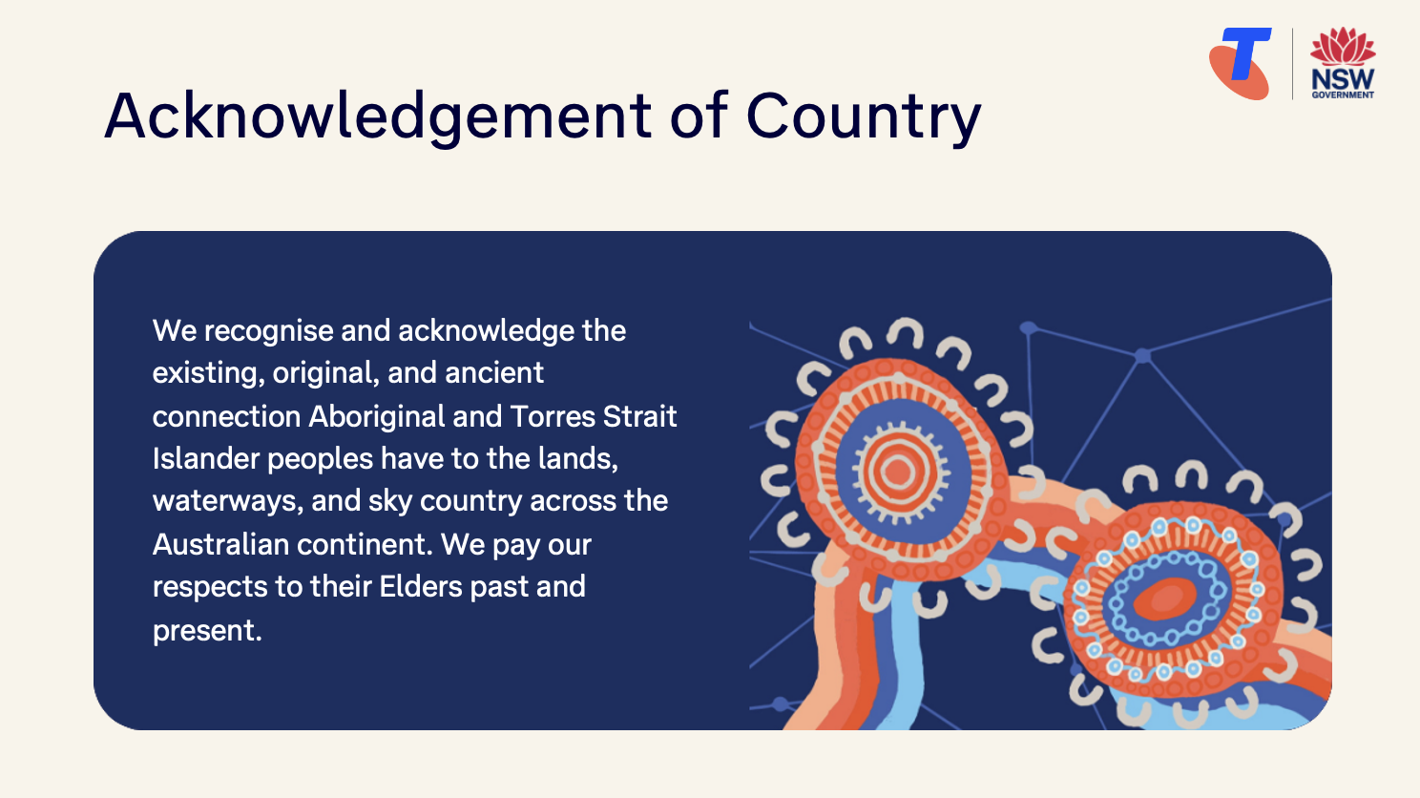  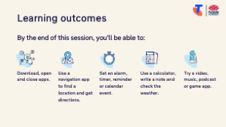 | On arrival, ensure each learner has a device, printed Learning Canvas and pen. Group learners by device so they can support each other.  Deliver: An Acknowledgement of Country.  Say:  - Welcome! Today we’re going to explore some of the handy and fun things your device can do — from setting reminders and checking the weather to playing music, podcasts or games.  - These apps can help with everyday tasks, keep you entertained, and make your device feel more useful and personal.  - Whether you’re planning a day out, making a shopping list, or just want something fun to do while having a cuppa — your device has apps that can help.  - In this session, we’ll explore how to use tools like the alarm, calculator, and weather app, try a navigation or map app, and discover something entertaining — like a podcast, video or game.  - We’ll also practise switching between apps and closing them when you’re done.  - Don’t worry if some of this is new — we’ll go slowly, support each other, and you can choose the features that interest you most.  - Before we touch anything, let’s agree: it’s fine to make mistakes. That’s how we learn.  - By the end of this session, you’ll be able to:  - Download, open and close apps.  - Use a navigation app to find a location and get directions.  - Set an alarm, timer, reminder or calendar event.  - Use a calculator, write a note and check the weather.  - Try a video, music, podcast or game app.  Introduce Learning Canvas:  - Use your printed Learning Canvas to write notes in your own words, tick off skills as you learn them, and highlight what feels most useful to you. Writing things down helps you remember and understand them better, and makes it easier to recall later. Take your Canvas home to keep practising. On the back, you’ll find extra tips and trusted links if you want to explore more.

Timing breakdown | Content
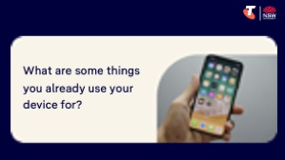 | Ask:  - What are some things you already use your device for?  - What’s something new or fun you’d like to try today?  (Write answers on a whiteboard or butchers paper. These will help shape the ‘Built-in Flexibility’ section later in the session.)  Confirm everyone has a device; pair anyone without.  Transition:  - Let’s begin by learning what an app is.

2. What is an app? (10 min)
Overview
Purpose:
- Help learners understand what apps are, where to find them, and how they are used for different tasks.
- Explain how to open and close apps.
Timing breakdown | Content
What is an app?  2 min  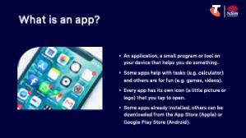 | Say:  - “App” is short for application — it’s just a small program or tool on your device that helps you do something.  - Some apps help with tasks — like setting an alarm, checking the weather, or looking at maps.  - Others are for fun — like games, videos, music, or reading the news.  - Every app has its own icon (a little picture or logo) that you tap to open.  - Your phone or tablet comes with some apps already installed. Others can be downloaded from the App Store (Apple) or Google Play Store (Android).
Open and close apps  8 min | Demonstrate how to:  - Open an app:  - Show your home screen and point out some app icons like Clock, Weather, Camera, or Maps.  - Tap to open one, then return to the home screen using the home button, navigation bar or by swiping up (depending on the device).  - Switch between apps:  - Android: Swipe up from the bottom and hold, or tap the square/recent apps button.  - Apple: Swipe up from the bottom and pause, or double-tap the Home button.  - Show how to swipe left/right to move between open apps.  - Close an app:  - In the open apps view, swipe an app upwards (or off screen) to close it.  - Explain this can help if an app isn’t working or to keep the device running smoothly.  Try it:  - Guide learners to practise opening one app, switching to another, then closing both (with support if needed).  Transition:  - Now let’s look at some helpful everyday tools — like setting a timer, adding a calendar reminder, or checking the weather — all using apps built into your device.

3. Tools for everyday use (30 min)
Overview
Purpose:
- Help learners use common built-in apps on their device to organise their day, get information, and practise basic tasks like setting reminders and checking the weather.
Timing breakdown | Content
Use the clock app  10 min  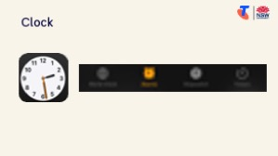 | Say:  - Your device isn’t just for staying in touch — it’s full of tools that make everyday tasks simpler.  - Let’s explore some of the built-in apps that can help you stay organised or find useful information.  Explain the clock app:  - Let’s start with the Clock app — it’s more than just a clock!  - The Clock app helps you stay on track — set alarms to wake up, use a timer for cooking, or start a stopwatch to see how long something takes.  - There are four key features:  - Alarm – to wake up or set a reminder at a specific time.  - Timer – counts down from a set time (great for cooking).  - Stopwatch – tracks how long something takes.  - World Clock – check the time in other parts of the world.  Demonstrate how to:  - Open the Clock app and navigate to these four common sections (names may vary slightly between Apple and Android).  - Set a new alarm: Tap the Alarm tab > tap the + or Add > choose the time > change ‘repeat’ setting (as desired) > add a label (if desired) > Save. (iPhone)  - Set a timer: Tap the Timer tab > set the duration (e.g. 5 minutes) > Start. When it goes off, show how to click x to acknowledge it. (iPhone)  Try it:  - Ask learners to open their Clock app and set one alarm and one timer.  Ask:  - What kinds of things might you use these apps for?
  Extension activities:
  - Check the time across different time zones: Clock > World Clock > Tap + to add a time zone/city. (iPhone)
  - Use the stopwatch: Clock > Stopwatch > Tap Start, then Stop and Reset. (iPhone)

Timing breakdown | Content
Create a reminder and calendar event  10 min  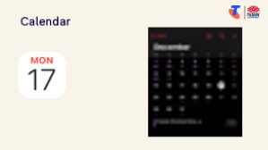 | Say:  - You can also use your device to remind you about appointments or to-dos — like “dentist at 11am Monday” or “take the bins out tonight.”  Demonstrate how to create a reminder:  - Apple: Open the Reminders app > tap New Reminder > type a short task > add time if needed. (iPhone)  - Android: Use Google Calendar or Google Tasks.  Demonstrate how to use calendar:  - Create a calendar event: Open the Calendar app > tap + or “Add Event” > give it a title (e.g. “Lunch with Sam”) > choose date/time > add an ‘alert’ and set a time for the alert > Save. (iPhone)(Google Calendar)  - View and edit calendar events: Open the Calendar app > select days to view events > tap on the event and select edit  Try it:  - Guide learners to create one calendar event and one reminder.  Ask:  - How do you currently set reminders (e.g. paper diary, wall calendar)?  - Why might using your phone calendar be helpful?  (e.g. You always have it with you, helps when booking appointments.)
  Extension activities:
  - Add a repeating calendar event (e.g. weekly craft group)
  Open Calendar > Add event > set date/time > choose “Repeat weekly.”
  - Set a birthday reminder
  Open Calendar or Reminders > Add event > set to repeat yearly.
  - Try a voice assistant to create a reminder
  Say “Hey Siri” or “Hey Google” > “Remind me to water the plants at 6pm.”
Use the calculator, write a note and check the weather  10 min  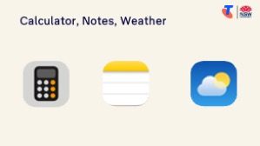 | Say:  - Let’s finish this section with three more handy tools you might like:  - Calculator: Quickly do sums — e.g. adding bills or working out prices.  - Notes/Memo: Jot down shopping lists, questions, or anything you want to remember.  - Weather: Check today’s forecast or the week ahead — especially helpful for planning trips or outdoor activities.  Demonstrate how to use each app:  - Calculator: Open app > show simple operations like 25 x 3, then clear.  - Notes or Memo: Open Notes (Apple) or Google Keep (Android) > create a new note > write “Shopping: milk, bread, tea.”  - Weather: Open Weather app > explain symbols (sun, rain), temperature, and upcoming days. (iPhone) (Samsung)  Try it:  - Guide learners to practise using each tool.  Transition:  - Well done — you’ve just explored some of the most useful built-in tools. Next, we’ll explore how to use maps on your device to find places and get directions.
  Extension activities:
  - Save multiple cities in the Weather app
  Open your Weather app > tap the “+” or “Add City” button > type the name of a city (e.g. where family live, a holiday destination) > select it > select Add. (iPhone) (Android - Pixel)
  - Convert units or currency in Calculator app
  iPhone: tap the calculator icon (bottom left) > turn on Convert > tap the arrows and choose the units or currencies you want to convert from and to.
  Samsung: Tap the Unit converter icon (it looks like a ruler) to convert different measurements.
  - iPhone: Add a photo, audio recording and link to a note, and share a note
  Add photo: In a note, tap the paperclip icon > choose an option (e.g. take a photo or choose from photo library). (iPhone)
  Add audio recording: In a note, tap the paperclip icon > tap Record Audio > tap the red button to start recording > tap the stop button.
  Add link: In a note, select the text, tap the arrow, then tap Add Link. (You can use the copy and paste.)
  Share a note: Open the note you want to share, tap the share button, then choose Collaborate. (This only works between Apple users.)
  - Organise notes using folders or pin a note for quick access
  iPhone: In Notes: Tap “Folders” > New Folder (e.g. “Shopping Lists”, “Health Info”) > Move your new note into this folder. Alternatively, swipe the note left and choose “Pin” so it stays at the top.
  Android: Google Keep: Tap “+” to create a note > Tap three-dots menu > “Add label” (e.g. “Games”, “Outings”) > Use the pin icon to keep it at the top.
10 min | Break

4. Maps and directions (20 min)
Overview
Purpose:
- Help learners use navigation apps to find locations, get directions, and plan trips using walking, public transport or driving routes.
Timing breakdown | Content
Maps and directions  20 min  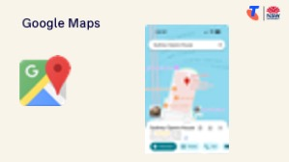 | Say:  - Did you know your device can help you find your way — just like a paper map, but with live directions and more?  - You can use an app like Google Maps or Apple Maps to:  - Search for an address or business  - See what’s nearby (like shops, parks or ATMs)  - Get directions for walking, public transport or driving  - View how long it will take to get somewhere  Demonstrate how to use Google Maps:  - Open Google Maps or download it from the App store (Apple) or Google Play Store (Android).  - Search for a place  - Tap search bar and type a specific place (e.g. “Sydney Opera House” or a “[name] library”)  - Tap a result to view it on the map  - Zoom in and out, navigate around the screen, and select the location button to navigate to your current location  - View shop information:  - Show the ‘Overview’ tab and how it may present the shop’s opening times, address, link to their website, phone number, photos, reviews, etc.  - Explore directions  - Tap “Directions”  - Show how to:  - Switch between Walking, Driving, Public transport and Bicycle  - View estimated time and distance  - Tap “Start” for live navigation  - Tap the sound button to mute/unmute directions  Try it:  - Guide learners to complete the tasks.  Ask:  - What kinds of places would you like to search for using your device?  Transition:  - You now know how to find places and get directions on your device. Let’s explore how to enjoy entertainment like videos, music, podcasts, and games.
  Extension activities:
  - Search for nearby categories instead of exact places
  In the search bar, type a category like “restaurants near me”, “parks nearby” or “petrol stations”.
  - Get directions between two places that are not your current location
  Tap “Directions” > enter a starting point manually (e.g. friend’s house) and destination > review route.
  - Share a location with someone
  Tap a location > tap “Share” > choose a method (e.g. text message or email).
  - Save to a list and customise the list’s icon
  Tap a place > tap “Save” > create a new list (e.g. “Cafés to Try”) > tap the pencil/edit icon to add a custom name or icon (e.g. a coffee cup). Then, see how the icons are marked on the map.
  - Use voice search in Maps
  Tap microphone icon > say something like “Find [suburb] post office”.

5. Entertainment on your device (20 min)
Overview
Purpose:
- To introduce learners to apps that provide entertainment, and encourage them to explore content they enjoy, including videos, music, podcasts and simple games.
Timing breakdown | Content
Videos, music and podcasts  10 min  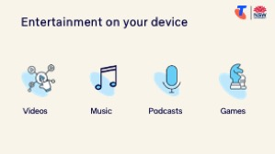 | Say:  - Your device can be a great source of entertainment — not just for watching shows or listening to music, but also for playing games, listening to podcasts, or exploring your interests.  - Many of the apps you see on smart TVs — like Netflix, YouTube, or ABC iView — can also be downloaded, or you can visit their websites.  - Some apps are completely free. Others have both free versions (often with ads) and paid subscriptions that remove ads or unlock more features. For example:  - YouTube and Spotify are free to use with ads, but you can pay monthly to remove them.  - Many games are free, but offer in-app purchases or upgrades.  - Let’s try out some fun apps and features that many Australians use to pass the time or enjoy a hobby.  Demonstrate how to use one of the following platforms:  - YouTube (videos):  - Open YouTube (download if needed)  - Search for a topic of interest (e.g. “gardening tips” or “60s music”)  - Tap a video and explain how to pause, rewind, play, adjust volume, or go fullscreen  - ABC Listen (podcasts/radio):  - Open the app (download if needed)  - Browse shows by topic or listen live  - Explain how to use the play, pause and skip buttons  - Spotify Free (music and podcasts):  - Open Spotify (download if needed) > search for an artist, song or podcast  - Show how to play content and follow a playlist or show  Try it:  - Guide learners to download use an app (they might need to create an account).  Ask:  - How might these apps help you learn or explore more about your hobbies or interests?  - Have you ever wanted to re-watch an old TV clip, concert or interview from years ago? You might be able to find it on YouTube!
  Extension activities:
  - Create a playlist on YouTube or Spotify
  Search for content > tap “Add to playlist” > create and name your own list.
  - Download an episode or track to listen offline
  → In apps like Spotify or ABC Listen, look for the download icon (usually a down arrow).
  - Explore settings in an entertainment app
  Adjust sound, subtitles, screen brightness, or auto-play preferences for comfort.
  - Search for a favourite show or music on a new platform
  Try searching the same artist or show in YouTube, Spotify, ABC or a podcast app — compare what you find.
Try a game app  10 min | Say:  - Let’s now look at games — a fun way to relax or keep your brain active.  - There are thousands of free games — from puzzles and word games to cards and strategy games.  Demonstrate how to download and use a game app:  - Download and open a free game like Solitaire, Wordscapes, Sudoku, Mahjong or Candy Crush.  - Show how to open the app, start a game, and return to the home screen.  Ask:  - What types of games do you like playing? You can use the search function in the App Store/Google Play Store to look for it. Check the price before downloading!  Try it:  - Guide learners to download use an app (they might need to create an account).  Ask:  - What games are you excited to try?  Transition:  - That was a fun session! After a quick break, we’ll spend time on your questions and goals from earlier.
  Extension activities:
  - Multiplayer games:
  You can enjoy games on your device by yourself or play with others — such as family or friends. To play together, you’ll usually both need the same app and an account. Multiplayer games include:
  - Words With Friends 2 – like Scrabble; take turns with a friend
  - UNO!™ – card game you can play with family or online players
  - Chess.com – play chess with friends or online opponents
  - Draw Something – take turns drawing and guessing pictures
  Download the app and send an invite or enter your friend’s username to connect.
10 min | Break

6. Built in flexibility (20 min)
Overview
Purpose:
- To address the questions and skills learners were hoping this session covers
- To practice skills
- If time and learner confidence allow, introduce one or more extension activities from earlier sections
Timing breakdown | Content
Flexible time  20 min  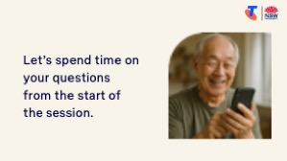 | Facilitator note:  - If learners identified additional questions or topics in the Welcome section:  - Refer to the list you captured  - Say: “Let’s go through the things you said you most wanted to learn today. I’ll demonstrate each one, and then you’ll have a go.”  - If some learners would prefer to focus on practicing instead, divide the group accordingly  - If there are no further learner questions, recap key skills  - If time and learner confidence allow, introduce extension activities covered earlier in the session  Transition:  - Let’s wrap up by reflecting on what you’ve learned today and planning your next steps.
  Extension activities:
  Clock
  - Check the time across different time zones: Clock > World Clock > Tap + to add a time zone/city. (iPhone)
  - Use the stopwatch: Clock > Stopwatch > Tap Start, then Stop and Reset. (iPhone)
  Calendar events and reminders
  - Add a repeating calendar event (e.g. weekly craft group)
  Open Calendar > Add event > set date/time > choose “Repeat weekly.”
  - Set a birthday reminder
  Open Calendar or Reminders > Add event > set to repeat yearly.
  - Try a voice assistant to create a reminder
  Say “Hey Siri” or “Hey Google” > “Remind me to water the plants at 6pm.”
  Calculator, notes and weather
  - Save multiple cities in the Weather app
  Open your Weather app > tap the “+” or “Add City” button > type the name of a city (e.g. where family live, a holiday destination) > select it > select Add. (iPhone) (Android - Pixel)
  - Convert units or currency in Calculator app
  iPhone: tap the calculator icon (bottom left) > turn on Convert > tap the arrows and choose the units or currencies you want to convert from and to.
  Samsung: Tap the Unit converter icon (it looks like a ruler) to convert different measurements.
  - iPhone: Add a photo, audio recording and link to a note, and share a note
  Add photo: In a note, tap the paperclip icon > choose an option (e.g. take a photo or choose from photo library).
  Add audio recording: In a note, tap the paperclip icon > tap Record Audio > tap the red button to start recording > tap the stop button.
  Add link: Ina note, select the text, tap the arrow, then tap Add Link. (You can use the copy and paste.)
  Share a note: Open the note you want to share, tap the share button, then choose Collaborate. (This only works between Apple users.)
  Organise notes using folders or pin a note for quick access
  iPhone: In Notes: Tap “Folders” > New Folder (e.g. “Shopping Lists”, “Health Info”) > Move your new note into this folder. Alternatively, swipe the note left and choose “Pin” so it stays at the top.
  Android: Google Keep: Tap “+” to create a note > Tap three-dots menu > “Add label” (e.g. “Games”, “Outings”) > Use the pin icon to keep it at the top.
  Maps and directions
  - Search for nearby categories instead of exact places
  In the search bar, type a category like “restaurants near me”, “parks nearby” or “petrol stations”.
  - Get directions between two places that are not your current location
  Tap “Directions” > enter a starting point manually (e.g. friend’s house) and destination > review route.
  - Share a location with someone
  Tap a location > tap “Share” > choose a method (e.g. text message or email).
  - Save to a list and customise the list’s icon
  Tap a place > tap “Save” > create a new list (e.g. “Cafés to Try”) > tap the pencil/edit icon to add a custom name or icon (e.g. a coffee cup). Then, see how the icons are marked on the map.
  - Use voice search in Maps
  Tap microphone icon > say something like “Find [suburb] post office”.
  Videos, music and podcasts
  - Create a playlist on YouTube or Spotify
  Search for content > tap “Add to playlist” > create and name your own list.
  - Download an episode or track to listen offline
  → In apps like Spotify or ABC Listen, look for the download icon (usually a down arrow).
  - Explore settings in an entertainment app
  Adjust sound, subtitles, screen brightness, or auto-play preferences for comfort.
  - Search for a favourite show or music on a new platform
  Try searching the same artist or show in YouTube, Spotify, ABC or a podcast app — compare what you find.
  Game apps
  - Multiplayer games:
  You can enjoy games on your device by yourself or play with others — such as family or friends. To play together, you’ll usually both need the same app and an account. Multiplayer games include:
  - Words With Friends 2 – like Scrabble; take turns with a friend
  - UNO!™ – card game you can play with family or online players
  - Chess.com – play chess with friends or online opponents
  - Draw Something – take turns drawing and guessing pictures
  Download the app and send an invite or enter your friend’s username to connect.

7. Wrap up (20 min)
Overview
Purpose:
- Consolidate learning and celebrate progress.
- Demonstrate scanning QR codes on the Learning Canvas for trusted follow‑up resources.
- Set a simple action for the week and signpost support.
Timing breakdown | Content
Reflection  10 min  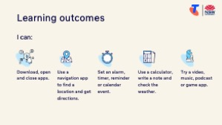  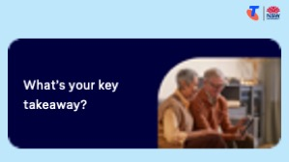   | Say:  - We’ve covered some key information and skills in using your device for entertainment. Let’s take a moment to celebrate what you’ve learned and record it so you can refer back to it later.  Say:  - Let’s revisit your Learning Canvas - tick the skills you can do.  Ask:  - What’s your key takeaway from today’s session?  Learners note reflections on their Learning Canvas. Invite responses.  - What three things will you try in the next week?  E.g. share what you learned with someone, download and explore a video/music/podcase/audiobook app, download and play a game app.  Learners note actions on their Learning Canvas. Invite responses.
Support  10 min   | Say:  - There are QR codes on the back of your Learning Canvas that provide more information online.  - There’s a lot of information online, so don't feel you need to access it. We’ll cover lots more in our Tech Savvy Seniors program.  - But being able to scan a QR code is a handy skill. A QR code is a visual link to a website. It saves you from needing to type the URL/web address into your browser. So, let’s practice today’s final skill!  Demonstrate how to:  - Scan QR code (Open the Camera > point at QR code on Canvas > tap the link)  Try it:  - Guide learners to scan the QR codes on the back of the Learning Canvas.  Explain:  - Where learners can go for support (e.g. 1:1 help at the library, tech groups, or other programs).  Learners note support on Learning Canvas.  - Show Tech Savvy Seniors program and provide the schedule for upcoming sessions.  Say:  - Well done! You’ve all achieved something new today. Keep practising little and often. We look forward to seeing you at another session.

