Tech Savvy Seniors
Module 7
Take, save and share great photos and videos
Session plan

Table of contents
Session overview 3
Learning architecture 3
Learning outcomes 3
Resources checklist 4
Session summary 5
Session plan 6
1. Welcome (10 min) 6
2. What is the camera app? (15 min) 7
3. Take great photos and videos (25 min) 9
4. View, delete and organise your photos and videos (25 min) 12
5. Edit your photos and videos (20 min) 14
6. Share your photos and videos (15 min) 16
7. Built in flexibility (25 min) 18
8. Wrap up (20 min) 20

Session overview
This relaxed 2–2.5-hour session helps older Australians feel more confident using their device’s camera to take, view, and share photos and videos. Participants will explore photo modes, organise their gallery, perform basic edits, and send photos to friends or family via message or email.

Learning architecture
This module forms part of a 12-module series.
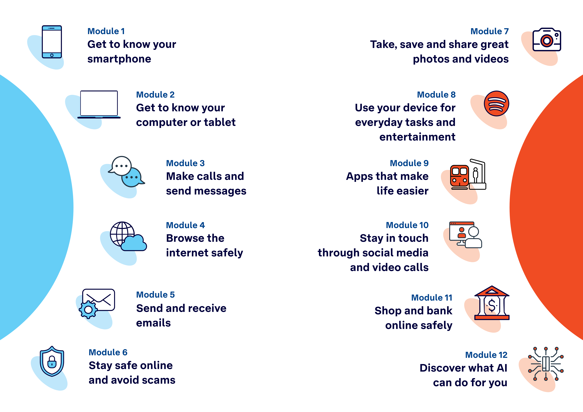

Learning outcomes
At the end of this session, learners will be able to:
- Open and use the camera to take photos and videos.
- View, delete, and organise photos and videos.
- Perform basic photo and video edits.
- Share a photo or video by message or email.
- Understand privacy considerations when sharing.

Resources checklist
This session requires the following resources:
☐ | Session plan (this document)
☐ | PowerPoint presentation
☐ | Learning Canvas - printed (one per learner)
☐ | Pens for learners (one per learner)
☐ | Butchers paper/markers or a whiteboard/markers may be useful to assist with capturing ‘learning goals’ which will be touched on throughout the session
☐ | Tech Savvy Seniors program schedule - printed (one per learner)
☐ | Learners’ own device (smartphone or tablet)
☐ | Smartphones or tablets (as available)
☐ | Facilitator’s computer for presentation
☐ | Projector and screen (optional)

Session summary
This session summary provides an overview of topics, the activities relevant to each topic and the duration.

Duration | Topic | Useful links
10 min | 1. Welcome
10 min | 2. What is the camera app?
25 min | 3. Take great photos and videos
10 min | Break
25 min | 4. View, delete and organise your photos and videos
20 min | 5. Edit your photos and videos
15 min | 6. Share your photos and videos
10 min | Break
25 min | 7. Built in flexibility
20 min | 8. Wrap up | - iPhone: Scan a QR code with your iPhone or iPad  - Android: How do you scan QR codes on Android?
Total duration: 2.5 hours

Session plan

1. Welcome (10 min)
Overview
Purpose:
- Introduce Module 7: Take, save and share great photos and videos, including the flow (short demos + practice)
- Set a safe, calm tone; reduce anxiety about ‘pressing the wrong thing’
- Introduce the Learning Canvas as a personal guide they can use during the session and take home
- Gather learner goals to tailor the ‘Built‑in flexibility’ section later
Timing breakdown | Content
Session overview  10 min      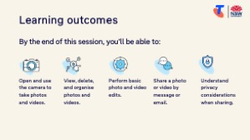     | On arrival, ensure each learner has a device, printed Learning Canvas and pen. Group learners by device so they can support each other.  Deliver: An Acknowledgement of Country.  Say:  - Welcome! Today we’re going to explore how to take, view and share great photos and videos using your smartphone or tablet. Whether you’re capturing grandkids, a beautiful garden, or a community event, we’ll help you feel confident using your device’s camera. It’s okay if you’ve never used it before – we’ll take things one step at a time and there are no silly questions.  - Before we touch anything, let’s agree: it’s fine to make mistakes. That’s how we learn.  - By the end of this session, you’ll be able to:  - Open and use the camera to take photos and videos.  - View, delete, and organise photos and videos.  - Perform basic photo and video edits.  - Share a photo or video by message or email.  - Understand privacy considerations when sharing.  Introduce Learning Canvas:  - Use your printed Learning Canvas to write notes in your own words, tick off skills as you learn them, and highlight what feels most useful to you. Writing things down helps you remember and understand them better, and makes it easier to recall later. Take your Canvas home to keep practising. On the back, you’ll find extra tips and trusted links if you want to explore more.  Ask:  - Who has taken a photo with their device before?  - Do you have any favourite things to take photos of?  - What’s one thing you’d like to feel more confident about by the end of today?  (Write answers on a whiteboard or butchers paper. These will help shape the ‘Built-in Flexibility’ section later in the session.)  Confirm everyone has a device; pair anyone without.  Transition:  - Let’s begin by learning what email is.

2. What is the camera app? (15 min)
Overview
Purpose:
- Help learners identify the camera app and understand its purpose.
- Clarify difference between taking photos and videos.
- Build awareness of front vs rear camera.
Timing breakdown | Content
What is the camera app?  10 min  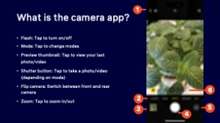 | Say:  - Most smartphones and tablets have built-in cameras that let you take photos and videos. The camera app is usually found on the home screen, and its icon often looks like a small camera.  - On an Apple device (iPhone/iPad): The Camera app icon looks like a grey camera. It’s usually on the first home screen or in the bottom dock.  If not visible: Swipe down from the middle of the home screen (not the very top) to open the Search bar. Type "Camera" and tap to open it.  Alternatively, scroll to the last menu page to the App Library and search there.  - On an Android device: Look for a grey or colourful camera icon. It may be on the Home screen or in the App Drawer (swipe up from the bottom).  If not visible: Use the Google search bar or swipe down from the middle of the home screen (on some Androids) and type "Camera."  Demonstrate:  - Open the camera app  - Identify the key buttons:  - Flash: Tap to turn on/off  - Mode switch (Photo/Video): Swipe left/right or tap "Video" to change modes  - Preview thumbnail: Small square image (bottom corner) – tap to view your last photo/video  - Shutter button: Large circle in the middle – tap to take a photo  - Flip camera icon: Circular arrows – switch between front and rear camera  - Zoom: Tap to zoom in/out  - Identify the front and back cameras on the device  Explain:  - The rear camera is ideal for taking pictures of people, pets, scenery or events  - The front camera is good for selfies or video calls  Try it:  - Guide learners complete the tasks.  Ask:  - Do you know where your photos go after you take them?  Explain:  - Photos and videos are automatically saved to your Photos app (Apple) or Gallery/Google Photos app (Android). We’ll explore how to find, organise and share them soon.  Transition:  - Now that we’ve opened our cameras and explored the main buttons, let’s try taking some photos and videos!

3. Take great photos and videos (25 min)
Overview
Purpose:
- Build learner confidence by practising simple techniques for taking photos and videos.
- Demonstrate different types of photos (portrait, object, scenery).
- Introduce video capture and simple camera features like focus and flash.
Timing breakdown | Content
Take great photos and videos  25 min  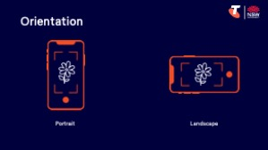 | Say:  - Let’s practise using the camera to take different types of photos and a short video. Whether you're capturing a family moment, a beautiful view, or an object, knowing how to frame and focus your shot helps you get better results.  Explain basic photo concepts:  - Portrait orientation = phone held upright (good for people or vertical objects)  - Landscape orientation = phone held sideways (good for scenery or group shots)  - Framing: The subject should be in the middle or slightly off-centre for a more natural look  - Lighting: More light usually means a clearer photo. Try to face toward the light.  - Focus: Tap the subject on the screen to help the camera focus  - Stability: Holding the phone with two hands or resting elbows on a surface helps reduce blur  - Selfie: A photo you take of yourself, usually using the front-facing camera  - Screenshot: A photo of what’s currently on your screen (e.g. a message, map, or webpage)  Demonstrate how to:  - Take a selfie  - Take a photo of an object  - Take a scenery photo (e.g. a window view or across the room)  - Take a short video (5–10 seconds of something still or moving) (Swipe to "Video" mode, tap the red record button to start and again to stop)  - Take a screenshot (Apple: Press the Side button + Volume Up at the same time) (Android: Usually press the Power button + Volume Down at the same time)  - View the photo/video just taken via the preview thumbnail (small square image (bottom corner)), then navigate back via the back arrow  Tips:  - Photos don’t have to be perfect. Take a few and we’ll choose the best one later.  - Use volume buttons on the side of the device as an alternative shutter button (easier for some learners)  - Tap the screen where you want the camera to focus.  - If the photo is dark, try turning toward a window or turning on a light.  Try it: Guide learners to:  - Take three photos: one selfie, one object, one scenery  - Take a screenshot  - Take a short video

Timing breakdown | Content
Extension activities:
- Turn the flash on or off (especially helpful indoors)
Apple: Tap the lightning bolt icon at the top left of the screen. Tap again to toggle between Auto, On, and Off.
Android: Tap the lightning bolt icon (usually at the top or side of the screen). Choose between Auto, On, or Off.
Tip: Flash can help in dim lighting, but sometimes creates harsh light.
- Use the timer (great for group selfies or setting the phone down)
Apple: Tap the arrow or small ^ icon at the top of the screen > Tap the timer icon (clock) > Choose 3s or 10s.
Android: Tap the timer icon. Choose a delay (e.g. 2, 5, or 10 seconds).
After tapping the shutter, the phone will count down before taking the photo.
- Try the zoom slider (good for distant subjects)
Apple: Pinch outwards on the screen to zoom in. Pinch in to zoom out. Alternatively, select the 1x/2x/0.5x toggles.
Android: Pinch to zoom, or use on-screen zoom slider (typically on the side of the viewfinder).
Tip: Digital zoom can reduce image quality.
- Change photo mode (e.g. Portrait, Panorama)
Apple: Swipe left or right across the mode list above the shutter button to switch between Photo, Video, Portrait, Square, and Pano.
Android: Tap “More” or swipe the mode list to find options like Panorama, Pro, or Food mode (varies by brand).
Encourage learners to try Portrait mode for people, and Panorama for wide scenes like landscapes. When using Pano, select the shutter, move your device following the arrow, and select the shutter to finish.
- Take a burst of photos (good for action shots)
Apple: On older models, tap and hold the shutter button. On newer models, drag the shutter button to the left.
Android: Tap and hold the shutter button (varies by device). It will take a burst of shots.
Tip: Use when photographing movement – like pets, children or sport.
- Explore live photos or motion photos
Apple: Tap the circle icon at the top of the screen to turn Live Photos on or off (if supported). Live Photos record a short video around each photo.
Android: Some devices (e.g. Samsung) have “Motion Photo” or “Moving Picture” – check settings or mode options.
Tip: Great for capturing movement or laughter, but files are larger.
Transition:
- Now that you've taken some photos and a video, let’s explore where they go and how to view and organise them.
10 min | Break

4. View, delete and organise your photos and videos (25 min)
Overview
Purpose:
- Help learners locate the photos and videos they’ve taken.
- Teach how to browse, identify, group and delete their photos and videos.
Timing breakdown | Content
View your photos/videos  5 min     | Say:  - Once you've taken a few great photos and videos, it's important to know how to find them again. Let’s learn how to view what you’ve captured, sort your photos into albums, and delete the ones you no longer need.  Demonstrate how to find your photo library:  - Apple: Open the Photos app. The most recent photo appears first in “Recents.” Tap to view.  - Android: Open the Gallery or Google Photos app. Tap on “Photos” or “Library” to find recent images and videos.  Try it:  - Ask learners to find the photos and video they just took.  Ask:  - Can you find your latest photo?  - Can you swipe through to see earlier photos?
Organise your photos/videos  10 min   | Explain:  - Albums are like folders or photo albums at home – they help you organise and group your favourite photos so they’re easier to find later.  - Your device might automatically sort media into categories, for example, by:  - Media type (e.g. videos, selfies, screenshots)  - People (using face recognition if enabled)  - Places (based on location info, if enabled)  - Date taken  - These can help locate memories without needing to scroll endlessly.  - You can also create your own albums for personal topics – for example: “Holiday 2026”, “Favourite Recipes”, “Grandkids”  Demonstrate how to create albums:  - Apple: Tap “Albums” at the bottom > Tap “+” to create a new album > Name it > Select photos to add.  - Android: Open “Library” tab > Tap “New album” or “Folder” > Choose and name it > Select items to include.  Try it:  - Guide learners to create an album titled ‘Tech Savvy Seniors’ with the photos and videos they took today.  Ask:  - What kind of albums would be helpful or fun for you?

Timing breakdown | Content
Deleting photos and videos  10 min  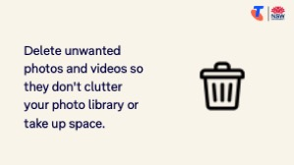 | Say:  - Sometimes we take photos that are blurry or accidental. It's helpful to know how to delete these so they don't clutter your photo library or take up space.  Explain:  - Deleting is safe and reversible in most cases. When you delete a photo, it goes into a ‘Recently Deleted’ folder for 30 days before it is permanently removed. This means you can recover it if you delete something by mistake.  Demonstrate how to delete a photo or video:  - Tap on the photo to open it  - Tap the bin/trash icon (top or bottom of screen)  - Confirm the deletion  - Navigate to the Recently Deleted folder to recover media deleted by mistake  Try it:  - Guide learners to delete photos and videos they no longer want, and navigate to the Recently Deleted folder to recover media they deleted by mistake.  Demonstrate how to multiple photos at once:  - Apple: In the Photos app, tap “Select” in the top-right corner > Tap multiple photos > Tap the bin icon.  - Android: Tap and hold one photo until selection mode appears > Tap others > Tap the bin icon.  Try it:  - Learners delete a group of similar or unneeded photos.  Transition:  - Let's explore some easy ways to improve your photos and videos with basic edits.

5. Edit your photos and videos (20 min)
Overview
Purpose:
- Teach how to crop, rotate, and adjust basic photo settings.
- Help learners trim videos.
Timing breakdown | Content
Edit your photos and videos  20 min | Say:  - Now let’s look at how we can improve our photos and videos with a few simple tools. You don’t need fancy editing skills — even just cropping or brightening a photo can make a big difference.  Demonstrate basic edits:  - Cropping a photo (removes unwanted edges)  Open a photo > Tap pencil/edit icon > Tap crop icon > Adjust frame > Tap “Save” or “Done”  - Rotating a photo  Same as above, look for the rotate icon (usually a square with a circular arrow)  - Use “Auto-enhance” tools (one-tap fix that improves colour/contrast)  Tap magic wand icon in edit mode  - Adjusting brightness and contrast  Tap the “Edit” or magic wand icon > Slide to adjust brightness, contrast or warmth  On Android, look under “Adjust” or similar  - Undoing edits  Tap “Revert” or “Reset” or return to original  - Trimming a video (removing start or end bits)  Apple: Open a video > Tap “Edit” > Drag sliders left/right to trim > Tap “Done” > Save as new clip  Android: Open a video > Tap pencil/edit icon > Tap “Trim” or scissors icon > Adjust sliders > Save  Try it:  - Guide learner to complete tasks.  Ask:  - Did editing help improve your photo?  - Which tool did you enjoy using?  Transition:  - Let’s learn how to share your photos and videos with others.
  Extension activities:
  - Explore preset filters (black & white, vivid, warm tones)
  Apple: Tap three overlapping circles in edit mode
  Android: Tap “Filters” or “Effects” in edit mode
  - Mark up or draw on a photo
  Apple: Edit > Tap three dots > Markup > Use pen tools
  Android: Edit > Look for “Markup” or pen icon
  Try it: Circle something or write a short label

6. Share your photos and videos (15 min)
Overview
Purpose:
- Teach learners how to send photos and videos using email or messages.
- Reinforce privacy and consent when sharing images with others.
Timing breakdown | Content
Share your photos and videos  15 min  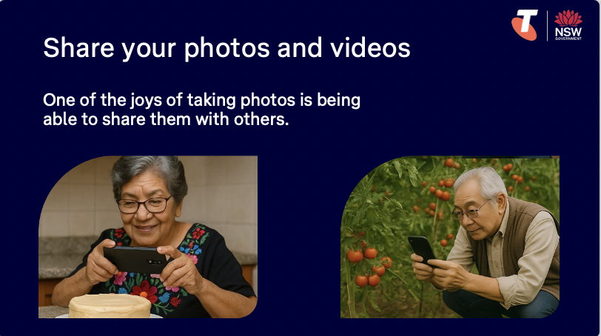 | Say:  - One of the joys of taking photos is being able to share them with others. Today we’ll practise sending a photo or video to a friend or family member by message or email.  Demonstrate how to share a photo or video:  - Using Messages (texting)  Apple: Open a photo > Tap the Share icon (square with arrow) > Tap “Messages” > Enter name or number > Type a message (if desired) > Tap Send  Android: Open a photo > Tap Share icon > Choose “Messages” > Enter name/number > Type a message (if desired) > Send  - Using Email  Apple: Tap Share > Tap “Mail” > Enter recipient, subject and message > Send  Android: Tap Share > Choose Gmail or Email app > Fill in details > Send  Explain privacy considerations:  - Ask before sharing someone else’s photo or face  - Be mindful of private or personal content in the background  - Remind learners that shared images can be saved or forwarded by others  Try it:  - Guide learner to share a photo/video.  Tip:  - Long videos may be too large to send. You might need to trim them.  Transition:  - Great work! Next, let’s spend some time on the questions and goals you raised at the start of today’s session.
  Extension activities:
  - Send to more than one person
  After selecting the photo and tapping “Share,” add more than one recipient by entering multiple names, numbers or emails.
  - Send multiple photos or videos at once
  Apple: Open the Photos app > Tap “Select” > Tap multiple photos/videos > Tap Share icon > Choose how to send
  Android: Open Gallery or Google Photos > Tap and hold to select > Tap others > Tap Share icon > Choose how to send
  - Send using other platforms (e.g. Messenger)
  Apple/Android: Open the photo > Tap Share > Select “Messenger” or app of choice (must be installed and signed in)
  - Upload to Facebook
  Apple/Android: Open a photo > Tap the Share icon > Tap the Facebook widget > Tap Feed/Story/Groups > Select blue button to send/post (must be installed and signed in)
10 min | Break

7. Built in flexibility (25 min)
Overview
Purpose:
- To address the questions and skills learners were hoping this session covers
- To practice skills
- If time and learner confidence allow, introduce one or more extension activities from earlier sections
Timing breakdown | Content
Flexible time  25 min   | Facilitator note:  - If learners identified additional questions or topics in the Welcome section:  - Refer to the list you captured  - Say: “Let’s go through the things you said you most wanted to learn today. I’ll demonstrate each one, and then you’ll have a go.”  - If some learners would prefer to focus on practicing instead, divide the group accordingly  - If there are no further learner questions, recap key skills  - If time and learner confidence allow, introduce extension activities covered earlier in the session  Transition:  - Let’s wrap up by reflecting on what you’ve learned today and planning your next steps.
  Extension activities:
  - Download the email app:
  Take photos and videos:
  - Turn the flash on or off (especially helpful indoors)
  Apple: Tap the lightning bolt icon at the top left of the screen. Tap again to toggle between Auto, On, and Off.
  Android: Tap the lightning bolt icon (usually at the top or side of the screen). Choose between Auto, On, or Off.
  Tip: Flash can help in dim lighting, but sometimes creates harsh light.
  - Use the timer (great for group selfies or setting the phone down)
  Apple: Tap the arrow or small ^ icon at the top of the screen > Tap the timer icon (clock) > Choose 3s or 10s.
  Android: Tap the timer icon. Choose a delay (e.g. 2, 5, or 10 seconds).
  After tapping the shutter, the phone will count down before taking the photo.
  - Try the zoom slider (good for distant subjects)
  Apple: Pinch outwards on the screen to zoom in. Pinch in to zoom out. Alternatively, select the 1x/2x/0.5x toggles.
  Android: Pinch to zoom, or use on-screen zoom slider (typically on the side of the viewfinder).
  Tip: Digital zoom can reduce image quality.
  - Change photo mode (e.g. Portrait, Panorama)
  Apple: Swipe left or right across the mode list above the shutter button to switch between Photo, Video, Portrait, Square, and Pano.
  Android: Tap “More” or swipe the mode list to find options like Panorama, Pro, or Food mode (varies by brand).
  Encourage learners to try Portrait mode for people, and Panorama for wide scenes like landscapes. When using Pano, select the shutter, move your device following the arrow, and select the shutter to finish.
  - Take a burst of photos (good for action shots)
  Apple: On older models, tap and hold the shutter button. On newer models, drag the shutter button to the left.
  Android: Tap and hold the shutter button (varies by device). It will take a burst of shots.
  Tip: Use when photographing movement – like pets, children or sport.
  - Explore live photos or motion photos
  Apple: Tap the circle icon at the top of the screen to turn Live Photos on or off (if supported). Live Photos record a short video around each photo.
  Android: Some devices (e.g. Samsung) have “Motion Photo” or “Moving Picture” – check settings or mode options.
  Tip: Great for capturing movement or laughter, but files are larger.
  Edits photos and videos:
  - Explore preset filters (black & white, vivid, warm tones)
  Apple: Tap three overlapping circles in edit mode
  Android: Tap “Filters” or “Effects” in edit mode
  - Mark up or draw on a photo
  Apple: Edit > Tap three dots > Markup > Use pen tools
  Android: Edit > Look for “Markup” or pen icon
  Try it: Circle something or write a short label
  Send photos and videos:
  - Send to more than one person
  After selecting the photo and tapping “Share,” add more than one recipient by entering multiple names, numbers or emails.
  - Send multiple photos or videos at once
  Apple: Open the Photos app > Tap “Select” > Tap multiple photos/videos > Tap Share icon > Choose how to send
  Android: Open Gallery or Google Photos > Tap and hold to select > Tap others > Tap Share icon > Choose how to send
  - Send using other platforms (e.g. Messenger)
  Apple/Android: Open the photo > Tap Share > Select “Messenger” or app of choice (must be installed and signed in)
  - Upload to Facebook
  Apple/Android: Open a photo > Tap the Share icon > Tap the Facebook widget > Tap Feed/Story/Groups > Select blue button to send/post (must be installed and signed in)

8. Wrap up (20 min)
Overview
Purpose:
- Consolidate learning and celebrate progress.
- Demonstrate scanning QR codes on the Learning Canvas for trusted follow‑up resources.
- Set a simple action for the week and signpost support.
Timing breakdown | Content
Reflection  10 min  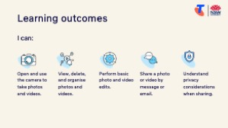     | Say:  - We’ve covered some key information and skills in taking great photos and videos. Let’s take a moment to celebrate what you’ve learned and record it so you can refer back to it later.  Say:  - Let’s revisit your Learning Canvas - tick the skills you can do.  Ask:  - What’s your key takeaway from today’s session?  Learners note reflections on their Learning Canvas. Invite responses.  - What three things will you try in the next week?  E.g. share what you learned with someone, take a selfie, trim a video, send a photo or video, use features like zoom, flash and ‘live’, use portrait mode.  Learners note actions on their Learning Canvas. Invite responses.
Support  10 min   | Say:  - There is a QR code on the back of your Learning Canvas that provides more information online.  - There’s a lot of information online, so don't feel you need to access it. We’ll cover lots more in our Tech Savvy Seniors program.  - But being able to scan a QR code is a handy skill. A QR code is a visual link to a website. It saves you from needing to type the URL/web address into your browser. So, let’s practice today’s final skill!  Demonstrate how to:  - Scan QR code (Open the Camera > point at QR code on Canvas > tap the link)  Try it:  - Guide learners to scan the QR codes on the back of the Learning Canvas.  Explain:  - Where learners can go for support (e.g. 1:1 help at the library, tech groups, or other programs).  Learners note support on Learning Canvas.  - Show Tech Savvy Seniors program and provide the schedule for upcoming sessions.  Say:  - Well done! You’ve all achieved something new today. Keep practising little and often. We look forward to seeing you at another session.

