Scam message examples

Email example
What might make someone believe this is real?
What’s suspicious about it?

Text message example 1
What might make someone believe this is real?
What’s suspicious about it?
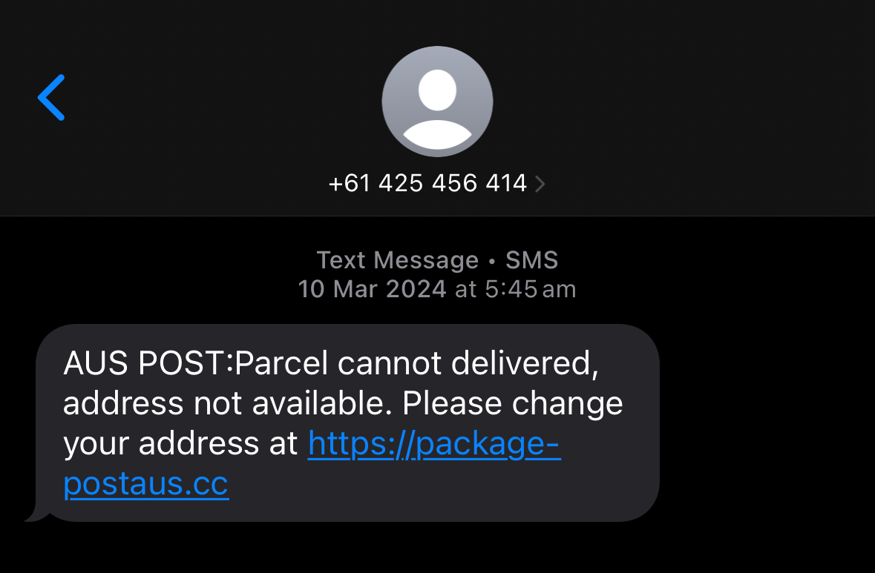

Text message example 2
What might make someone believe this is real?
What’s suspicious about it?
