Tech Savvy Seniors
Module 5
Send and receive emails
Session plan

Table of contents
Session overview 3
Learning architecture 3
Learning outcomes 3
Resources checklist 4
Session summary 5
Session plan 6
1. Welcome (10 min) 6
2. What is email? (15 min) 8
3. Create a Gmail account (if required) and login (15 min) 9
4. Read, send, reply, forward and delete emails (35 min) 11
5. Recognising and dealing with spam (10 min) 15
6. Built in flexibility (25 min) 16
7. Wrap up (20 min) 19

Session overview
This relaxed 2–2.5-hour session is all about helping older Australians feel more confident using email. They will learn how to write, send, receive, and reply to emails, and understand key safety tips for managing spam and scams.
Designed for beginners, this session focuses on Gmail as the default provider due to its ease of use and broad support.

Learning architecture
This module forms part of a 12-module series.
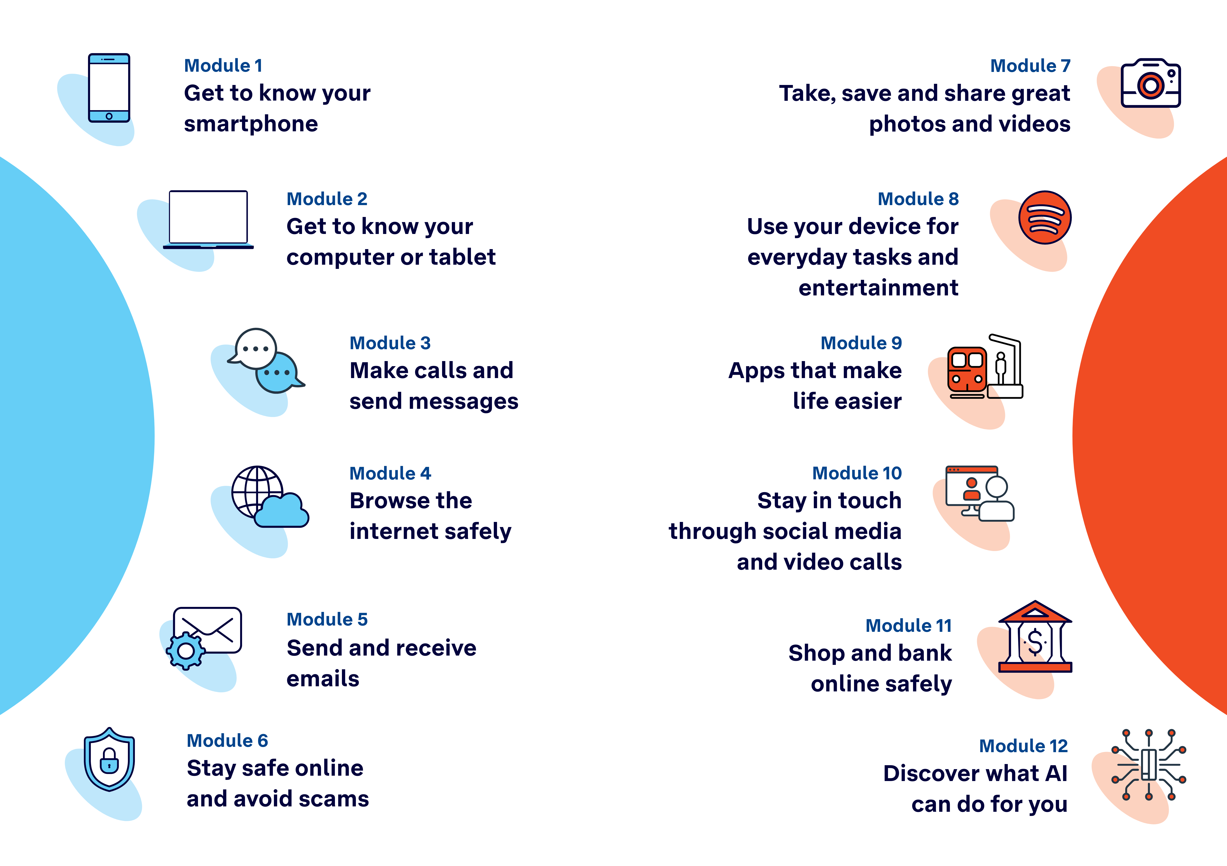

Learning outcomes
At the end of this session, learners will be able to:
- Log into an email account.
- Send, reply to, forward and delete emails.
- Attach a file or image to an email.
- Recognise and report spam or suspicious messages.

Resources checklist
This session requires the following resources:
☐ | Session plan (this document)
☐ | PowerPoint presentation
☐ | Learning Canvas - printed (one per learner)
☐ | Pens for learners (one per learner)
☐ | Butchers paper/markers or a whiteboard/markers may be useful to assist with capturing ‘learning goals’ which will be touched on throughout the session
☐ | Library’s Wi-Fi password
☐ | Tech Savvy Seniors program schedule - printed (one per learner)
☐ | Learners’ own device (smartphone, tablet or computer)
☐ | Internet-connected smartphones, tablets or computers (as available)
☐ | Facilitator’s computer for demonstrations
☐ | Projector and screen (optional)

Session summary
This session summary provides an overview of topics, the activities relevant to each topic and the duration.

Duration | Topic | Useful links
10 min | 1. Welcome
15 min | 2. What is email?
15 min | 3. Create a Gmail account (if required) and login | - www.gmail.com
10 min | Break
35 min | 4. Read, send, reply, forward and delete emails
10 min | 5. Recognising and dealing with spam
10 min | Break
25 min | 6. Built in flexibility | Digital legacy:  - eSafety: What happens to your digital accounts after you die  - Service NSW: Get started making a will
20 min | 7. Wrap up | - iPhone: Scan a QR code with your iPhone or iPad  - Android: How do you scan QR codes on Android?
Total duration: 2.5 hours

Session plan

1. Welcome (10 min)
Overview
Purpose:
- Introduce Module 5: Send and receive emails, including the flow (short demos + practice)
- Set a safe, calm tone; reduce anxiety about ‘pressing the wrong thing’
- Introduce the Learning Canvas as a personal guide they can use during the session and take home
- Gather learner goals to tailor the ‘Built‑in flexibility’ section later
Timing breakdown | Content
Session overview  10 min  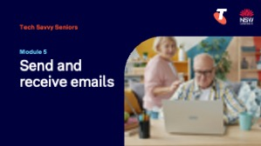  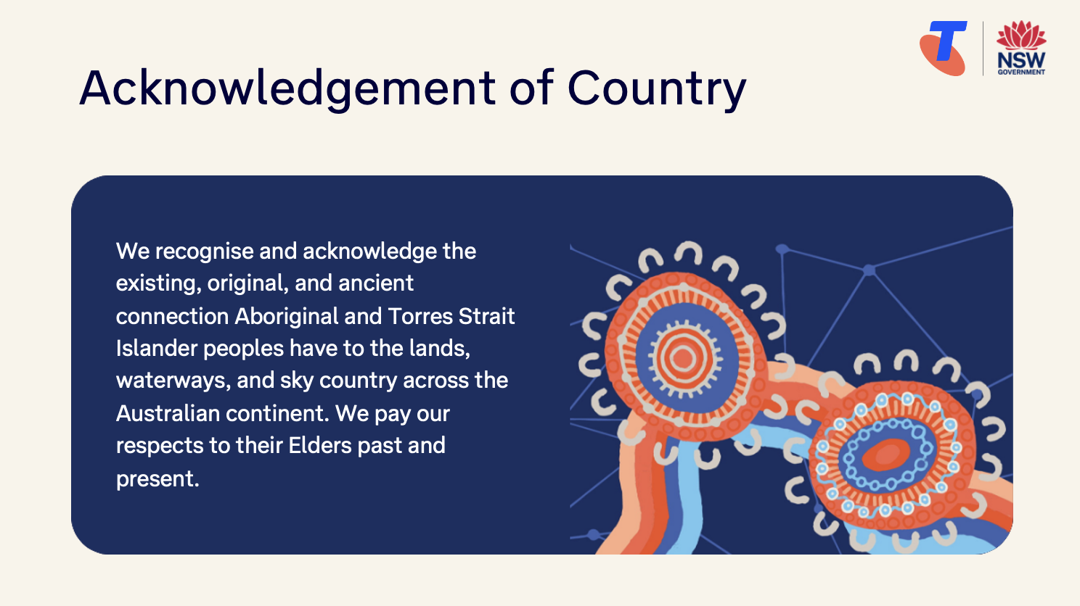  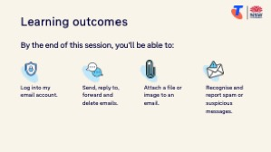  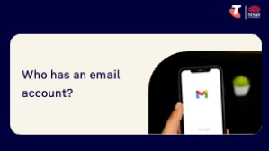  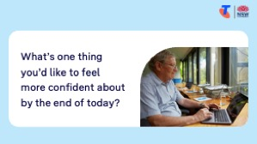 | On arrival, ensure each learner has a device, printed Learning Canvas and pen. Group learners by device so they can support each other.  Deliver: An Acknowledgement of Country.  Say:  - Welcome! Today we’re going to explore one of the most useful and popular tools on the internet — email. Email is a great way to keep in touch with family, friends, clubs, or services like your GP or council. It’s also used when you shop online, book tickets, or get bills and receipts. In this session, we’ll learn how to send and receive emails, add a photo or document, and stay safe from spam or suspicious messages. It’s okay if you’ve never used email before — we’ll take it one step at a time.  - Before we touch anything, let’s agree: it’s fine to make mistakes. That’s how we learn.  - By the end of this session, you’ll be able to:  - Log into an email account.  - Send, reply to, forward and delete emails.  - Attach a file or image to an email.  - Recognise and report spam or suspicious messages.  Introduce Learning Canvas:  - Use your printed Learning Canvas to write notes in your own words, tick off skills as you learn them, and highlight what feels most useful to you. Writing things down helps you remember and understand them better, and makes it easier to recall later. Take your Canvas home to keep practising. On the back, you’ll find extra tips and trusted links if you want to explore more.  Ask:  - Who here has an email account?  If some learners don’t have an email address, say: Don’t worry — if you don’t yet have an email address, we’ll go through the steps to set up a free Gmail account together.  - Who have you emailed? What sorts of emails do you receive?  - What’s one thing you’d like to feel more confident about by the end of today?  (Write answers on a whiteboard or butchers paper. These will help shape the ‘Built-in Flexibility’ section later in the session.)  Confirm everyone has a device; pair anyone without.  Transition:  - Let’s begin by learning what email is.

2. What is email? (15 min)
Overview
Purpose:
- Help learners understand what email is in everyday language.
- Connect the idea of email to real-life tasks and benefits.
- Introduce basic terminology like inbox, email address, sender, subject.
- Break down the parts of an email address.
Timing breakdown | Content
What is email?  10 min  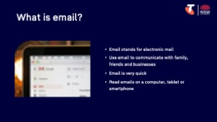 | Say:  - Email stands for electronic mail — it’s like sending a letter, but instead of going through the post, it travels through the internet.  - You can use email to stay in touch with family or friends, send a message to a business, receive bills, get appointment reminders, or even send photos or documents.  - Email is very quick — it can arrive in someone’s inbox within seconds. You can read it on a computer, tablet or smartphone, and reply whenever it suits you.  Explain:  - You can email one person or many people at once  - You can also attach things — like a photo, a letter, or a document  - You can reply, delete, or forward emails to others
What is an email address?  5 min  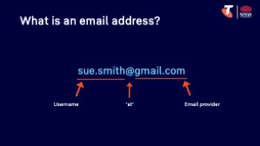  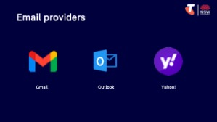 | Say:  - To send or receive email, you need an email address — like having a home address, but for the internet.  - Every email address is unique. It tells the internet where to send your message, just like a street address tells the post office where to deliver a letter.  Explain the structure of an email address, e.g. using sue.smith@gmail.com:  - Username – the first part (e.g. sue.smith) is chosen when creating the account  - @ symbol – read aloud as “at”; separates the name from the provider  - Email provider – the second part (e.g. gmail.com) is the service you use — like Gmail, Outlook, or Yahoo (in this example, Gmail as Sue’s email provider)  Ask:  - Does anyone know their own email address already? Who is your email provider?  Note: If learners don’t have an email address, explain we’ll create one together.  Transition:  - Let’s create a Gmail account (if required).

3. Create a Gmail account (if required) and login (15 min)
Overview
Purpose:
- Help learners who don’t have an email address set up a free Gmail account.
- Help those with an existing account log in confidently.
Timing breakdown | Content
Create a Gmail account  10 min  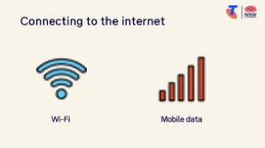 | Say:  - If you don’t yet have an email address, now is your chance to create one. We’ll set up a free Gmail account — it’s easy to use, and works well on most phones and computers.  - I’ll walk you through it one step at a time. If you already have an email account, you can log into it now — or help someone else nearby if they’d like support.  - Before we start, let’s check everyone is connected to the internet.  Demonstrate how to:  - Connect to the Library’s Wi-Fi.  Try it:  - Guide learners to connect to the library’s Wi-Fi.  Demonstrate how to create a Gmail account:  - Go to: www.gmail.com  - Tap “Create account”  - Choose “For myself”  - Follow the prompts.  Try it:  - Guide learners who don't have an email address to create a Gmail account.  Say:  - Write down your email address on your Learning Canvas so you don't forget.  - Passwords should be private but memorable.  Transition:  - Now that everyone has an email account, let’s login.

Timing breakdown | Content
Log into an email account  5 min | Say:  - If you already have an email address, the first step is to log into your account, using a browser or an app.  Demonstrate how to login using browser:  - Open your web browser (e.g. Chrome, Safari, Edge, Firefox)  - Go to: www.gmail.com (or relevant email provider)  - Tap Sign in  - Enter your email address (e.g. sue.brown@gmail.com)  - Tap Next  - Enter your password  - Tap Next to access your inbox  Try it:  - Guide learners to login using a browser (or app if downloaded).
10 min | Break

4. Read, send, reply, forward and delete emails (35 min)
Overview
Purpose:
- Help learners confidently use the main functions of their inbox.
- Practise the full cycle of communication: reading, writing, replying, forwarding, and deleting emails.
Timing breakdown | Content
Reading an email  10 min  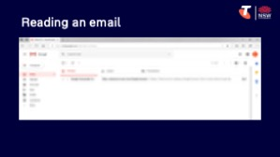 | Say:  - Now that we’ve created or logged into our email accounts, let’s start using the inbox.  - Together we’ll practise how to read a message, send one to someone, reply to a message, forward it to someone else, and delete emails you no longer need. These are the everyday things most people do with email — and we’ll take our time going through each one.  - First, let’s open the inbox. The inbox is like your letterbox — new messages arrive here.  Demonstrate reading an email:  - Open your Gmail inbox  - Point out how unread emails appear bold, while read emails are in normal text  - Tap on one of the messages (e.g. a welcome email or test message)  - Point out:  - Sender – who sent the email (their name and email address)  - Subject line – a short summary of the email  - Date and time – when the email was sent  - To: – who the message was sent to (just you, or multiple people?)  - Message content – the main body of the email  - Attachments – small icons or links at the bottom of the email if a file or image is included (click/double-click or download to view)  Try it:  - Guide learners complete the tasks.  Ask:  - Can you spot any unread messages in your inbox?  - Who is the message from?  - Was it sent to only you or to others as well?  - What clues does the subject line give you about the message?

Timing breakdown | Content
Sending an email with an attachment  10 min  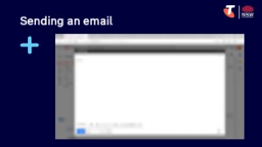 | Say:  - Now let’s send a simple email to someone. You might write a quick hello, ask a question, or just practise.  Demonstrate sending an email:  - Tap “Compose” (in Gmail, bottom-right or top-left)  - In the To field, type an email address (e.g. the facilitator’s address or a classmate's)  - Add a short Subject (e.g. “Test message”)  - In the message area, type a short message (e.g. “Hi, this is [your name]. This is my first email!”)  - Tip: tap the emoji icon (usually in the formatting bar) and choose an emoji to insert into your message  - Tap the paperclip or attach icon  - Select a recent photo from your gallery or files  - Tap Send  Demonstrate how to view the sent folder.  Try it:  - Guide learners to send an email to a partner or to themselves.
Replying to an email  5 min  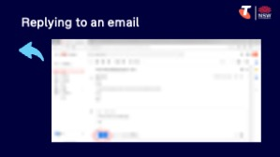 | Say:  - When someone writes to you, you can reply by clicking the “Reply” button. This means your message goes back to the same person — without needing to type their address again.  Demonstrate replying to an email:  - Open a received email  - Tap Reply  - Type a short message (e.g. “Thanks, I got your email!”)  - Tap Send  Try it:  - Guide learners to reply to the email they received earlier.
Forwarding an email  5 min  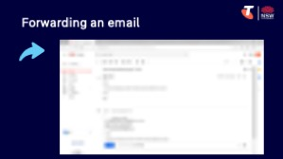 | Say:  - Forwarding means sending a copy of a message to someone else — for example, if someone sends you a recipe, and you want to share it with a friend.  Demonstrate forwarding an email:  - Open an email  - Tap Forward  - Type in a different recipient  - (Optional) Add a note at the top  - Tap Send  Try it:  - Guide learners to forward a message to the facilitator or to a second partner.

Timing breakdown | Content
Deleting an email  5 min  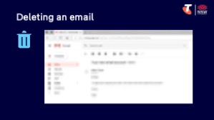 | Say:  - If you get messages you don’t want — or once you’re finished reading something — you can delete it to tidy your inbox.  Demonstrate deleting an email:  - Open an email  - Tap the Bin or Delete icon  - Show where deleted messages go (Trash or Bin folder)  Try it:  - Guide learners to forward a message to the facilitator or to a second partner.
  Extension activities:
  - Download the email app:
  - Open the app store (Play Store or App Store)
  - Tap the search bar and type the name (e.g. “Gmail”)
  - Tap Install or Get
  - Wait for the app to download
  - Tap Open to start the app, then Login
  - Use the search bar to find an old email:
  - Open your inbox
  - Tap the Search bar
  - Type part of the sender’s name, subject, or a keyword (e.g. “bill” or “appointment”)
  - Tap a result to open it
  - Organise emails using folders/labels:
  - Open an email you’d like to sort
  - Tap the three dots (⋮) or Move to icon
  - Select “Move to” or “Label”
  - Choose an existing label or create a new one (e.g. “Family”, “Bills”, “Bowls Club”)
  - Save and revisit a draft email:
  - Start a new email
  - Type a short message but don’t send it
  - Tap the back arrow or navigate away — Gmail will save it automatically as a draft
  - Tap Menu > Drafts to open and finish it later
  - Tap Send when ready
  - Use CC and BCC:
  - Open a new message
  - Tap “CC/BCC” under the “To” field
  - CC (Carbon Copy): Use to copy someone when you want them to see the message
  - BCC (Blind Carbon Copy): Use when you don’t want other recipients to see who else got the message
  - Type names or addresses into the CC or BCC fields and send as normal
  - Explain: You might CC a family member when sending holiday plans. You might BCC a group if you’re sending the same message to many people but don’t want to share their addresses.

5. Recognising and dealing with spam (10 min)
Overview
Purpose:
- Help learners identify unwanted, suspicious or scam emails.
- Build awareness of terms like “spam”, “junk”, and “phishing”.
- Teach simple steps for deleting, blocking, or reporting these emails
- Empower learners to stay safe and confident using email.
Timing breakdown | Content
Recognising and dealing with spam 10 min  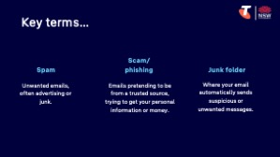  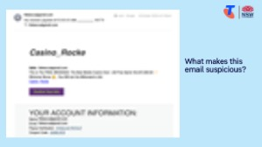  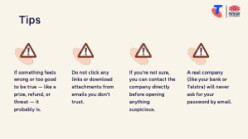 | Say:  - Not all emails are safe or useful. Some are spam — these might be advertising, scams, or suspicious messages from unknown senders.  - It’s important to learn how to spot these and know what to do if one lands in your inbox.  Explain terms:  - Spam = unwanted emails, often advertising or junk.  - Scam/phishing = emails pretending to be from a trusted source, trying to steal your personal information or money.  - Junk folder = where your email program automatically moves suspicious or unwanted messages.  Show a sample spam/scam email and point out:  - Suspicious sender name or email address  - Generic greetings (e.g. “Dear customer”)  - Urgent language or threats (e.g. “Your account will be closed!”)  - Strange links or attachments  - Spelling or grammar mistakes  Say:  - If something feels wrong or too good to be true — like a prize, refund, or threat — it probably is.  - Do not click any links or download attachments from emails you don’t trust.  Demonstrate how to:  - To delete a suspicious email: Open the email > Tap the bin/trash icon  - To mark as spam or report it: Open the email > Tap the three dots (⋮ or ⋯) > Select “Report spam” or “Block”  Say:  - If you’re not sure, it’s always okay to ask a family member or friend before opening anything suspicious. And remember — a real company (like your bank or Telstra) will never ask for your password by email.  - We’ll go into even more detail about online scams and how to stay safe in Module 6: Stay safe online and avoid scams.
10 min | Break

6. Built in flexibility (25 min)
Overview
Purpose:
- To address the questions and skills learners were hoping this session covers
- To practice skills
- If time and learner confidence allow, introduce one or more extension activities from earlier sections
Timing breakdown | Content
Digital legacy (optional) | Facilitator note: This is an optional extension activity available across several modules. Before delivering it, check whether learners have already covered it in a previous session.  Say:  - Let’s take a moment to think about something important but often overlooked: what happens to your digital accounts and files when you pass away?  - Many of us have online accounts — like email, photos, social media, or even digital bank records. These are called your digital assets. Your digital accounts don’t automatically close when you die — someone needs to manage them.  - Some people choose to include instructions for these in their will, or appoint a trusted person to help manage things like:  - Deleting or memorialising social media accounts  - Accessing online photo albums or email accounts  - Closing down subscriptions or accounts  Explain how to prepare:  - You can prepare by:  - Making a list of your key digital accounts (and how to access them)  - Thinking about what you’d like to happen to them and including these wishes in your will  - Most online platforms (like Google, Facebook, Apple) have their own settings to manage accounts after death. For example:  - Google has an “Inactive Account Manager” where you can choose what happens and who is notified  - Facebook lets you appoint a “Legacy Contact” or request your account be memorialised  Explain how to start a will:  - In Australia, making a will is the best way to say who gets your belongings and digital assets.  - You can:  - Make a will through a solicitor, trustee service, or using an online will kit  - Visit Service NSW: Get started making a will for a step-by-step guide to get started (QR code on Learning Canvas)  Try it:  - If desired, support learners to visit Service NSW to start a will, or add a legacy contact/Inactive Account Manager to Facebook/Google.  - Learn more: eSafety: What happens to your digital accounts after you die

Timing breakdown | Content
Flexible time  25 min  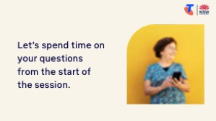 | Facilitator note:  - If learners identified additional questions or topics in the Welcome section:  - Refer to the list you captured  - Say: “Let’s go through the things you said you most wanted to learn today. I’ll demonstrate each one, and then you’ll have a go.”  - If some learners would prefer to focus on practicing instead, divide the group accordingly  - If there are no further learner questions, recap key skills  - If time and learner confidence allow, introduce extension activities covered earlier in the session  Transition:  - Let’s wrap up by reflecting on what you’ve learned today and planning your next steps.
  Extension activities:
  - Download the email app:
  - Open the app store (Play Store or App Store)
  - Tap the search bar and type the name (e.g. “Gmail”)
  - Tap Install or Get
  - Wait for the app to download
  - Tap Open to start the app, then Login
  - Use the search bar to find an old email:
  - Open your inbox
  - Tap the Search bar
  - Type part of the sender’s name, subject, or a keyword (e.g. “bill” or “appointment”)
  - Tap a result to open it
  - Organise emails using folders/labels:
  - Open an email you’d like to sort
  - Tap the three dots (⋮) or Move to icon
  - Select “Move to” or “Label”
  - Choose an existing label or create a new one (e.g. “Family”, “Bills”, “Bowls Club”)
  - Save and revisit a draft email:
  - Start a new email
  - Type a short message but don’t send it
  - Tap the back arrow or navigate away — Gmail will save it automatically as a draft
  - Tap Menu > Drafts to open and finish it later
  - Tap Send when ready
  - Use CC and BCC:
  - Open a new message
  - Tap “CC/BCC” under the “To” field
  - CC (Carbon Copy): Use to copy someone when you want them to see the message
  - BCC (Blind Carbon Copy): Use when you don’t want other recipients to see who else got the message
  - Type names or addresses into the CC or BCC fields and send as normal
  - Explain: You might CC a family member when sending holiday plans. You might BCC a group if you’re sending the same message to many people but don’t want to share their addresses.

7. Wrap up (20 min)
Overview
Purpose:
- Consolidate learning and celebrate progress.
- Demonstrate scanning QR codes on the Learning Canvas for trusted follow‑up resources.
- Set a simple action for the week and signpost support.
Timing breakdown | Content
Reflection  10 min  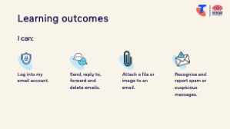  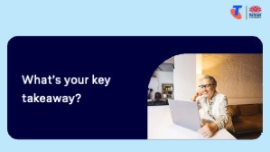  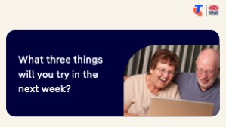 | Say:  - We’ve covered some key information and skills in sending and receiving emails. Let’s take a moment to celebrate what you’ve learned and record it so you can refer back to it later.  Say:  - Let’s revisit your Learning Canvas - tick the skills you can do.  Ask:  - What’s your key takeaway from today’s session?  Learners note reflections on their Learning Canvas. Invite responses.  - What three things will you try in the next week?  E.g. share what you learned with someone, sent an email, forward or reply to an email, send an email with an attachment.  Learners note actions on their Learning Canvas. Invite responses.
Support  10 min  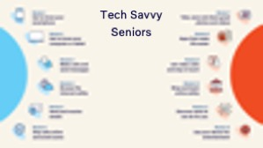 | Say:  - There is a QR code on the back of your Learning Canvas that provides more information online.  - There’s a lot of information online, so don't feel you need to access it. We’ll cover lots more in our Tech Savvy Seniors program.  - But being able to scan a QR code is a handy skill. A QR code is a visual link to a website. It saves you from needing to type the URL/web address into your browser. So, let’s practice today’s final skill!  Demonstrate how to:  - Scan QR code (Open the Camera > point at QR code on Canvas > tap the link)  Try it:  - Guide learners to scan the QR codes on the back of the Learning Canvas.  Explain:  - Where learners can go for support (e.g. 1:1 help at the library, tech groups, or other programs).  Learners note support on Learning Canvas.  - Show Tech Savvy Seniors program and provide the schedule for upcoming sessions.  Say:  - Well done! You’ve all achieved something new today. Keep practising little and often. We look forward to seeing you at another session.

