Tech Savvy Seniors
Module 4
Browse the internet safely
Session plan

Table of contents
Session overview 3
Learning architecture 3
Learning outcomes 3
Resources checklist 4
Session summary 5
Session plan 6
1. Welcome (10 min) 6
2. What is the internet? (10 min) 7
3. Search the internet (20 min) 9
4. Recognise safe vs risky websites & scams (15 min) 11
5. Use tabs and return to favourite sites (30 min) 13
6. Built in flexibility (25 min) 15
7. Wrap up (20 min) 16

Session overview
This relaxed 2–2.5-hour session is all about helping older Australians feel more confident using a web browser to search for everyday information safely. It introduces the internet in simple terms, teaches basic searching techniques, and focuses heavily on how to identify safe websites and avoid common online risks.
It also builds practical confidence using tabs and bookmarks to help learners return to websites they find useful.

Learning architecture
This module forms part of a 12-module series.
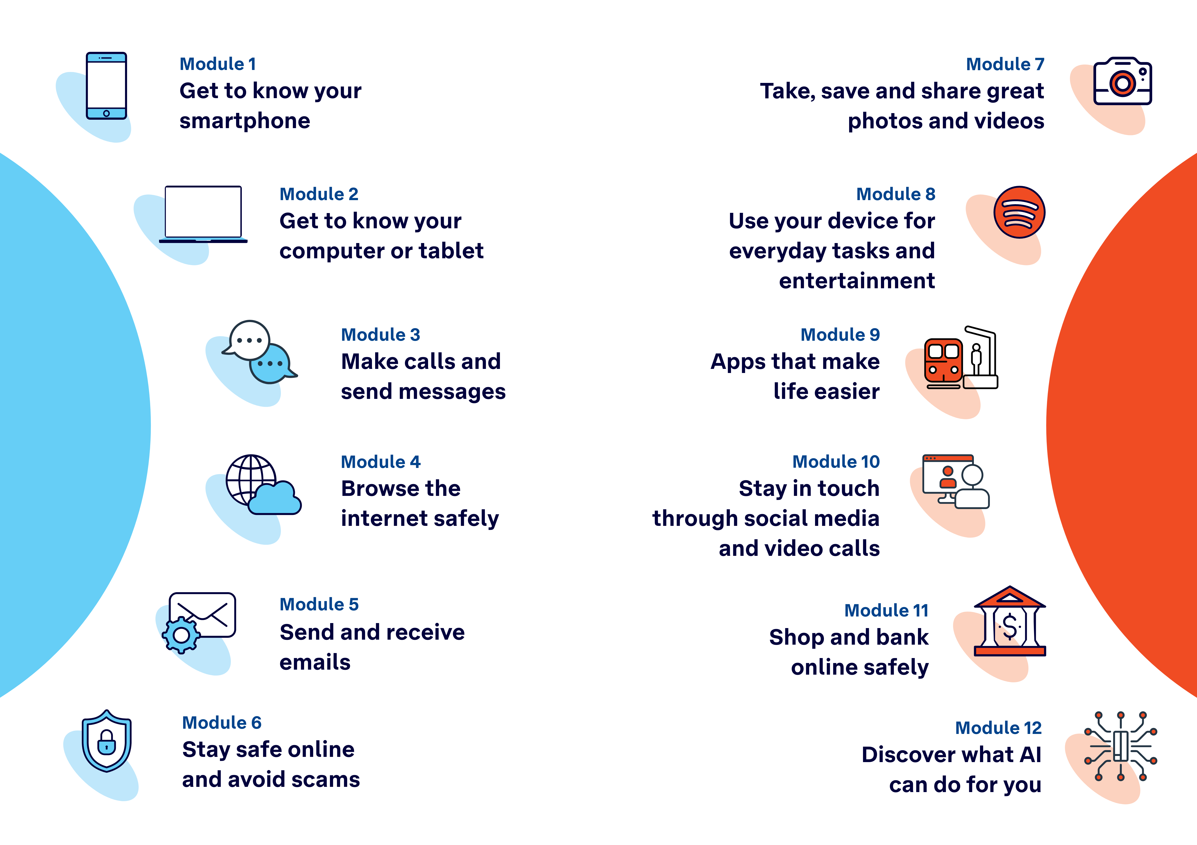

Learning outcomes
At the end of this session, learners will be able to:
- Explain what the internet is and how it can be used.
- Use a web browser to search for everyday information.
- Recognise safe, trustworthy websites and warning signs of risky ones.
- Navigate between websites using tabs.
- Return to a favourite website using a bookmark or history.

Resources checklist
This session requires the following resources:
☒ | Session plan (this document)
☐ | PowerPoint presentation
☐ | Learning Canvas - printed (one per learner)
☐ | Pens for learners (one per learner)
☐ | Butchers paper/markers or a whiteboard/markers may be useful to assist with capturing ‘learning goals’ which will be touched on throughout the session
☐ | Library’s Wi-Fi password
☐ | Tech Savvy Seniors program schedule - printed (one per learner)
☐ | Learners’ own device (smartphone, tablet or computer)
☐ | Internet-connected smartphones, tablets or computers (as available)
☐ | Facilitator’s phone and computer for demonstrations, with a search engine app (e.g. Chrome, Safari, Firefox, Edge)
☐ | Projector and screen (optional)

Session summary
This session summary provides an overview of topics, the activities relevant to each topic and the duration.

Duration | Topic | Useful links
10 min | 1. Welcome
10 min | 2. What is the internet?
20 min | 3. Search the internet
10 min | Break
15 min | 4. Recognise safe vs risky websites & scams
30 min | 5. Use tabs and return to favourite sites
10 min | Break
25 min | 6. Built in flexibility
20 min | 7. Wrap up | - iPhone: Scan a QR code with your iPhone or iPad  - Android: How do you scan QR codes on Android?
Total duration: 2.5 hours

Session plan

1. Welcome (10 min)
Overview
Purpose:
- Introduce Module 4: Browse the internet safely, including the flow (short demos + practice)
- Set a safe, calm tone; reduce anxiety about ‘pressing the wrong thing’
- Introduce the Learning Canvas as a personal guide they can use during the session and take home
- Gather learner goals to tailor the ‘Built‑in flexibility’ section later
Timing breakdown | Content
Session overview  10 min    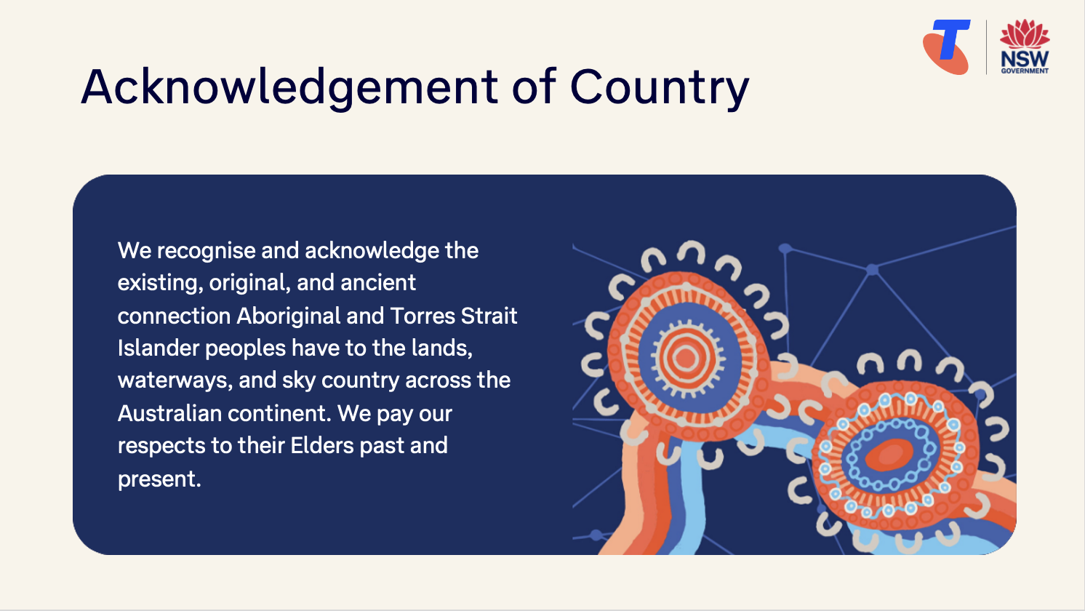  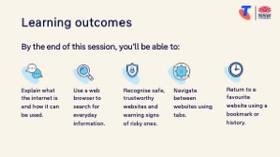  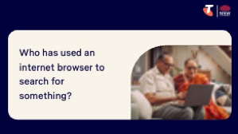  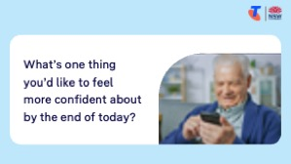 | On arrival, ensure each learner has a device, printed Learning Canvas and pen. Group learners by device so they can support each other.  Deliver: An Acknowledgement of Country.  Say:  - Welcome! Today we’re going to learn how to use the internet with more confidence — and how to stay safe while doing it. We’ll look at simple ways to search for everyday information and how to spot signs that a website or message may not be trustworthy. We’ll go slowly and practise each step together. This is a safe space – no question is silly and no mistake is wrong.  - Before we touch anything, let’s agree: it’s fine to make mistakes. That’s how we learn.  - By the end of this session, you’ll be able to:  - Explain what the internet is and how it can be used.  - Use a web browser to search for everyday information.  - Recognise safe, trustworthy websites and warning signs of risky ones.  - Navigate between websites using tabs.  - Return to a favourite website using a bookmark or history.  Introduce Learning Canvas:  - Use your printed Learning Canvas to write notes in your own words, tick off skills as you learn them, and highlight what feels most useful to you. Writing things down helps you remember and understand them better, and makes it easier to recall later. Take your Canvas home to keep practising. On the back, you’ll find extra tips and trusted links if you want to explore more.  Ask:  - Who here has used an internet browser to search for something?  - What sorts of things have you used the internet for?  - What’s one thing you’d like to feel more confident about by the end of today?  (Write answers on a whiteboard or butchers paper. These will help shape the ‘Built-in Flexibility’ section later in the session.)  Confirm everyone has a device; pair anyone without.  Transition:  - Let’s begin by learning what the internet is.

2. What is the internet? (10 min)
Overview
Purpose:
- Help learners understand the internet in simple, relatable terms.
- Introduce related terms like Wi-Fi, websites, and search in a way that feels familiar.
- Help learners connect the idea of the internet to things they already do or recognise.
- Set a strong foundation for later topics by clarifying how the internet works and what it can be used for.
Timing breakdown | Content
What is the internet?  10 min  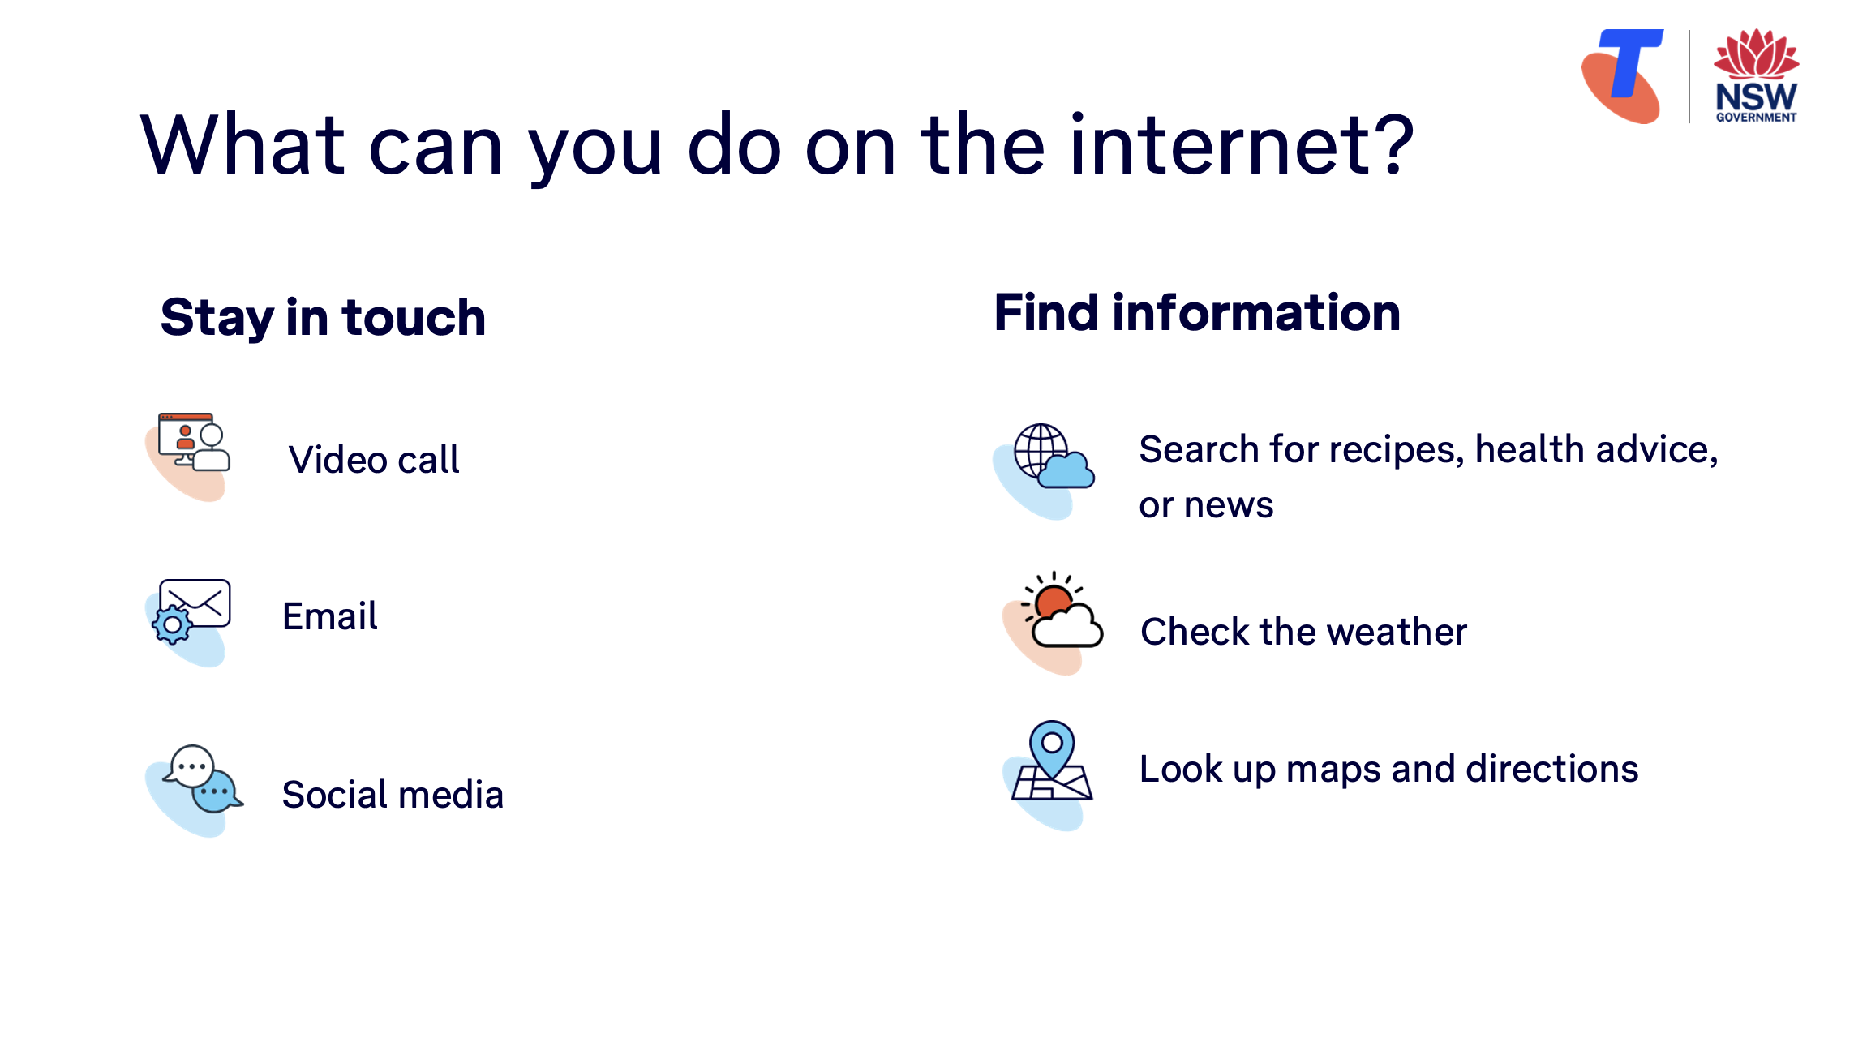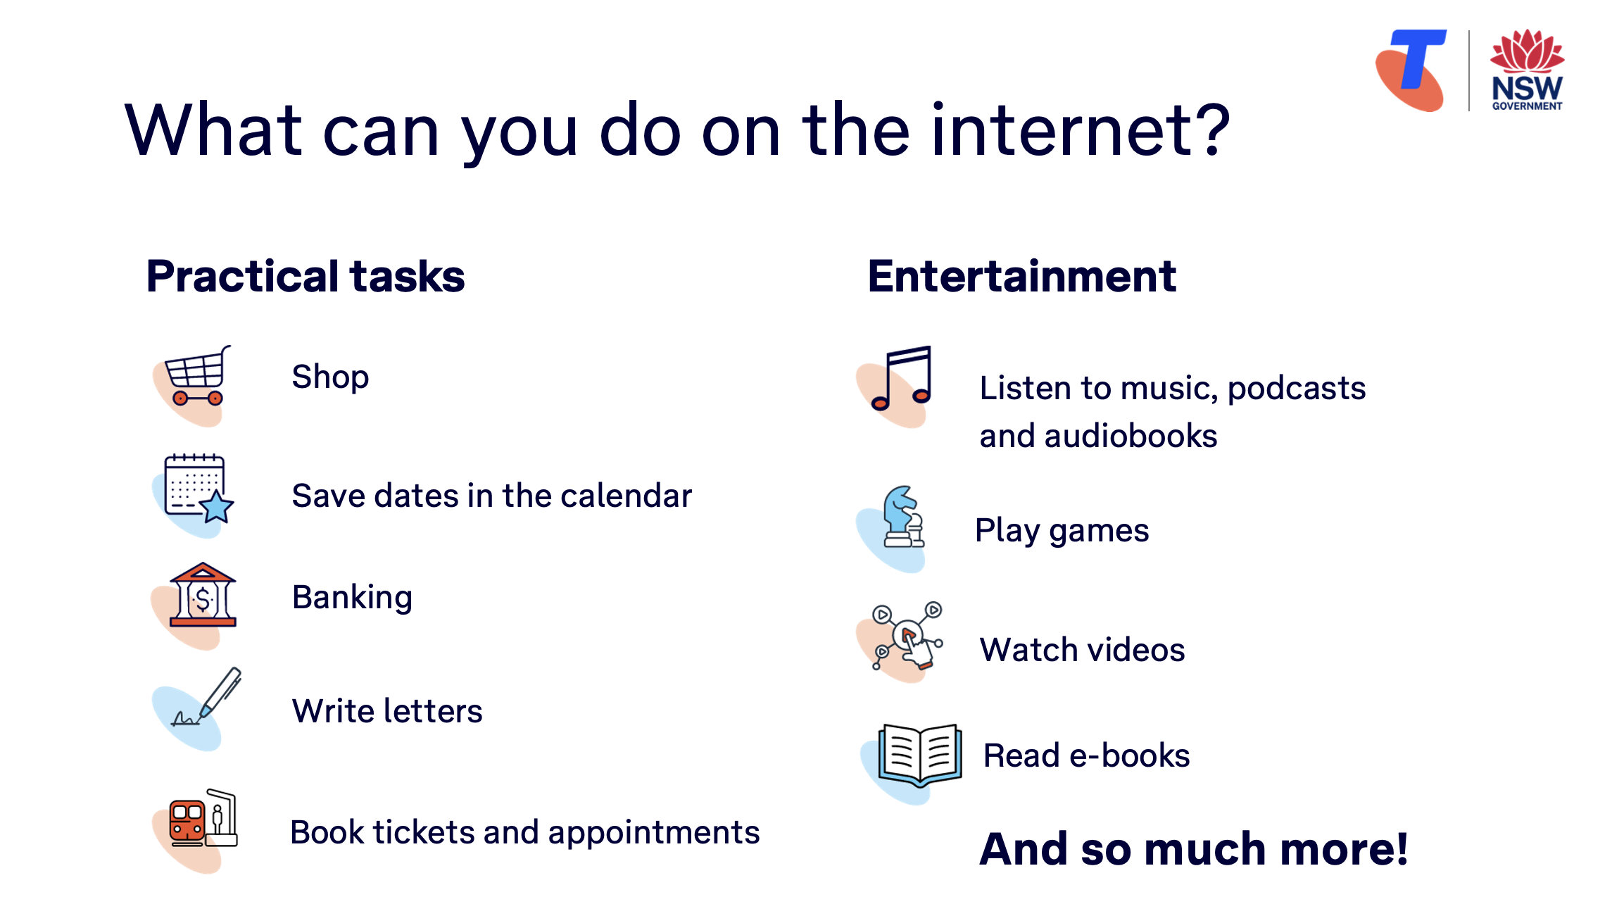  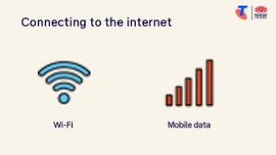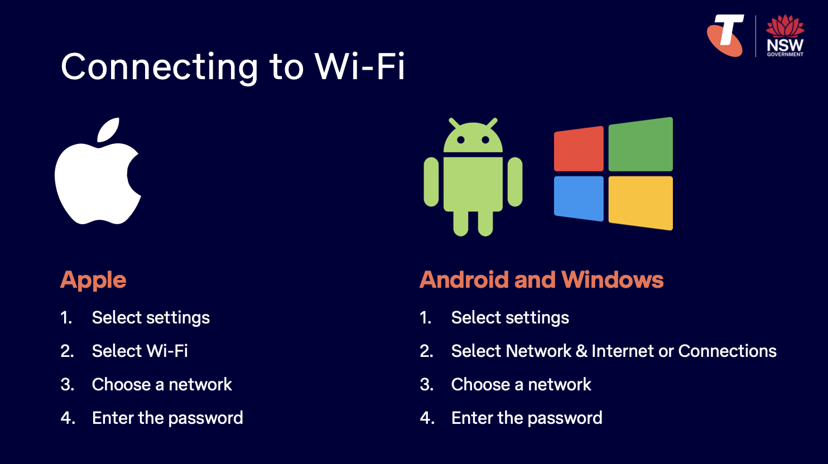  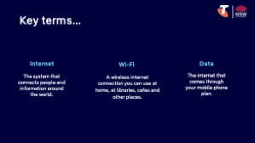  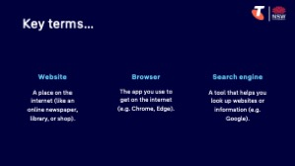 | Say:  - You can think of the internet like a giant web that connects computers, phones and information all around the world. It’s what allows us to do things like read the news online, look up a recipe, watch a video, or check the weather.  Ask:  - What can you do on the internet?  Brainstorm. Prompt for:  Say:  - To use the internet, your phone, tablet or computer needs to be connected — either to Wi-Fi (a home or public wireless connection), or to mobile data (which comes with your mobile plan). Without that connection, the internet won’t work.  Demonstrate how to:  - Connect to the Library’s Wi-Fi.  Try it:  - Guide learners to connect to the library’s Wi-Fi.  Explain:  - When your device is connected to the internet, you can use an app — usually called a browser (e.g. Chrome, Safari, Firefox, Edge) — to get online.  - The browser is what helps you open websites — these are places on the internet where you can read, watch, or do things (like book appointments or shop).  - If you’re not sure where to go, you can use something called a search engine — like Google — which helps you find what you’re looking for.  Explain key terms in plain English:  - Internet – the system that connects computers, phones and information around the world  - Wi-Fi – a way to connect to the internet wirelessly, often available at home and in public places like libraries and cafes  - Data – what lets your phone use internet when you're not on Wi-Fi  - Website – a place on the internet (like an online newspaper, library, or shop)  - Browser – an app that lets you visit websites (e.g. Chrome, Edge)  - Search engine – a tool that helps you find websites or information (e.g. Google)  Demonstrate:  - Show the Wi-Fi or mobile data symbol on a device.  - Point out the browser app (e.g. Chrome, Safari, Firefox, Edge).  - Open the browser and show a blank page with the search/address bar.  Try it:  - Guide learners to open the browser app on their device (but don’t type anything yet).  Transition:  Now you have a browser open, let’s use the search engine to surf the internet!
  Staying in touch  - Send and receive emails  - Join a video call  - Use social media  Finding information  - Search for recipes, health advice, or news  - Look up maps and directions  - Check the weather | Practical tasks  - Shop  - Save dates in calendar  - Banking  - Write letters  - Book tickets and appointments  Entertainment  - Watch TV shows, movies or YouTube  - Play games  - Listen to music, podcasts or audiobooks  - Read e-books

3. Search the internet (20 min)
Overview
Purpose:
- Build confidence using a web browser and search engine step by step.
- Help learners practise typing and recognising search results.
- Begin forming safe habits around choosing which links to click.
Timing breakdown | Content
Search the internet  20 min  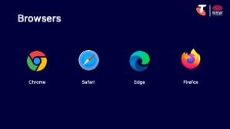  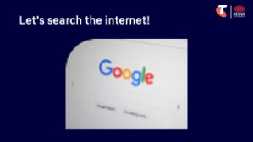 | Say:  - Search engines help us find websites, information, pictures and more — all based on what we type into the search bar.  - You can type a question — like “How do I grow tomatoes?” — or just the key words, like “growing tomatoes”.  - Google is very good at understanding what you’re looking for, so there’s no need to write a whole paragraph. A few words or a short question is usually enough.  Demonstrate:  - How to search for something on the internet on a computer, e.g. type ‘best time to plant tomatoes Sydney’ into search bar, then select search.  Explain what appears on screen:  - You might see a summary or answer at the top — this is written by AI (artificial intelligence). It can be useful but it’s good to scroll down and check other sources too.  - Sponsored results are paid advertisements that appear at the top of search results. They look similar to regular search results but have a small "sponsored" or "ad" label".  - Below that are the search results:  - The blue heading is the title of the website or article  - The green or grey link is the web address  - The short text underneath is a quick description of what you’ll find on that page  - Show how to tap or click a link to open it  - Show how to use the Back button (arrow pointing left) to return to the results  - (Optional) Show the Forward button to go back to the website again  - Show how the visited links change colour (to purple)  - Point out tabs under the search bar: All, Images, News, Video, Shopping, Maps etc. These let you search by type. So, if you’re after an image, tap “Images” to see pictures related to your search.  Demonstrate:  - How to search for something on the internet on a smartphone/tablet, highlighting the back and forward buttons might be in different positions depending on the device.

Timing breakdown | Content
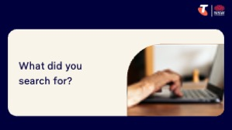 | Try it:  - Guide learners to search the internet:  - Decide what to search (e.g. opening hours, recipes, directions)  - Determine keywords/phrase/question  - Select search  - Click on the relevant tab  - Go back and forth between multiple websites  Ask:  - What did you search for? Did you find the information you were after?  Tips:  - Google can still find results even with spelling mistakes — just do your best  - Scroll down for more options — don’t rely only on the first link  Transition:  - Great work! Now let’s look at how to identify safe websites and avoid risky ones.
  Extension activity
  - Try a voice search:
  - Tap the microphone icon in the search bar
  - Say what you want to search for clearly (e.g. “weather in Sydney tomorrow”)
  - Your search will appear automatically
  - Try a photo search:
  - Tap the camera icon in the search bar
  - Take a photo or select the image button to upload a photo from your device
  - Scroll down to view results — tap an image to view it larger
10 min | Break

4. Recognise safe vs risky websites & scams (15 min)
Overview
Purpose:
- Help learners identify safe websites and avoid risky ones.
- Introduce common online scams and how to spot warning signs.
- Build confidence navigating the internet with awareness and caution.
Timing breakdown | Content
Safe vs unsafe websites  5 min  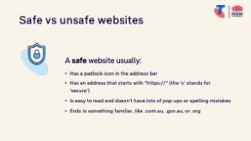  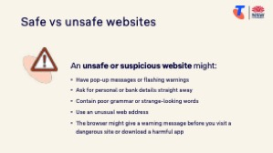 | Say:  - Most websites on the internet are safe to visit — but some are not. Some people try to trick others online by pretending to be a trusted company, like a bank or government service. This is called a scam.  - Today we’ll learn simple ways to recognise a trusted site, and what warning signs to look out for.  Explain:  - A safe website usually:  - Has a padlock icon in the address bar  - Has an address that starts with “https://” (the ‘s’ stands for ‘secure’)  - Is easy to read and doesn’t have lots of pop-ups or spelling mistakes  - Ends in something familiar, like .com.au, .gov.au, or .org  - An unsafe or suspicious website might:  - Have pop-up messages or flashing warnings  - Ask for personal or bank details straight away  - Contain poor grammar or strange-looking words  - Use an unusual web address (e.g. mybank-help-login.com instead of commbank.com.au)  - The browser might give a warning message before you visit a dangerous site or download a harmful app  Demonstrate:  - Show a trusted website (e.g. www.abc.net.au or www.australia.gov.au)  - Point out the padlock icon in the address bar (you might need to select the  icon in the search bar to reveal the padlock icon)  - Show the website’s full address and explain trusted endings like “.gov.au”, “.org”, or known businesses like “telstra.com.au”  - Scroll through the page and note how it looks professional, no strange messages

Timing breakdown | Content
Phishing and scam messages  10 min  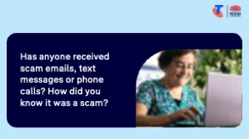  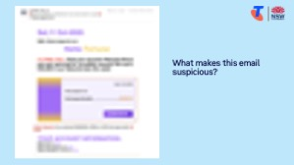  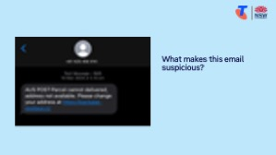  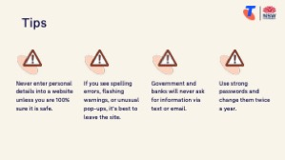 | Explain:  - Sometimes scammers don’t wait for you to visit a website — they send fake emails or texts instead. Most of these emails will go into your junk folder, but some might appear in your inbox.  - These messages might:  - Pretend to be from your bank, MyGov or Australia Post  - Say your account has a problem, and ask you to click a link to fix it  - Ask for personal details like your date of birth or address  Ask:  - Has anyone received scam emails, text messages or phone calls? How did you know it was a scam?  Try it together:  - Show an email scam example and ask, ‘What makes this email suspicious?’  - Show an SMS scam example and ask, ‘What makes this text suspicious?’  Explain safe practice:  - If you ever get a message like this, stop and ask: Did I expect this? Does it feel urgent or strange?  - Does the phone number or email address seem strange? Are there spelling mistakes in the message?  - Does it say ‘urgent’ or ask for personal details? (e.g. passwords, PINs, account numbers, date of birth, etc.)  - Don’t click links in emails or texts if you’re not sure it’s real. Instead, go to the official website yourself.  - When in doubt, ask someone you trust or type the company's official name or web address into your browser (not from a link). If you're still unsure, call their official number for help.  Tips:  - Never enter personal details (like your Medicare number or bank login) into a website if you’re not sure it’s safe  - If you see spelling errors, flashing warnings, or unusual pop-ups, it’s best to leave the site  - Government and banks will never ask for information via text or email  - Use strong passwords (minimum 8 characters, include lower-case and upper-case letters, numbers and special characters) and change them twice a year  Say:  - We’ll go into even more detail about online scams and how to stay safe in Module 6: Stay safe online and avoid scams. Today’s session gives you a good starting point, and we’ll build on it soon.

5. Use tabs and return to favourite sites (30 min)
Overview
Purpose:
- Help learners switch between websites, using tabs, without losing their place.
- Show how to save useful websites, using bookmarks, to revisit later.
- View website history.
Timing breakdown | Content
Tabs  15 min  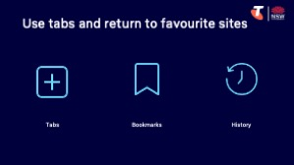 | Say:  - When you’re using the internet, sometimes you want to keep one page open while looking at another. Tabs let you open more than one website in the same window — like having several pages of a notebook open. A window is the entire browser screen — and tabs sit inside that window.  - You can bookmark a website (also called adding to favourites) so you don’t have to search for it again later.  - You can search through the history to go back to a recent website.  Demonstrate:  - Tabs:  - Open a web browser  - Tap the Tabs icon (often two overlapping squares or a number in a square)  - Tap the + symbol to open a new tab  - Show how to switch between tabs or close one  - Explain the difference between switching tabs vs opening a new window (not required unless confident)  - Open a link in a new tab (right-click or hold):  - On a computer: Right-click a link > Select “Open link in new tab”  - On a touchscreen: Press and hold on a link > Tap “Open in new tab”  - Switch back and forth between the original and new tab  Try it:  - Ask learners to open a new tab and search for something different  - Try opening a link in a new tab using press-and-hold or right-click  - Practise switching between tabs and closing one

Timing breakdown | Content
Bookmarks and history  15 min | Demonstrate:  - Bookmarking a site:  - Navigate to a useful website (e.g. www.abc.net.au or local library)  - From the browser menu, select Bookmarks  - Select “Add to bookmarks” or “Add to Favourites”  - Explain: This saves the site for next time — like saving a page in a book  - Show how to access saved bookmarks/favourites form the bookmarks bar or bookmarks menu  - Viewing history:  - From the browser menu, select “History”  - Show how to reopen a recently visited page  Try it: Guide learners to:  - Bookmark a website they find useful (e.g. news, weather, health)  - View their browser history and reopen a previous page  Ask:  - Do you visit any websites regularly — like news or weather?  - Would bookmarking those sites make things easier?  Transition:  - Great work! Next, let’s spend some time on the questions and goals you raised at the start of today’s session.
  Extension activity
  - Reopen a closed tab (desktop only): Right-click the tab bar > Select “Reopen closed tab” OR press Control+Shift+T (Windows) or Command+Shift+T (Mac)
  - Organise bookmarks into a folder (if available): Open the bookmarks menu > Tap “Add folder” > Name the folder (e.g. Travel) > Move selected bookmarks into it.
  - Add shortcuts: Open Google > select Add shortcut > type the name and URL.
10 min | Break

6. Built in flexibility (25 min)
Overview
Purpose:
- To address the questions and skills learners were hoping this session covers
- To practice skills
- If time and learner confidence allow, introduce one or more extension activities from earlier sections
Timing breakdown | Content
Flexible time  25 min  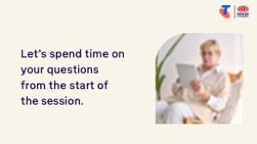 | Facilitator note:  - If learners identified additional questions or topics in the Welcome section:  - Refer to the list you captured  - Say: “Let’s go through the things you said you most wanted to learn today. I’ll demonstrate each one, and then you’ll have a go.”  - If some learners would prefer to focus on practicing instead, divide the group accordingly  - If there are no further learner questions, recap key skills  - If time and learner confidence allow, introduce extension activities covered earlier in the session  Transition:  - Let’s wrap up by reflecting on what you’ve learned today and planning your next steps.
  Extension activities:
  Search the internet
  - Try a voice search:
  - Tap the microphone icon in the search bar
  - Say what you want to search for clearly (e.g. “weather in Sydney tomorrow”)
  - Your search will appear automatically
  - Try a photo search:
  - Tap the camera icon in the search bar
  - Take a photo or select the image button to upload a photo from your device
  - Scroll down to view results — tap an image to view it larger
  Use tabs and return to favourite sites
  - Reopen a closed tab (desktop only): Right-click the tab bar > Select “Reopen closed tab” OR press Control+Shift+T (Windows) or Command+Shift+T (Mac)
  - Organise bookmarks into a folder: Open the bookmarks menu > Tap “Add folder” > Name the folder (e.g. Travel) > Move selected bookmarks into it.
  - Add shortcuts: Open Google > select Add shortcut > type the name and URL.

7. Wrap up (20 min)
Overview
Purpose:
- Consolidate learning and celebrate progress.
- Demonstrate scanning QR codes on the Learning Canvas for trusted follow‑up resources.
- Set a simple action for the week and signpost support.
Timing breakdown | Content
Reflection  10 min  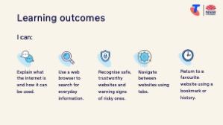  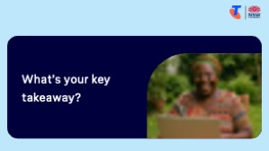  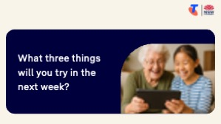 | Say:  - We’ve covered some key information and skills in browsing the internet. Let’s take a moment to celebrate what you’ve learned and record it so you can refer back to it later.  Say:  - Let’s revisit your Learning Canvas - tick the skills you can do.  Ask:  - What’s your key takeaway from today’s session?  Learners note reflections on their Learning Canvas. Invite responses.  - What three things will you try in the next week?  E.g. share what you learned with someone, search for a recipe, browse information about a hobby, bookmark a webpage.  Learners note actions on their Learning Canvas. Invite responses.
Support  10 min  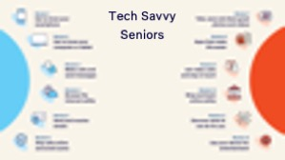 | Say:  - There is a QR code on the back of your Learning Canvas that provides more information online.  - There’s a lot of information online, so don't feel you need to access it. We’ll cover lots more in our Tech Savvy Seniors program.  - But being able to scan a QR code is a handy skill. A QR code is a visual link to a website. It saves you from needing to type the URL/web address into your browser. So, let’s practice today’s final skill!  Demonstrate how to:  - Scan QR code (Open the Camera > point at QR code on Canvas > tap the link)  Try it:  - Guide learners to scan the QR codes on the back of the Learning Canvas.  Explain:  - Where learners can go for support (e.g. 1:1 help at the library, tech groups, or other programs).  Learners note support on Learning Canvas.  - Show Tech Savvy Seniors program and provide the schedule for upcoming sessions.  Say:  - Well done! You’ve all achieved something new today. Keep practising little and often. We look forward to seeing you at another session.

