Tech Savvy Seniors
Module 3
Make calls and send messages
Session plan

Table of contents
Session overview 3
Learning architecture 3
Learning outcomes 3
Resources checklist 4
Session summary 5
Session plan 6
1. Welcome (10 min) 6
2. Make a phone call (15 min) 7
3. Send and receive text messages (20 min) 9
4. Understanding notifications (10 min) 11
5. Add and manage contacts (15 min) 12
6. Messaging apps (optional) (15 min) 14
7. Built in flexibility (25 min) 16
8. Wrap up (20 min) 18

Session overview
This relaxed 2–2.5-hour session is all about helping older Australians feel more confident using their smartphones or tablets to stay in touch. The session focuses on making and receiving calls, sending and replying to text messages, recognising notifications, and managing contacts.
We’ll also introduce messaging apps like WhatsApp or Messenger for those ready to explore further. Each topic includes a short demo followed by a hands-on activity. Learners will leave feeling proud of what they tried and ready to reach out more easily to friends and family.

Learning architecture
This module forms part of a 12-module series.
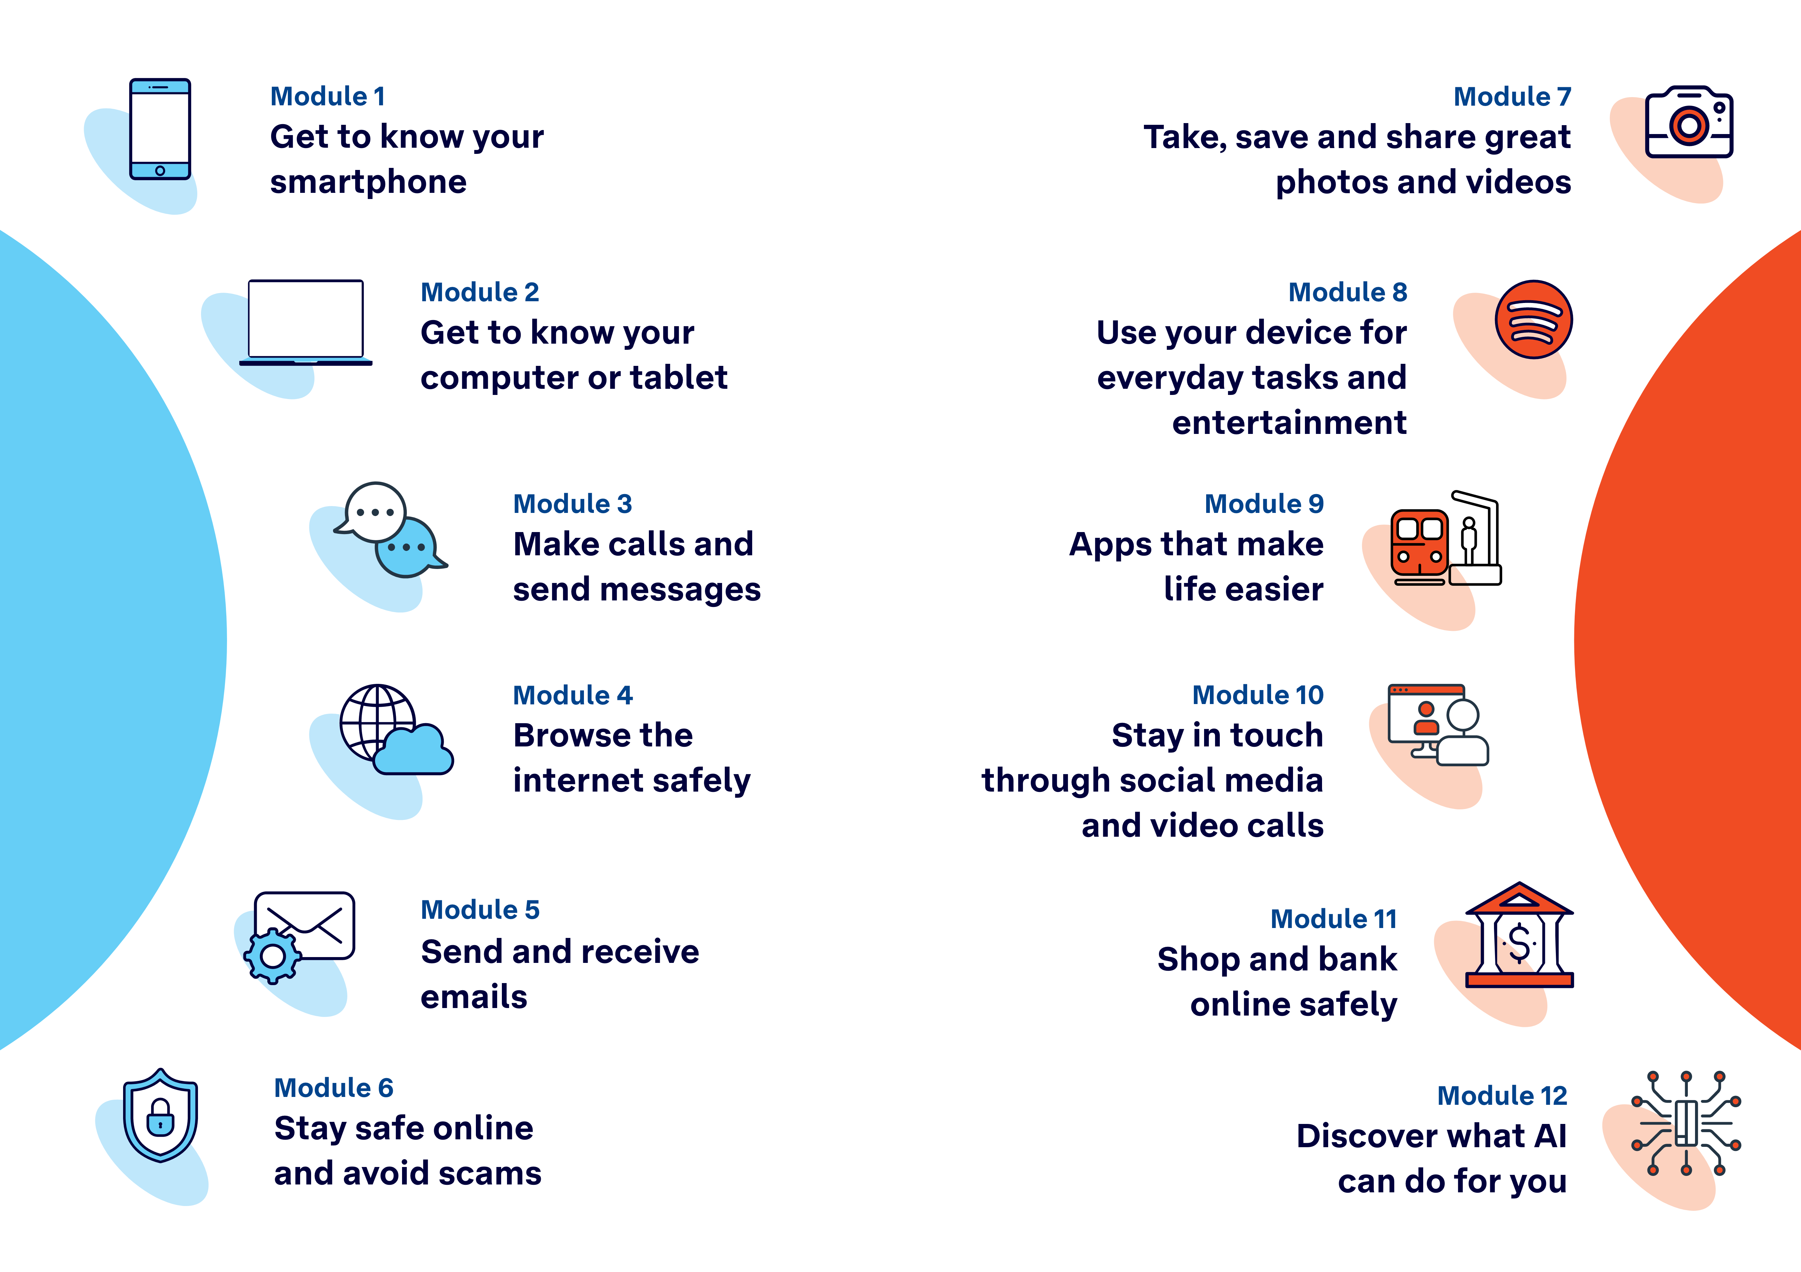

Learning outcomes
At the end of this session, learners will be able to:
- Make and receive a phone call.
- Send and reply to a text message.
- Recognise and manage missed calls or message notifications.
- Add, edit or delete contacts.
- Use messaging apps like WhatsApp or Messenger (optional).

Resources checklist
This session requires the following resources:
☐ | Session plan (this document)
☐ | PowerPoint presentation
☐ | Learning Canvas - printed (one per learner)
☐ | Pens for learners (one per learner)
☐ | Butchers paper/markers or a whiteboard/markers may be useful to assist with capturing ‘learning goals’ which will be touched on throughout the session
☐ | Library’s Wi-Fi password
☐ | Tech Savvy Seniors program schedule - printed (one per learner)
☐ | Learners’ own mobile phones (or tablets with SIM capability)
☐ | Facilitator’s phone for demonstrations, with WhatsApp and Messenger installed
☐ | Projector and screen (optional)
☐ | Computer (facilitator’s)

Session summary
This session summary provides an overview of topics, the activities relevant to each topic and the duration.

Duration | Topic | Useful links
10 min | 1. Welcome
15 min | 2. Make a phone call
20 min | 3. Send and receive text messages | Send a text (iPhone)(Samsung)
10 min | Break
10 min | 4. Understand notifications
15 min | 5. Add and manage contacts
15 min | 6. Messaging apps (e.g. WhatsApp, Messenger)
10 min | Break
25 min | 7. Built in flexibility
20 min | 8. Wrap up | - iPhone: Scan a QR code with your iPhone or iPad  - Android: How do you scan QR codes on Android?
Total duration: 2.5 hours

Session plan

1. Welcome (10 min)
Overview
Purpose:
- Introduce Module 3: Make calls and send messages, including the flow (short demos + practice)
- Set a safe, calm tone; reduce anxiety about ‘pressing the wrong thing’
- Introduce the learning Canvas as a personal guide they can use during the session and take home
- Gather learner goals to tailor the ‘Built‑in flexibility’ section later
Timing breakdown | Content
Session overview  10 min  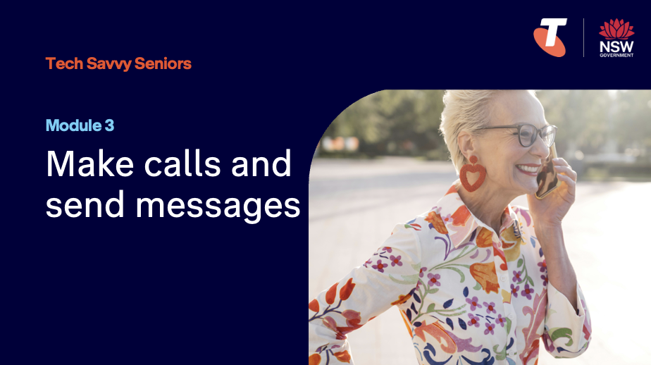  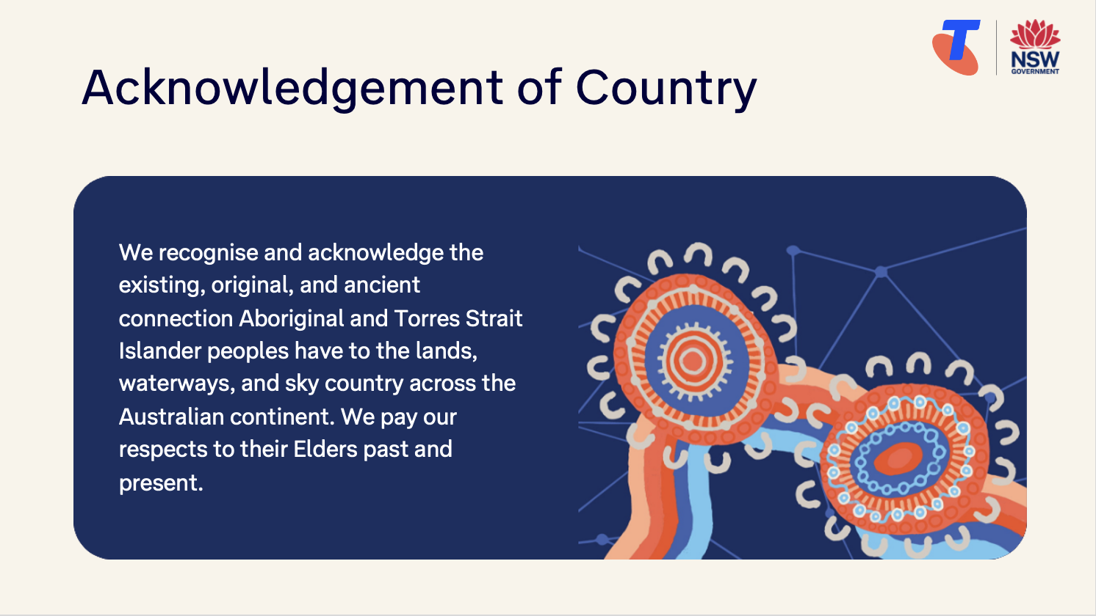  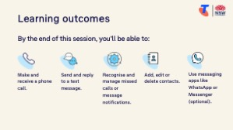  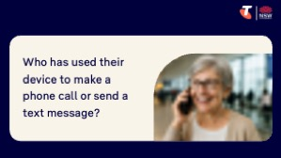  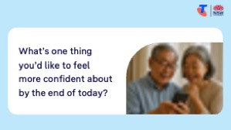 | On arrival, ensure each learner has a device (phone or tablet), printed Learning Canvas and pen. Group learners by device (e.g. Android, iPhone) so they can support each other.  Deliver: An Acknowledgement of Country.  Say:  - Welcome! Today is all about making calls and sending messages with your smartphone or tablet. We’ll go slowly and practise each step together. This is a safe space – no question is silly and no mistake is wrong.  - By the end of the session, you’ll be able to make a call, send a message, and feel more confident staying in touch.  - Before we touch anything, let’s agree: it’s fine to make mistakes. That’s how we learn.  - By the end of this session, you’ll be able to:  - Make and receive a phone call.  - Send and reply to a text message.  - Use messaging apps (optional).  - Add, edit or delete contacts.  - Recognise and manage missed calls or message notifications.  Introduce Learning Canvas:  - Use your printed Learning Canvas to write notes in your own words, tick off skills as you learn them, and highlight what feels most useful to you. Writing things down helps you remember and understand them better, and makes it easier to recall later. Take your Canvas home to keep practising. On the back, you’ll find extra tips and trusted links if you want to explore more.  Ask:  - Who here has used their device to make a phone call before? Who has sent a text message?  - What’s one thing you’d like to feel more confident about by the end of today?  (Write answers on a whiteboard or butchers paper. These will help shape the ‘Built-in Flexibility’ section later in the session.)  Confirm everyone has a device; pair anyone without.  Transition:  - Let’s begin by learning how to make and answer a call.

2. Make a phone call (15 min)
Overview
Purpose:
- Build confidence making and receiving a phone call.
- Help learners understand what is needed to make a call.
- Demonstrate different ways to make a call, including through the Phone app, Contacts app and messaging app.
- Practise answering, ending, and identifying incoming calls.
Timing breakdown | Content
Make a phone call  15 min  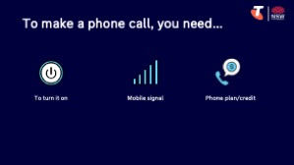  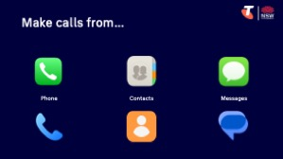 | Say:  - Let’s begin with one of the simplest and most useful things your phone can do: making a phone call. You can call friends, family, doctors, and services.  - To receive a phone call, your phone needs to be turned on and have signal (bars at the top of the screen) or a Wi-Fi connection.  - To make a phone call, you’ll also need a phone plan/credit or a Wi-Fi connection.  Explain you can make calls from:  - Phone app  - Contacts app  - Messages app  Demonstrate different ways to make a call:  - Using the Phone app:  - Unsaved number: Open the app > tap the keypad > enter the phone number > tap green call button  - Saved number: Open the app > tap Favourites or Contacts > tap the saved contact (if in Contacts, then tap the phone icon)  - Using the Contacts app: Open a saved contact > tap the phone icon  - Using the Messages app: Open a message > select the contact tap the phone icon  Explain:  - How to end the call using the red button  - The speaker and mute buttons, and when to use them  - What happens when someone calls you – the phone rings, and you can swipe/tap to answer or reject  - How to access voicemail:  iPhone: Open the Phone app, then tap Voicemail.  Android: Hold down the 1 key on the keypad.  Try it:  - Guide learners to find the different apps (phone, contacts and messages), make calls, use the speaker, and end the call.

Timing breakdown | Content
Extension activity
- Use voice assistant to call a contact (note: voice assistant must be enabled in settings):
iPhone: “Hey Siri, call John Smith”
Android: “Hey Google, call John Smith”
Ask:
- What did you notice? What went well? What didn’t?
(Address challenges, e.g., if people struggled to hear, explain how to increase the volume.)
Transition:
- Now that you’ve made a phone call, let’s look at how to send and reply to a text message – another simple way to stay in touch.

3. Send and receive text messages (20 min)
Overview
Purpose:
- Introduce the concept of texting as a simple and popular way to communicate.
- Help learners understand what is needed to send and receive messages.
- Demonstrate how to send, read, and reply to SMS messages.
- Build confidence using the keyboard, emojis, and voice typing if available.
Timing breakdown | Content
Key features  10 min  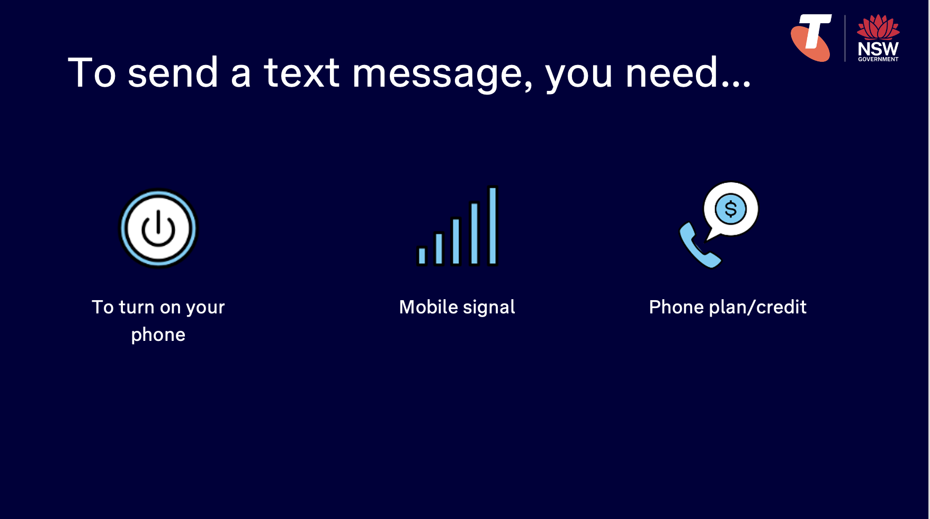  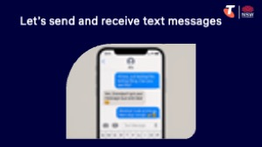 | Say:  - Texting is a way to send someone a message. You can use it to confirm appointments, check in with family, or send media (photos, videos, voice messages).  - To receive a text message (AKA SMS), your phone needs to be turned on and have a signal or a Wi-Fi connection. If it is not turned on or is out of signal, you will still receive the text message once it’s turned on/has signal.  - To send a text message, you’ll also need a phone plan/credit or a Wi-Fi connection.  Demonstrate how to write and send a text:  - Open the Messages app > tap + or New Message button > type a phone number or tap a saved contact > use the on-screen keyboard to type a short message > tap Send (usually a paper plane or arrow icon) (iPhone)(Samsung)  Try it:  - Guide learners to write and send a text message.  Demonstrate how to:  - Send a text message to multiple people  - Edit a text message  - Copy and paste text  - Delete an entire conversation thread:  iPhone: swipe left on conversation > select the bin emoji  Samsung: long-press the conversation > select the bin icon  - Delete individual text messages: open the Messages app > open the specific conversation you want to delete from > long-press on a message to select it for deletion  Transition:  - Great work! You’ve now sent and received text messages. Let’s look at how your phone notifies you of text messages and missed phone calls.
  Extension activity
  - Add an emoji to a message: when writing a message, select + button > select emoji icon > select an emoji > select send.
  - Send a photo/video: when writing a message, select + button > select photo icon > select a photo/video > select send.
  - Use voice to text, if available on their device: when writing a message, select the microphone button and begin speaking > select send.
  - Send a voice message:
  iPhone: when writing a message, select + button > select audio > recording starts automatically, so begin speaking > select the stop button > select send.
  Samsung: when writing a message, select soundwave button, select the microphone to start recording > select stop > select send.
10 min | Break

4. Understanding notifications (10 min)
Overview
Purpose:
- Help learners recognise when someone is trying to contact them via call or message.
- Build confidence in checking and clearing notifications.
- Explain how notification icons and banners work on different devices.
Timing breakdown | Content
Understanding notifications  10 min  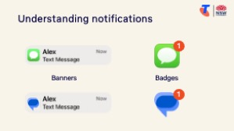 | Say:  - Your phone shows notifications when someone has tried to call or text you. These usually appear as banners or as badges (numbers on app icons), with the relevant app widget displayed (e.g. phone for missed call, speech bubble for a text message).  - Sometimes notifications appear as banners when your screen is locked. They may disappear when the phone is unlocked. That doesn’t mean they’re gone - they’re still saved in your notification centre. Let’s learn how to view them.  Demonstrate how to view notifications:  - iPhone:  - Swipe down from the top of the screen to open the Notification Centre.  - Tap on a notification to open the message or app.  - Swipe left on a notification to clear it (tap Clear).  - Or tap the X and choose Clear All Notifications.  - Android (Samsung example):  - Swipe down from the top of the screen to open the Notifications Panel.  - Tap a notification to open the app or message.  - Swipe left or right on a notification to dismiss it.  - Tap Clear All to remove all notifications at once.  Try it:  - Guide learners to view notifications.  Transition:  - Now, let’s make it easier to reach out by saving people in your Contacts.
  Extension activity
  - Customise notification sounds:
  iPhone: Settings > Sounds & Haptics > Text Tone or Ringtone
  Android: Settings > Sounds and vibration > Notification sound
  - Adjust which apps can send notifications:
  iPhone: Settings > Notifications > Select app
  Android: Settings > Notifications > App notifications

5. Add and manage contacts (15 min)
Overview
Purpose:
- Help learners save and manage phone numbers so they can call or message someone easily.
- Introduce the Contacts app and how it connects to the Phone and Messages apps.
- Build confidence adding, editing and deleting contacts.
Timing breakdown | Content
Add and manage contacts  15 min  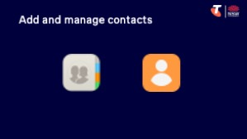 | Say:  - You don’t need to remember everyone’s phone number. By saving a contact, you can call or message someone with just a tap. Let’s add a contact to your phone.  Explain:  - Contacts can include names, numbers, emails, addresses and even photos.  - You can access contacts through:  - The Contacts app (on most phones)  - The Phone app (under the Contacts or Recents tab)  - The Messages app (by tapping a name/number)  Demonstrate how to add a new contact:  - iPhone:  - Open the Phone app > Tap Contacts > Tap + in the top-right  - Enter Name and Phone number  - Tap Done to save  - Android (Samsung example):  - Open the Contacts app or Phone app > Tap Contacts  - Tap + Add or Create contact  - Enter Name and Phone number  - Tap Save  Demonstrate how to edit or delete a contact:  - iPhone:  - Open Contacts app > Tap a contact  - Tap Edit, make changes, then tap Done  - Scroll down and tap Delete Contact to remove  - Android (Samsung example):  - Open Contacts app > Tap a contact  - Tap Edit (pencil icon) to update details  - Tap More > Delete to remove  Try it:  - Guide learners to perform tasks.

Timing breakdown | Content
Extension activities
- Add contacts to “Favourites” for quicker calling:
iPhone: Open Phone app > Tap Favourites > Tap + > Choose a contact and number type (e.g. mobile)
Android (Samsung): Open Phone app > Tap Contacts > Select a contact > Tap the star icon to favourite
- Search for a contact using the search bar:
iPhone: Open Contacts app > Swipe down or tap Search bar at the top > Type the name
Android (Samsung): Open Contacts app > Tap the Search icon (magnifying glass) > Type the name
Transition:
- Now that you’ve saved some contacts, let’s explore other ways to send messages using apps like WhatsApp or Messenger.

6. Messaging apps (optional) (15 min)
Overview
Purpose:
- Introduce popular messaging apps (WhatsApp, Messenger, iMessage) and their use in real life.
- Help learners understand how messaging apps differ from SMS.
- Show how to open a chat, send a message, and view replies.
Timing breakdown | Content
Adjust settings  15 min  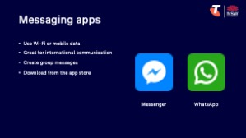  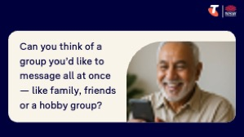 | Say:  - Messaging apps like WhatsApp, Messenger, and iMessage help you send texts, photos, and even make calls using the internet. You’ll need to be connected to Wi-Fi or have mobile data turned on for them to work.  - These apps are free to use and can be great for staying in touch with family or friends who live far away. They also making it easier to send group messages to several people at once. For example, you might message your children, a group of friends, or members of a club in the same chat.  Explain the difference:  - SMS (text messages) use your mobile signal/Wi-Fi and phone plan/Wi-Fi. If you’re sending texts or making calls overseas using SMS, it can be quite expensive.  - Messaging apps use Wi-Fi or mobile data, not phone credit. That means you can message or call people overseas without paying international rates.  - You can send messages, photos, videos, voice messages, or even make video calls in the same app.  - Messaging apps allow you to create group messages.  - You’ll need to download these apps from the app store (they’re free!).  Ask:  - Does anyone have family or friends overseas? How do you usually stay in touch with them?  - Who here has a Facebook account? Have you ever used Messenger to send a message?  - Are you in any group messages already — like with your family, friends, or a community group?  - Can you think of a group you’d like to message all at once — like family, friends or a hobby group?  (Some learners may already use these apps regularly, others may be curious, and some may prefer to stick with SMS for now. Reassure them that trying it is optional.)  Demonstrate how to send a message:  - WhatsApp:  - Open the WhatsApp app  - Tap the Chats tab > Tap the speech bubble + icon to start a new chat  - Select a contact or type their name in the search bar  - Type a short message using the keyboard > Tap Send (paper plane icon)

Timing breakdown | Content
- Messenger (Facebook):
- Open the Messenger app
- Tap the pencil + icon to start a new message
- Choose a contact or search for their name
- Type a message and tap Send
- iMessage (iPhone only - no need to download):
- Explain: iMessage is a built-in feature, not a separate app. It allows you to send messages over the internet to other Apple users (iPhones, iPads, or Macs). iPhone default it iMessage instead of SMS. You can tell you’re using iMessage when your message bubbles are blue instead of green. You can only send iMessages to people using Apple devices who also have iMessage turned on.
- To turn on iMessage: Open Settings > Tap Messages > Toggle iMessage on (green).
- To send an iMessage: send a text message (iMessage bubbles are blue instead of green)
Try it:
- Guide learners to perform tasks.
Extension activities:
- Download WhatsApp or Messenger from the App Store (iPhone) or Play Store (Android):
iPhone: Open the App Store > Tap Search > Type "WhatsApp" or "Messenger" > Tap Get > Enter Apple ID password or use Face ID if prompted > Wait for the app to install
Android: Open the Play Store > Tap Search bar > Type "WhatsApp" or "Messenger" > Tap Install > Wait for the app to install
- Create a group message:
WhatsApp: Open the app > Tap Chats > Tap New Chat icon > Tap New Group > Select contacts > Tap Next > Enter a group name > Tap Create > Type your message and tap Send
Messenger: Open the app > Tap the New Message icon > Select multiple contacts > Type your message > Tap Send
Transition:
- Great work! Next, let’s spend some time on the questions and goals you raised at the start of today’s session.
10 min | Break

7. Built in flexibility (25 min)
Overview
Purpose:
- To address the questions and skills learners were hoping this session covers
- To practice skills
- If time and learner confidence allow, introduce one or more extension activities from earlier sections
Timing breakdown | Content
Flexible time  25 min  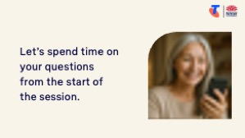 | Facilitator note:  - If learners identified additional questions or topics in the Welcome section:  - Refer to the list you captured  - Say: “Let’s go through the things you said you most wanted to learn today. I’ll demonstrate each one, and then you’ll have a go.”  - If some learners would prefer to focus on practicing instead, divide the group accordingly  - If there are no further learner questions, recap key skills:  - Making phone calls  - Sending and receiving messages  - Using messaging apps  - If time and learner confidence allow, introduce extension activities covered earlier in the session  Transition:  - Let’s wrap up by reflecting on what you’ve learned today and planning your next steps.
  Extension activities:
  Phone calls:
  - Use voice assistant to call a contact (note: voice assistant must be enabled in settings):
  iPhone: “Hey Siri, call John Smith”
  Android: “Hey Google, call John Smith”
  Text messages:
  - Add an emoji to a message: when writing a message, select + button > select emoji icon > select an emoji > select send.
  - Send a photo/video: when writing a message, select + button > select photo icon > select a photo/video > select send.
  - Use voice to text, if available on their device: when writing a message, select the microphone button and begin speaking > select send.
  - Send a voice message:
  iPhone: when writing a message, select + button > select audio > recording starts automatically, so begin speaking > select the stop button > select send.
  Samsung: when writing a message, select soundwave button, select the microphone to start recording > select stop > select send.
  Notifications:
  - Customise notification sounds:
  iPhone: Settings > Sounds & Haptics > Text Tone or Ringtone
  Android: Settings > Sounds and vibration > Notification sound
  - Adjust which apps can send notifications:
  iPhone: Settings > Notifications > Select app
  Android: Settings > Notifications > App notifications
  Contacts:
  - Add contacts to “Favourites” for quicker calling:
  iPhone: Open Phone app > Tap Favourites > Tap + > Choose a contact and number type (e.g. mobile)
  Android (Samsung): Open Phone app > Tap Contacts > Select a contact > Tap the star icon to favourite
  - Search for a contact using the search bar:
  iPhone: Open Contacts app > Swipe down or tap Search bar at the top > Type the name
  Android (Samsung): Open Contacts app > Tap the Search icon (magnifying glass) > Type the name
  Messaging apps:
  - Download WhatsApp or Messenger from the App Store (iPhone) or Play Store (Android):
  iPhone: Open the App Store > Tap Search > Type "WhatsApp" or "Messenger" > Tap Get > Enter Apple ID password or use Face ID if prompted > Wait for the app to install
  Android: Open the Play Store > Tap Search bar > Type "WhatsApp" or "Messenger" > Tap Install > Wait for the app to install
  - Create a group message:
  WhatsApp: Open the app > Tap Chats > Tap New Chat icon > Tap New Group > Select contacts > Tap Next > Enter a group name > Tap Create > Type your message and tap Send
  Messenger: Open the app > Tap the New Message icon > Select multiple contacts > Type your message > Tap Send

8. Wrap up (20 min)
Overview
Purpose:
- Consolidate learning and celebrate progress.
- Demonstrate scanning QR codes on the Learning Canvas for trusted follow‑up resources.
- Set a simple action for the week and signpost support.
Timing breakdown | Content
Reflection  10 min  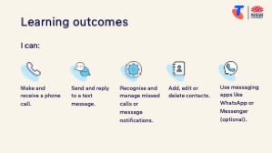  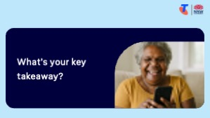  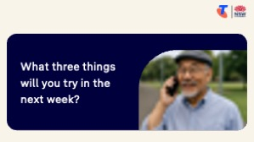 | Say:  - We’ve covered some key information and skills in using your computer or tablet. Let’s take a moment to celebrate what you’ve learned and record it so you can refer back to it later.  Say:  - Let’s revisit your Learning Canvas - tick the skills you can do.  Ask:  - What’s your key takeaway from today’s session?  Learners note reflections on their Learning Canvas. Invite responses.  - What three things will you try in the next week?  E.g. share what you learned with someone, add more contacts, send text messages with emojis, send a voice message, create a group message.  Learners note actions on their Learning Canvas. Invite responses.
Support  10 min   | Say:  - There are QR codes on the back of your Learning Canvas that provide more information online.  - There’s a lot of information online, so don't feel you need to access it. We’ll cover lots more in our Tech Savvy Seniors program.  - But being able to scan a QR code is a handy skill. A QR code is a visual link to a website. It saves you from needing to type the URL/web address into your browser. So, let’s practice today’s final skill!  Demonstrate how to:  - Scan QR code (Open the Camera > point at QR code on Canvas > tap the link)  Try it:  - Guide learners to scan the QR codes on the back of the Learning Canvas.  Explain:  - Where learners can go for support (e.g. 1:1 help at the library, tech groups, or other programs).  Learners note support on Learning Canvas.  - Show Tech Savvy Seniors program and provide the schedule for upcoming sessions.  Say:  - Well done! You’ve all achieved something new today. Keep practising little and often. We look forward to seeing you at another session.

