Tech Savvy Seniors
Module 2
Get to know your computer or tablet
Session plan

Table of contents
Session overview 3
Learning architecture 3
Learning outcomes 3
Resources checklist 4
Session summary 5
Session plan 6
1. Welcome (10 min) 6
2. What is a computer or tablet? (15 min) 7
3. Key physical features (10 min) 10
4. Turn device off/on and unlock it (10 min) 11
5. Navigate (25 min) 12
6. Adjust settings (15 min) 14
7. Built in flexibility (25 min) 16
8. Wrap up (20 min) 18

Session overview
This relaxed 2-2.5-hour session is all about helping older Australians feel more confident using either a computer or tablet.
We’re keeping it simple, practical, and paced to help everyone feel at ease. Each topic includes a short demo followed by a hands-on activity. Learners will leave feeling proud of what they tried and ready to explore more.

Learning architecture
This module forms part of a 12-module series.
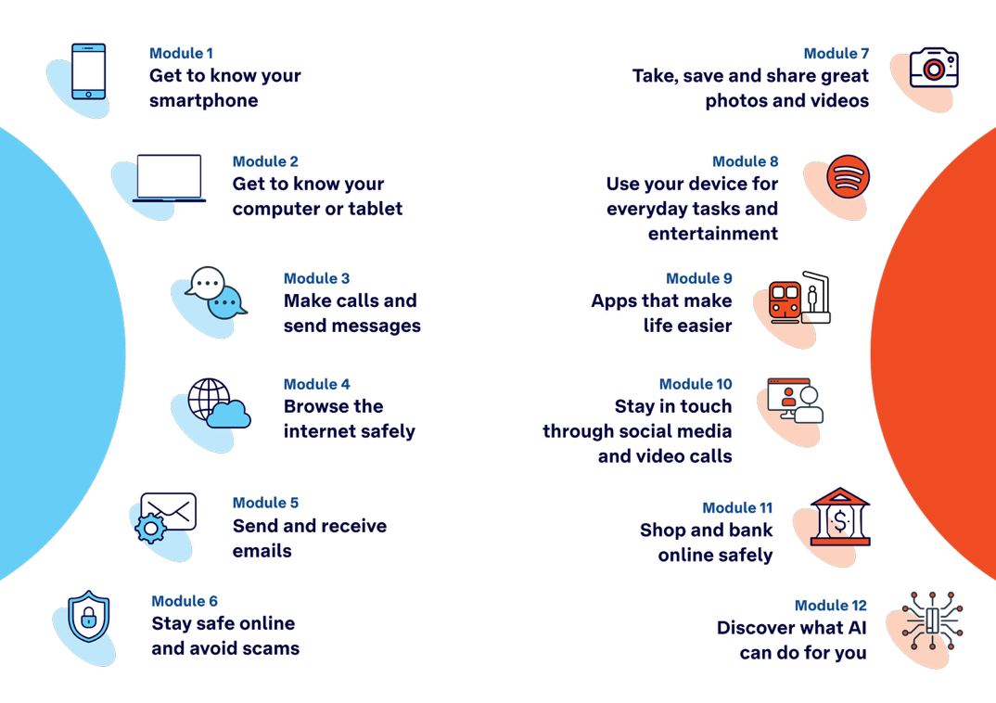

Learning outcomes
At the end of this session, learners will be able to:
- Explain what computers and tablets are and list common things they can do.
- Identify key physical features (screen, buttons, charging port, cameras).
- Turn the computer or tablet on/off and unlock it.
- Navigate using basic gestures (tablet) or mouse/ trackpad and keyboard (computer).
- Adjust basic settings like brightness, text size and volume.

Resources checklist
This session requires the following resources:
☐ | Session plan (this document)
☐ | PowerPoint presentation
☐ | Learning Canvas - printed (one per learner)
☐ | Pens for learners (one per learner)
☐ | Butchers paper/markers or a whiteboard/markers may be useful to assist with capturing ‘learning goals’ which will be touched on throughout the session
☐ | Library’s Wi-Fi password
☐ | Tech Savvy Seniors program schedule - printed (one per learner)
☐ | Computers and tablets (for learners who don't have their own)
☐ | Desktop to explain main parts of the device
☐ | Projector and screen (optional)
☐ | Computer (facilitator’s)

Session summary
This session summary provides an overview of topics, the activities relevant to each topic and the duration.

Duration | Topic | Useful links
10 min | 1. Welcome
15 min | 2. What’s a computer or tablet?
10 min | 3. Key physical features
10 min | Break
10 min | 4. Turn device off/on and unlock it
25 min | 5. Navigate
15 min | 6. Adjust settings | - Change the wallpaper or background image (macOS, Windows)  - Change the appearance settings (macOS, Windows)  - Change date and time settings (macOS, Windows)  - Use virtual assistants (iPadOS, macOS, Android)  - Pin apps (Windows only)  - Add, remove or rearrange Dock items (macOS only)  - Change Desktop & Dock settings (macOS only)  - Test the torch/flashlight (iPadOS)  - Move and groups apps/widgets on home screen (Android and iPadOS)
10 min | Break
25 min | 7. Built in flexibility
20 min | 8. Wrap up | - iPhone: Scan a QR code with your iPhone or iPad  - Android: How do you scan QR codes on Android?
Total duration: 2.5 hours

Session plan

1. Welcome (10 min)
Overview
Purpose:
- Introduce Module 2: Get to know your computer or tablet, including the flow (short demos + practice)
- Set a safe, calm tone; reduce anxiety about ‘pressing the wrong thing’
- Introduce the Learning Canvas as a personal guide they can use during the session and take home
- Gather learner goals to tailor the ‘Built‑in flexibility’ section later
Timing breakdown | Content
Session overview  10 min    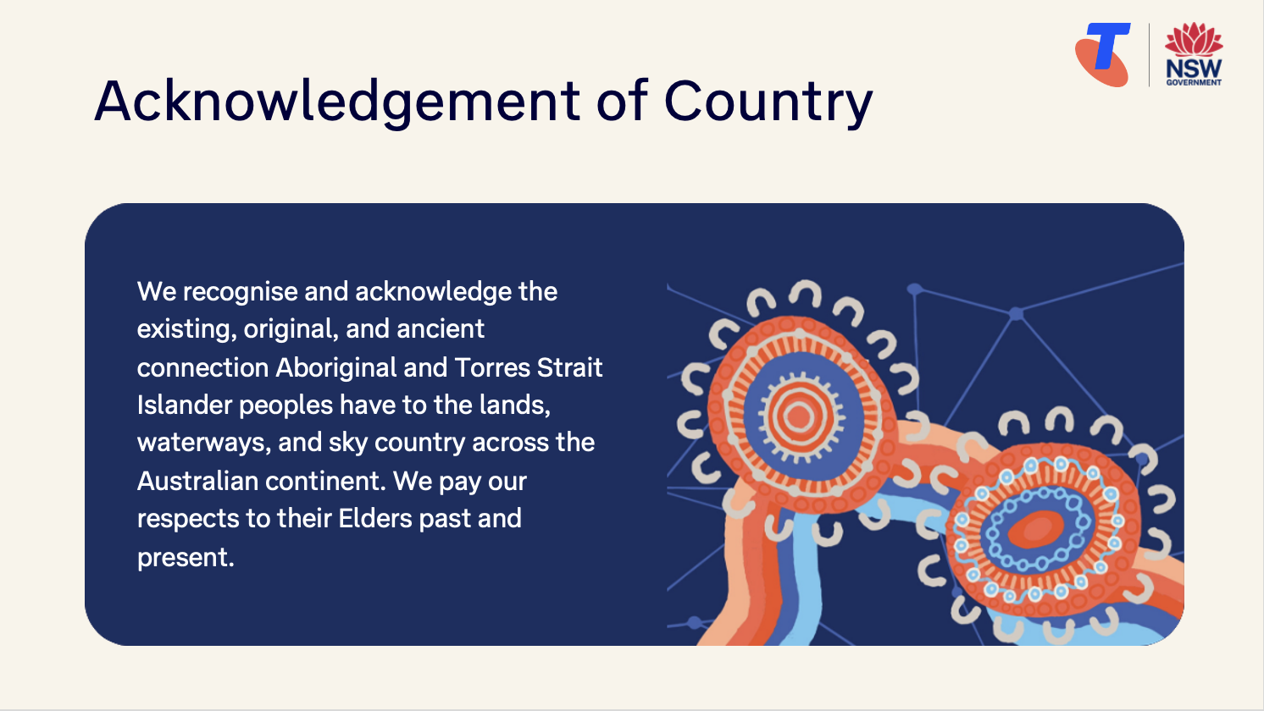  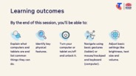   | On arrival, ensure each learner has a device (computer or tablet), printed Learning Canvas and pen. Group learners by device so they can support each other.  Deliver: An Acknowledgement of Country.  Say:  - Welcome! Today is all about getting to know your computer or tablet. This is a safe space to try things out without pressure. We’ll take it step by step. There are no silly questions.  - Before we touch anything, let’s agree: it’s fine to make mistakes. That’s how we learn.  - By the end of this session, you’ll be able to:  - Explain what computers and tablets are and list common things they can do.  - Identify key physical features (screen, buttons, charging port, cameras).  - Turn your computer or tablet on/off and unlock it.  - Navigate using basic gestures (tablet) or mouse/ trackpad and keyboard (computer).  - Adjust basic settings like brightness, text size and volume.  Introduce Learning Canvas:  - Use your printed Learning Canvas to write notes in your own words, tick off skills as you learn them, and highlight what feels most useful to you. Writing things down helps you remember and understand them better, and makes it easier to recall later. Take your Canvas home to keep practising. On the back, you’ll find extra tips and trusted links if you want to explore more.  Ask:  - Who here has used a computer before? Who has used a tablet?  (Gauge pace.)  - What’s one thing you’d like to feel more confident about by the end of today?  (Write answers on a whiteboard or butchers paper. These will help shape the ‘Built-in Flexibility’ section later in the session.)  Confirm everyone has a device; pair anyone without.  Transition:  - Before we start using the device, let’s begin by understanding what a computer or tablet actually is.

2. What is a computer or tablet? (15 min)
Overview
Purpose:
- Demystify what computers and tablets are, highlighting that while devices vary in brand or size, they all do similar things.
- Build shared language around key terms like desktop, laptop, tablet, and operating system.
- Help learners start to name and recognise their own device.
Timing breakdown | Content
Types of devices  5 min  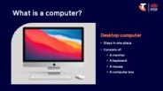  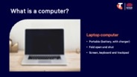  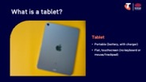  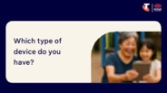 | Say:  - Let’s start right at the beginning. What exactly is a computer or a tablet? These days, they come in all shapes and sizes — but most do very similar things.  - There are three main types of devices:  - Desktop computers: Stay in one place - like on a desk at home - because they need to be connected to power. They have separate parts:  - A monitor (the screen)  - A keyboard (for typing)  - A mouse (for moving the pointer (cursor) and clicking)  - A computer box (this holds all the brains — the processor, memory, and storage)  Desktops are great if:  - You like a bigger screen  - You mostly use your device in one place, like a study or spare room  - You want to write documents or manage household task  - Laptop computers: Laptops are like smaller, portable desktops. They fold open and shut like a book, and can run on battery for several hours. They have a screen, keyboard and trackpad all in one piece, and a charger.  Laptops are ideal if you want to move around (e.g. from kitchen to couch).  - Tablets: Flat, touchscreen devices with no keyboard or mouse. You use your fingers to tap and swipe (like you would a smartphone). Run on battery and are very light and portable. Tablets are great for video calls or sending messages.  Ask:  - Which type of device do you have?  Do:  - Pair learners according to their device.

Timing breakdown | Content
Operating systems  3 min  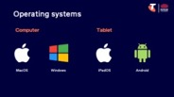 | Say:  - Different devices use different operating systems — that’s the software that runs the device and controls how it looks and works.  - Windows  Most laptops and desktop computers use Windows. If your screen has a Start menu or a Microsoft logo, you’re probably using Windows.  - MacOS  Apple computers (called Macs or MacBooks) use MacOS. It looks a little different from Windows but lets you do the same things — browse the internet, send emails, write documents, and more.  - Android  Most tablets (like Samsung, Lenovo, and some budget brands) use Android. You’ll see a colourful home screen with icons, and a Google Play Store for downloading apps.  - iPadOS  Apple iPads use iPadOS. It works in a very similar way to Android tablets, with a touchscreen home screen, app icons, and an App Store for downloading apps.  - Even though your device might look different to someone else’s, the way they work is very similar. You’ll still tap, swipe, click or scroll to get around — and we’ll show you how.
What can computers and tablets do?  5 min  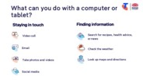  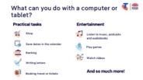   | Say:  - No matter what type of device you’re using, they all let you do similar things.  Ask:  - What can you do with a computer or tablet?  Brainstorm. Prompt for:  - What do you currently use your device for?  Discuss in pairs/small groups.
  Staying in touch  - Send and receive emails  - Join a video call  - Share and view photos  - Use social media  Finding information  - Search for recipes, health advice, or news  - Look up maps and directions  - Check the weather | Practical tasks  - Shop  - Save dates in calendar  - Banking  - Write letters  - Book tickets and appointments  Entertainment  - Watch TV shows, movies or YouTube  - Play games  - Listen to music, podcasts or audiobooks  - Read e-books

Timing breakdown | Content
Connecting to the internet  2 min  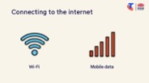 | Say:  - Let’s talk for a moment about how these devices connect to the internet. Some of the things your device can do won't need the internet — like typing a letter, looking at saved photos, or playing a game you’ve already downloaded. But many of the most useful things — like sending emails, browsing the web, or joining a video call — do need an internet connection.  - Wi-Fi is the most common way. At home, you usually pay for internet through a provider, and you’ll have a Wi-Fi box or modem. To connect, you need a password — often written on the side of the box/modem, on a magnet or given to you when it’s set up.  - Many public places also have Wi-Fi, like libraries and cafés. It’s often free, but you usually need to ask for the password. Once you’ve connected once, your device will normally remember it for next time. Be cautious when using public Wi-Fi — avoid entering personal, banking or sensitive information, as public networks aren’t always secure.  - Mobile data is a little different. Some tablets — just like smartphones — have a SIM card slot. This lets them use mobile data when you’re out and about, without needing Wi-Fi. You pay for this as part of a mobile plan, either monthly or prepaid.  - So, to keep it simple:  - Computers use Wi-Fi.  - Tablets use Wi-Fi, but some can also use mobile data if they have a SIM card.  Demonstrate:  - Connecting to Wi-Fi (Wi-Fi icon > library’s network name > password).  Try it:  - Guide learners to connect to Wi-Fi.  Transition:  - Now that we know what type of device you have, let’s take a closer look at the buttons, ports, and features that make it work.

3. Key physical features (10 min)
Overview
Purpose:
- Identify physical features
Timing breakdown | Content
Key features  10 min  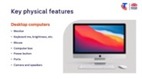  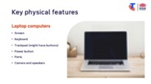  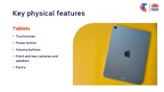 | Say:  - Before we start using our devices, it helps to know what the different parts are called, and what they do. Let’s look at these more closely.  Explain desktop computer setup:  - Monitor – the screen.  - Keyboard – used for typing and controlling volume, brightness, etc., - connected via a cord or Bluetooth.  - Mouse – used to move the pointer and click on things (most mice have a left button, a right button, and a scroll wheel) - connected via a cord or Bluetooth.  - Computer box – the “brains” of the computer, usually under the desk or beside the screen.  - Power button – turns the device on and off.  - Ports – small slots for plugging in extras like a memory stick or earphones.  - Camera and speakers (if integrated).  Explain laptop features:  - Screen – built-in monitor.  - Keyboard – built-in for typing and controlling volume, brightness, etc.  - Trackpad – flat square below the keyboard, acts like a mouse (might have buttons).  - Power button – often on the keyboard or near the top right.  - Ports – on the sides for the charger and accessories (e.g. mouse, earphones).  - Camera and speakers.  Explain tablet features:  - Touchscreen – the main way to use it.  - Power button – turns the tablet on, off, or wakes it from sleep.  - Volume buttons – control sound levels.  - Front and rear cameras and speakers – for photos, videos, and video calls.  - Port/s – where you plug in the charger or earphones.  Try it:  - Guide learners to identify each of the physical features on their own devices.  - Ask learners to draw a simple sketch of their device on the Learning Canvas and label the key features.  Transition:  - Great – now we know our way around the outside of the device. Next, let’s learn how to turn it on and unlock it, so we can start exploring what’s inside.
10 min | Break

4. Turn device off/on and unlock it (10 min)
Overview
Purpose:
- Teach learners how to safely power their device off and on, wake it from sleep, lock it, and unlock it.
- Help learners understand when powering off is useful (e.g., conserving battery).
Timing breakdown | Content
Turn device off/on and unlock it  10 min  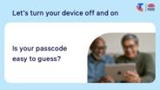 | Say:  - You don’t need to turn your computer or tablet fully off each time you finish using it. Most people just let it go to sleep — the screen goes dark to save power, and you can wake it up by pressing a key or the power button. You might choose to turn it off completely if you’re not using it for a few days, or if the device freezes and needs a restart, or needs an update.  Demonstrate tasks with a computer:  - Turn on: Press the power button once (on the tower for desktops, or on the keyboard/side for laptops). The screen will light up as the system starts.  - Sleep mode: Move the mouse, click, or press a key to wake them up.  - Unlocking: Some computers ask for a password before you can use them.  Demonstrate tasks with a tablet:  - Turn on: Hold down the power button for a few seconds until the logo appears.  - Sleep mode: Tap the screen or press the power button briefly to wake them.  - Unlocking: May need a PIN, password, fingerprint, or face recognition (similar to smartphone).  Try it:  - Guide learners to perform tasks.  Ask:  - Is your passcode easy to guess?  Say:  - Make sure your passcode is hard to guess. Avoid simple choices like your birthday or 1234 — choose something that others won’t know.  - You’ll have an option to change your unlock method/passcode later in the session.  Transition:  - Now, let’s explore how to move around the screen and start using it.

5. Navigate (25 min)
Overview
Purpose:
- Introduce learners to the basic ways of moving around on their device
- For computers, this means using the mouse/trackpad and keyboard
- For tablets, it means using touch gestures like tapping, swiping and pinching
- Practice opening and closing apps/programs and returning to the home screen or desktop
Timing breakdown | Content
Navigate  5 min  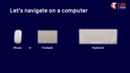  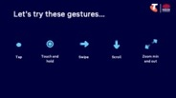 | Say:  - Let’s learn how to control your device. Computers use a mouse or trackpad and keyboard, while tablets use your fingers on the touchscreen. Once you know the basics, it becomes much easier to explore.  Demonstrate navigation on a computer (mouse/trackpad and keyboard):  - Mouse:  - Move it on the desk → pointer moves on screen.  - Left-click → select or open (sometimes you’ll need to double-click).  - Right-click → more options.  - Scroll wheel → move up and down pages.  - Trackpad (laptops):  - Slide your finger → pointer moves.  - Tap (or click buttons) → select.  - Two-finger scroll → move up and down.  - Keyboard:  - Enter/Return → confirm or move to a new line (email, document, text field).  - Backspace/Delete → remove text.  - Hold down Shift → make capital letters.  Demonstrate navigation on a tablet (gestures - similar to smartphone):  - Tap → like a mouse click, to select or open.  - Swipe → move between screens or scroll up/down.  - Scroll → drag your finger up/down to move through a page.  - Pinch to zoom → move two fingers apart or together to zoom in/out.  - Home button or swipe bar → return to the home screen.  Try it:  - Guide learners to perform tasks.
  Extension activities
  - Computer: Right-click on different apps/files - what options do you see?
  - Tablet:
  - Try using the on-screen keyboard — type a short word into a search bar.
  - Practise zooming in and out on a webpage, photo, or map.

Timing breakdown | Content
Symbols  5 min  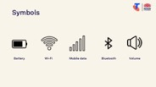 | Say:  - On both computers and tablets, you’ll see little symbols — sometimes at the top or bottom of the screen. These are shortcuts that tell you important things, like whether your battery is running low or if you’re connected to Wi-Fi. Let’s look at some of the most common ones.  - Battery – shows how much power you have left.  - Wi-Fi – shows if you’re connected to the internet. The more curved bars you see, the stronger the signal.  - Mobile data (tablets with SIM cards only) – shows if you’re connected through a mobile network (4G or 5G).  - Bluetooth – shows if Bluetooth is on (used for wireless accessories).  - Volume/sound – shows if the sound is muted, low, or loud.  Transition:  - Now that you know what these symbols mean, you’ll feel more confident when you see them pop up.
Opening programs and apps  15 min   | Say:  - Your device comes with lots of different programs or apps. Each one has its own job — like sending emails, browsing the internet, or playing music. Let’s practice how to open one up, and then how to close it again when you’re done.  Demonstrate on a computer:  - Click on an icon on the desktop/dock or in the Start menu to open.  - Explore the app using the navigation techniques.  - Click the “–” in the corner to minimise, then use the taskbar at the bottom to switch between open programs.  - Click the “X” in the corner to close.  Demonstrate on a tablet:  - Tap an app icon to open.  - Explore the app using the navigation techniques.  - Swipe up from the bottom (or press the Home button) to return to the home screen.  - Swipe up and hold (on most tablets) to see all open apps, then swipe away to close.  - Swipe up from the bottom of the screen to open the App Drawer to see all apps.  Try it:  - Guide learners to perform tasks - opening and closing multiple apps.  Transition:  - Well done — you’ve learned how to move around, open things up, and return home. Next, let’s explore how to adjust the settings.
  Extension activities
  - Can you find the following apps?
  Calculator, calendar, contacts, internet browser (Google Chrome/Firefox/ Edge/Safari), emails (Mail/Outlook), music, notes, photos, weather.

6. Adjust settings (15 min)
Overview
Purpose:
- Adjust basic settings like brightness, text size and volume
Timing breakdown | Content
Adjust settings  15 min  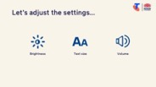 | Say:  - Every device comes with default settings, but you’ll need to change your settings in different situations. For example, brighten the screen if you’re near a sunny window, make the text bigger if it’s hard to read, or turn the volume up when watching a video or on a call. The good news is these settings are easy to adjust — and you can always change them back.  Demonstrate on a computer, then tablet:  - Brightness:  - Use the function keys (look for sun symbols) or go to Settings > Display.  - Text size:  - Windows: Go to Settings > Accessibility (Ease of Access) and increase text size or zoom level.  - OS: Go to Settings > Accessibility > Text Size.  - Volume:  - Computer: Use the function keys (look for speaker symbols), or use the volume buttons on the desktop (typically top right or bottom right).  - Tablet: Use side volume buttons and Settings > Sounds.  Try it:  - Guide learners to perform tasks.  Demonstrate how to change the passcode on a computer, then tablet.  Try it:  - Guide learners to change their device’s password:  OS: System Settings > Login Password  Windows: Accounts > Sign-in options  Transition:  - Great work! You’ve just learned how to make your device fit your needs — brighter, louder, or easier to read. Next, let’s spend some time on the questions and goals you raised at the start of today’s session.
  Extension activities:
  - Change the wallpaper or background image to make the device feel personal
  macOS: System Settings > Wallpaper
  Windows: Settings > Personalisation > Background
  - Change the appearance settings
  macOS: System Settings > Appearance
  Windows: Settings > Personalization
  - Change date and time settings
  macOS: System Settings > General > Date & Time
  Windows: Settings > Time & language > Date & time
  - Use virtual assistants:
  iPadOS:
  - Turn of Siri: Settings > Siri > Talk to Siri
  - Use Siri: Siri (say ‘Hey Siri’ or long-press the home or top button)
  MacOS:
  - Turn on: System Settings > Apple Intelligence & Siri > turn on Siri
  - Use Siri: Select the Siri button in the menu bar, press and hold the microphone button, or say ‘Hey Siri’
  Android: Google Assistant (say ‘Hey Google’ or long-press the home button)
  Computer:
  - Pin apps or shortcuts to Windows Start Menu (Windows only): Start menu > type the app you want to pin > right-click on the app > select Pin to Start
  - Add, remove or rearrange Dock items (macOS only):
  Add: Drag apps to the left side of (or above) the line that separates the recently used apps.
  Remove: Drag the app out of the Dock until Remove is shown.
  Rearrange: Drag and drop apps.
  - Change Desktop & Dock settings (OS only): System Settings > Desktop & Dock
  Tablet:
  - Test the torch/flashlight, if available
  iPadOS: Control centre > Flashlight
  - Move and groups apps/widgets on home screen: Touch and hold the app > drag and drop to location or group (Android and iPadOS)
10 min | Break

7. Built in flexibility (25 min)
Overview
Purpose:
- To address the questions and skills learners were hoping this session covers
- To practice skills
- If time and learner confidence allow, introduce one or more extension activities from earlier sections
Timing breakdown | Content
Flexible time  25 min   | Facilitator note:  - If learners identified additional questions or topics in the Welcome section:  - Refer to the list you captured  - Say: “Let’s go through the things you said you most wanted to learn today. I’ll demonstrate each one, and then you’ll have a go.”  - If some learners would prefer to focus on practicing instead, divide the group accordingly  - If there are no further learner questions, recap key skills:  - Turning the device on/off, and unlocking  - Navigating  - Adjusting settings  - If time and learner confidence allow, introduce extension activities covered earlier in the session  Transition:  - Let’s wrap up by reflecting on what you’ve learned today and planning your next steps.
  Extension activities:
  - Can you find the following apps?
  Calculator, calendar, contacts, internet browser (Google Chrome/Firefox/ Edge/Safari), emails (e.g. Mail/Outlook), music, notes, photos, weather.
  - Change the wallpaper or background image to make the device feel personal
  OS: System Settings > Wallpaper
  Windows: Settings > Personalization > Background
  - Change the appearance settings
  OS: System Settings > Appearance
  Windows: Settings > Personalization
  - Change date and time settings
  OS: System Settings > General > Date & Time
  Windows: Settings > Time & language > Date & time
  - Use virtual assistants:
  iPadOS:
  - Turn of Siri: Settings > Siri > Talk to Siri
  - Use Siri: Siri (say ‘Hey Siri’ or long-press the home or top button)
  MacOS:
  - Turn on: System Settings > Apple Intelligence & Siri > turn on Siri
  - Use Siri: Select the Siri button in the menu bar, press and hold the microphone button, or say ‘Hey Siri’
  Android: Google Assistant (say ‘Hey Google’ or long-press the home button)
  Computer:
  - Pin apps or shortcuts to Windows Start Menu (Windows only): Start menu > type the app you want to pin > right-click on the app > select Pin to Start
  - Add, remove or rearrange Dock items (OS only):
  Add: Drag apps to the left side of (or above) the line that separates the recently used apps.
  Remove: Drag the app out of the Dock until Remove is shown.
  Rearrange: Drag and drop apps.
  - Change Desktop & Dock settings (OS only): System Settings > Desktop & Dock
  Tablet:
  - Test the torch/flashlight, if available
  iPadOS: Control centre > Flashlight
  - Move and groups apps/widgets on home screen: Touch and hold the app > drag and drop to location or group (Android and iPadOS)

8. Wrap up (20 min)
Overview
Purpose:
- Consolidate learning and celebrate progress.
- Demonstrate scanning QR codes on the Learning Canvas for trusted follow‑up resources.
- Set a simple action for the week and signpost support.
Timing breakdown | Content
Reflection  10 min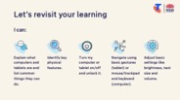     | Say:  - We’ve covered some key information and skills in using your computer or tablet. Let’s take a moment to celebrate what you’ve learned and record it so you can refer back to it later.  Say:  - Let’s revisit your Learning Canvas - tick the skills you can do.  Ask:  - What’s your key takeaway from today’s session?  Learners note reflections on their Learning Canvas. Invite responses.  - What three things will you try in the next week?  E.g. share what you learned with someone, change settings, change appearance and wallpaper.  Learners note actions on their Learning Canvas. Invite responses.
Support  10 min   | Say:  - There are QR codes on the back of your Learning Canvas that provide more information online.  - There’s a lot of information online, so don't feel you need to access it. We’ll cover lots more in our Tech Savvy Seniors program.  - But being able to scan a QR code is a handy skill. A QR code is a visual link to a website. It saves you from needing to type the URL/web address into your browser. So, let’s practice today’s final skill!  Demonstrate how to:  - Scan QR code (Open the Camera > point at QR code on Canvas > tap the link)  Try it:  - Guide learners to scan the QR codes on the back of the Learning Canvas.  Explain:  - Where learners can go for support (e.g. 1:1 help at the library, tech groups, or other programs).  Learners note support on Learning Canvas.  - Show Tech Savvy Seniors program and provide the schedule for upcoming sessions.  Say:  - Well done! You’ve all achieved something new today. Keep practising little and often. We look forward to seeing you at another session.

