Tech Savvy Seniors
Module 12
Discover what AI can do for you
Session plan

Table of contents
Session overview 3
Learning architecture 3
Learning outcomes 3
Resources checklist 4
Session summary 5
Session plan 6
1. Welcome (10 min) 6
2. What is AI? (5 min) 7
3. Everyday examples of AI (30 min) 8
4. Try a voice assistant and chatbot (40 min) 10
5. AI tools – risks, tips and safety (10 min) 13
6. Built in flexibility (25 min) 14
7. Wrap up (20 min) 15

Session overview
This 2–2.5-hour introduces older Australians to artificial intelligence (AI) in everyday life. Learners will discover what AI is, explore examples they might already use (like voice assistants and online suggestions), and practise trying simple AI tools such as Siri, Google Assistant/Gemini, or ChatGPT.

Learning architecture
This module forms part of a 12-module series.
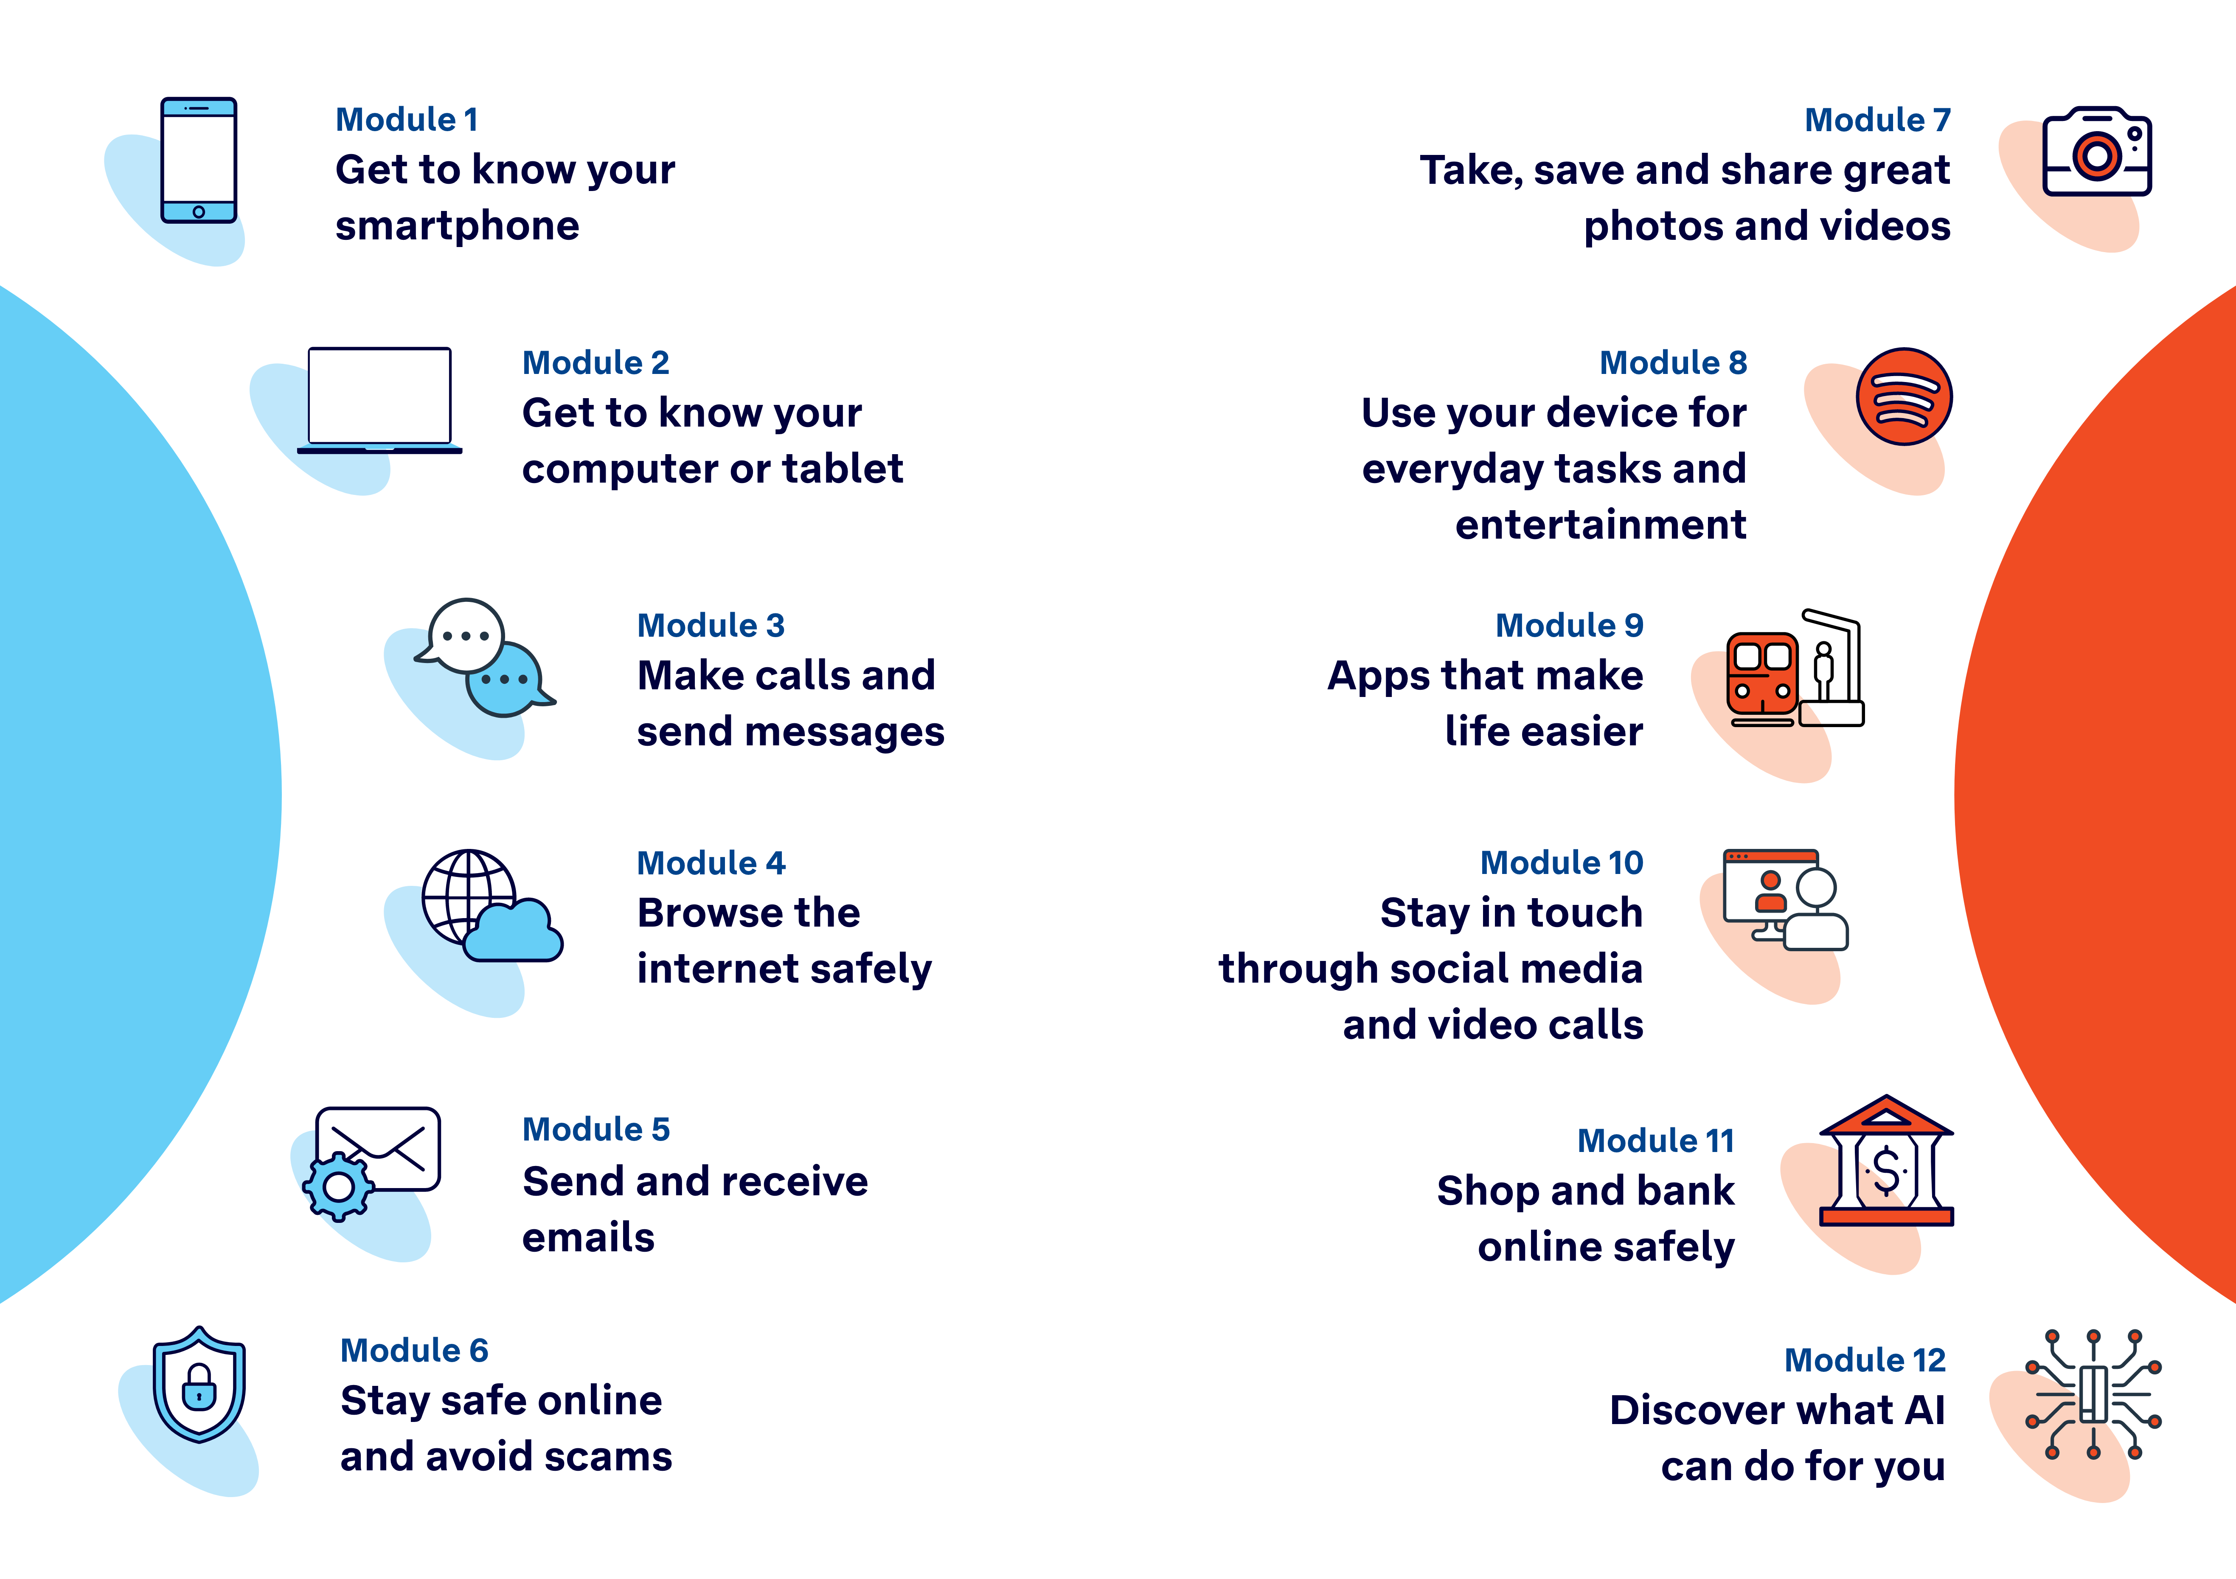

Learning outcomes
At the end of this session, learners will be able to:
- Explain what artificial intelligence (AI) means in simple terms.
- Identify examples of AI in apps and everyday tasks.
- Use a voice assistant and chatbot to ask a question.
- Explain AI risks and safety tips.

Resources checklist
This session requires the following resources:
☐ | Session plan (this document)
☐ | PowerPoint presentation
☐ | Learning Canvas - printed (one per learner)
☐ | Pens for learners (one per learner)
☐ | Butchers paper/markers or a whiteboard/markers may be useful to assist with capturing ‘learning goals’ which will be touched on throughout the session
☐ | Library’s Wi-Fi password
☐ | Tech Savvy Seniors program schedule - printed (one per learner)
☐ | Learners’ own device (smartphone, tablet or computer)
☐ | Internet-connected smartphones, tablets or computers (as available)
☐ | Facilitator’s computer for demonstrations
☐ | Projector and screen (optional)

Session summary
This session summary provides an overview of topics, the activities relevant to each topic and the duration.

Duration | Topic | Useful links
10 min | 1. Welcome
5 min | 2. What is AI?
30 min | 3. Everyday examples of AI
10 min | Break
40 min | 4. Try a voice assistant and a chatbot | - ChatGPT.com
10 min | 5. AI tools: tips and safety | - CSIRO’s AI Explained: It's maths, not magic (a simple guide)
10 min | Break
25 min | 6. Built in flexibility
20 min | 7. Wrap up
Total duration: 2.5 hours

Session plan

1. Welcome (10 min)
Overview
Purpose:
- Introduce Module 12: Discover what AI can do for you, including the flow (short demos + practice)
- Set a safe, calm tone; reduce anxiety about ‘pressing the wrong thing’
- Introduce the Learning Canvas as a personal guide they can use during the session and take home
- Gather learner goals to tailor the ‘Built‑in flexibility’ section later
Timing breakdown | Content
Session overview  10 min    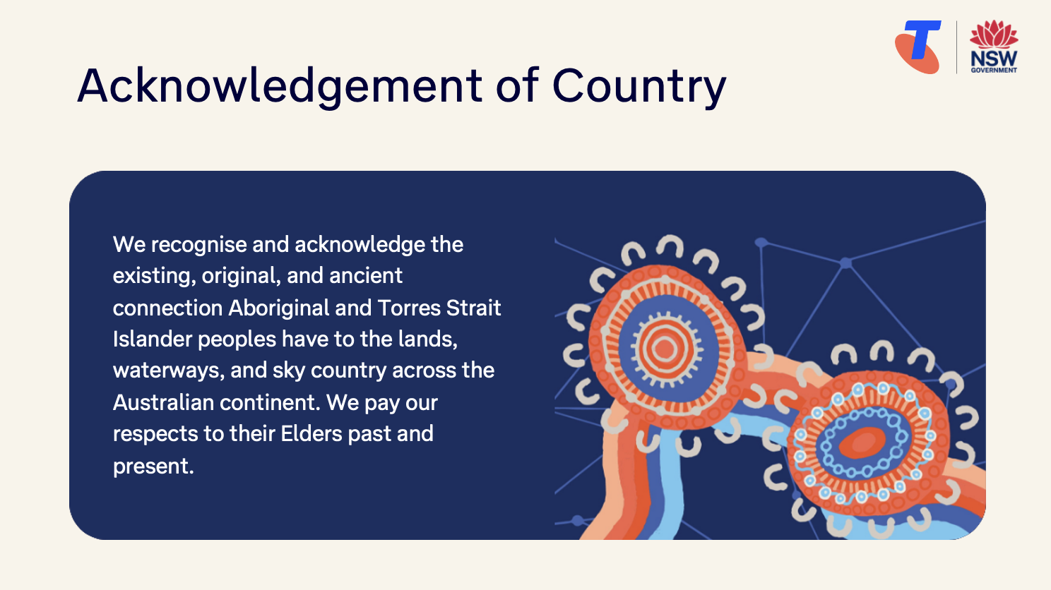  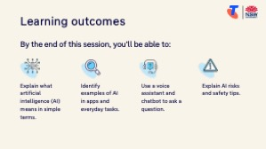     | On arrival, ensure each learner has a device, printed Learning Canvas and pen. Group learners by device so they can support each other.  Deliver: An Acknowledgement of Country.  Say:  - Welcome! Today we’re going to explore a topic that’s been in the news a lot lately — artificial intelligence, or AI.  - While AI might sound like something futuristic, it’s already built into everyday tools — like when your phone suggests words as you type, helps you search faster, or gives you directions. We’ll learn what AI means in simple terms, look at how it’s being used in common apps and websites, and try asking questions using tools like Siri or a chatbot like ChatGPT.  - Before we touch anything, let’s agree: it’s fine to make mistakes. That’s how we learn.  - By the end of this session, you’ll be able to:  - Explain what artificial intelligence (AI) means in simple terms.  - Identify examples of AI in apps and everyday tasks.  - Use a voice assistant and chatbot to ask a question.  - Explain AI risks and safety tips.  Introduce Learning Canvas:  - Use your printed Learning Canvas to write notes in your own words, tick off skills as you learn them, and highlight what feels most useful to you. Writing things down helps you remember and understand them better, and makes it easier to recall later. Take your Canvas home to keep practising. On the back, you’ll find extra tips and trusted links if you want to explore more.  Ask:  - Has anyone heard of the term AI or artificial intelligence? What do you know about it?  - What’s one thing you’d like to feel more confident about by the end of today?  (Write answers on a whiteboard or butchers paper. These will help shape the ‘Built-in Flexibility’ section later in the session.)  Confirm everyone has a device; pair anyone without.  Transition:  - Let’s begin by learning what AI actually means and how it works behind the scenes in tools you might already use.

2. What is AI? (5 min)
Overview
Purpose:
- Help learners understand the concept of artificial intelligence (AI).
Timing breakdown | Content
What is email?  5 min     | Say:  - You’ve probably heard the term “AI” before — it stands for Artificial Intelligence.  - AI is the ability of a computer system to perform tasks that would normally require human intelligence, such as learning, reasoning, and making decisions.  - AI doesn’t think like a human — instead it uses data and patterns to decide what to do next. The key point: you don’t need to be a tech-expert to use it, just familiar with how it works in everyday life.  - AI is already helping in many different areas:  - In healthcare, AI can assist doctors by analysing scans, spotting patterns like early signs of disease, or helping manage repetitive administrative tasks so clinicians have more time with patients.  - In financial services and banking, AI is used to detect fraud or unusual transactions quickly.  - In everyday apps, you might see AI when your phone suggests the next word, or when you ask for directions and the map recalculates around traffic.  - Because AI can process large amounts of information quickly, it helps us save time and can help organise complex tasks or data.  - At the same time, we must remember AI has limits — and that we’ll talk more about those shortly  - AI is already built into many tools we use, but we don’t always realise it’s there.  Ask:  - When you hear the word “AI”, what comes to mind?  Transition:  - Now that we’ve looked at what AI means, let’s explore some real-life ways it’s being used, and where you might already be seeing it.

3. Everyday examples of AI (30 min)
Overview
Purpose:
- Help learners recognise how AI already appears in tools they use.
Timing breakdown | Content
Everyday examples of AI  30 min  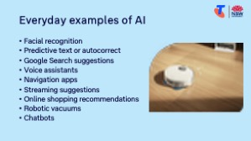 | Say:  - Even if you haven’t used a tool labelled “AI,” it’s likely you’ve already come across it.  - AI is built into lots of everyday technology to make things easier — sometimes without us even realising.  Explain examples:  - Facial recognition: A way to unlock your smartphone/tablet. Your device maps your facial features during your device setup or in your settings and stores it on your device. When you try to unlock your device, it compares your face to this stored template — if they match, the device unlocks.  Demonstrate using smartphone/tablet.  Ask: Who uses facial recognition already? Did you know it’s AI?  - Predictive text or autocorrect: When your phone suggests the next word or corrects spelling while you type a message.  Demonstrate by typing a short message and showing how the phone suggests or corrects words.  - Google Search suggestions: As you type in the search bar, AI helps by guessing what you’re looking for.  Demonstrate this live using a browser: type "chicken soup" or "weather in..." and point out the predictions.  - Voice assistants (e.g. Google Assistant/Gemini (Google Gemini is replacing Google Assistant) or Siri): AI allows these tools to understand voice commands.  Demonstrate on a phone or tablet by saying: "What’s the weather today?" or "Set a timer for 1 minute."  - Navigation apps (e.g. Google Maps): AI can estimate travel time and reroute based on traffic.  Demonstrate by putting a destination into Google Maps and showing various routes, estimates times, and orange/red areas indicating heavy traffic.  - Streaming suggestions: Netflix, YouTube or Spotify suggest videos or songs based on what you’ve watched or listened to before.  Demonstrate by showing a YouTube homepage and point out "Recommended for you" videos.  - Online shopping recommendations: Sites like eBay or Amazon show you related products based on your searches  Demonstrate by browsing a common item on a store’s website and pointing out the “You may also like” section.  - Robotic vacuums: Many robotic vacuums use AI to map your home and plan efficient cleaning routes. They learn where furniture is, avoid obstacles, and adjust based on floor type.

Timing breakdown | Content
  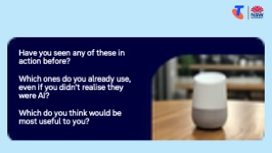 | - Chatbots (e.g. website help chats, ChatGPT): Chatbots are programs that can answer typed questions.  - Many websites —like Telstra, Centrelink, or your bank — use chatbots to answer common questions. These are built to answer simple customer questions, like “How do I pay my bill?” or “Where’s my nearest store?” Sometimes they’re used at the beginning of a conversation to determine the right customer service representative to put you through to.  - Some chatbots, like ChatGPT, are designed for broader conversations. These can do more — they can help write a message, plan a trip, or explain a topic. Some can create images, audio and video.  - Both types use similar technology, but one is trained to answer only certain questions (like on a website), and the other can cover many topics.  - These tools have become very popular in recent years and are often what people mean when they say they’ve “used AI.”  - We’ll practise using ChatGPT later in this session, so let’s take a look at a website chatbot.  - Demonstrate by going to https://www.telstra.com.au/chatnow/landing, scrolling down to ‘Not yet a customer?’ and selecting Chat now.  - Ask:  - What question might Telstra Assistant be able to answer? (Test these out in Telstra’s chatbot.)  - What questions would be better suited to ChatGPT?  Ask:  - Have you seen any of these in action before?  - Which ones do you already use, even if you didn’t realise they were AI?  - Which do you think would be most useful to you?  Transition:  - Let’s now try out one of these tools — a voice assistant and a chatbot — and see how we can use AI to ask questions or get help.
10 min | Break

4. Try a voice assistant and chatbot (40 min)
Overview
Purpose:
- Practice asking questions to a voice assistant.
- Practice using a chatbot like ChatGPT.
Timing breakdown | Content
Voice assistant  20 min  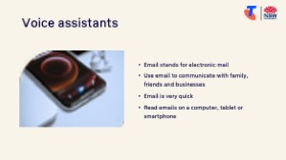 | Say:  - Let’s now try using some AI tools for ourselves.  - We’ll start with voice assistants like Google Assistant/Gemini or Siri, then try typing a question into a chatbot.  Explain:  - Most smartphones and tablets come with a built-in voice assistant:  - Android devices usually have Google Assistant/Gemini (Google Gemini is replacing Google Assistant, as it is more capable with complex tasks)  - Apple devices have Siri  - You can also buy home-based voice assistants like Google Nest or Amazon Alexa, which respond to voice commands and can play music, tell the weather, or control smart home devices (e.g. lights, TVs).  - You can ask them questions like:  - “What’s the weather today?”  - “What’s the capital of New Zealand?”  - “What’s the time in Perth?”  - “How do I get to the nearest chemist?”  - “What does marsupial mean?”  - They can also do simple tasks for you, depending on the devices they’re connected to (phone, lights, TV). Your phone might be able to:  - “Call [contact name].”  - “Set a timer for 10 minutes.”  - “Remind me to take my medicine at 4pm.”  Demonstrate how to activate the voice assistant and ask a question/request:  - On Android: Hold the home button (or swipe up from the bottom corner) or say “Hey Google.” Some devices may need Google Assistant/Gemini enabled in settings.  - On Apple devices: Hold the side or home button (depending on model) or say “Hey Siri.” Make sure Siri is turned on in Settings > Siri & Search.  - Ask a question aloud and show how the device responds.

Timing breakdown | Content
Try it:
- Guide learners to use voice assistant on their device and explore what it can do. Tasks might include (but will be dependent on apps installed):
- Set recurring reminders (e.g. “Remind me to take my blood pressure tablet every morning at 9am”)
- Add something to a shopping list (e.g. “Add milk to my shopping list”)
- Check the news or weather (e.g. “What’s the latest ABC News?” or “Will it rain tomorrow?”)
- Ask fun or curious questions (e.g. “What’s a fun fact about Australia?”, “Play 1960s music”)
- Use a timer or alarm (e.g. “Wake me at 7am tomorrow”)
- Play a radio station or podcast (“Play ABC Radio” or “Play a podcast about gardening”)
Ask:
- Was the response helpful?
- Would you feel comfortable trying this at home?
- How could this be useful in your daily life?
ChatGPT  20 min  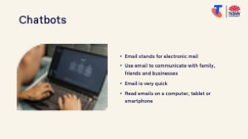 | Say:  - Now let’s try a chatbot — this is what many people think of when they hear “AI.”  - ChatGPT is a popular example. You can type a question or prompt, and it will reply in plain English.  - These tools are very powerful, but they don’t always get things right — so always check important information elsewhere.  Demonstrate:  - Use ChatGPT (chatgpt.com) on a shared screen.  - Type and show the responses to questions like:  - “Give me 3 simple exercises I can do at home.”  - “Write a birthday message for my 5-year-old granddaughter.”  - “What are some tips for saving money on groceries?”  - “Help me plan a 5-day trip in the Hunter Valley.”  - “What are 5 fun facts about Australia?”  - “Explain how to grow tomatoes in Sydney.”  - “Write a bedtime story for my 4-year-old grandson about dragons.”  - “Create a cartoon image of a dog.” (Show how to use follow-up questions to edit the image.)  Try it:  - Guide learners to use ChatGPT on their device.

Timing breakdown | Content
Extension activities:
Explore other AI capabilities demonstrated earlier, including:
- Facial recognition
- Predictive text or autocorrect
- Google Search suggestions
- Navigation apps (e.g. Google Maps)
- Streaming suggestions (e.g. YouTube)
- Online shopping recommendations
Ask:
- Was the response helpful?
- Would you feel comfortable trying this at home?
- How could this be useful in your daily life?
Transition:
- Now that we’ve tried using AI tools ourselves, let’s talk about how to use them safely and what to be mindful of.

5. AI tools – risks, tips and safety (10 min)
Overview
Purpose:
- Help learners understand the limits of AI, how to use it responsibly, and how to stay safe and in control.
Timing breakdown | Content
AI tools – risks and safety tips  10 min  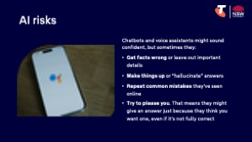    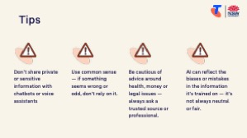 | Say:  - AI tools can be helpful, but it’s important to know what they can and can’t do. Unlike people, AI tools don’t truly “understand” – they use patterns to guess what might be helpful.  - Chatbots and voice assistants might sound confident, but sometimes they:  - Get facts wrong or leave out important details  - Make things up or “hallucinate” answers  - Repeat common mistakes they’ve seen online  - Try to please you. That means they might give an answer just because they think you want one, even if it’s not fully correct  - You should always double-check information, especially for health, legal or financial topics.  (Optional) Watch:  - CSIRO’s AI Explained: It's maths, not magic (a simple guide)  Explain additional risks:  - Fake content (deepfakes): AI can create realistic but fake videos, photos or voices. These are sometimes used in scams.  - Misinformation: AI may repeat things it’s seen online that are incorrect or misleading, or completely make things up. You’ll often see news headlines where people haven't checked AI’s outputs and have been caught out! (Refer to recent news story.)  - Bias: Because AI learns from data written by humans, it can copy or reinforce stereotypes or unfair assumptions.  Explain tips:  - Don’t share private or sensitive information with chatbots or voice assistants.  - Use common sense — if something seems wrong or odd, don’t rely on it.  - Be cautious of advice around health, money or legal issues — always ask a trusted source or professional.  - AI can reflect the biases or mistakes in the information it’s trained on — it’s not always neutral or fair.  Transition:  - We’ve now seen the positives and limits of AI. After a quick break, we’ll spend time on your questions and goals from earlier.
10 min | Break

6. Built in flexibility (25 min)
Overview
Purpose:
- To address the questions and skills learners were hoping this session covers
- To practice skills
- If time and learner confidence allow, introduce one or more extension activities from earlier sections
Timing breakdown | Content
Flexible time  25 min   | Facilitator note:  - If learners identified additional questions or topics in the Welcome section:  - Refer to the list you captured  - Say: “Let’s go through the things you said you most wanted to learn today. I’ll demonstrate each one, and then you’ll have a go.”  - If some learners would prefer to focus on practicing instead, divide the group accordingly  - If there are no further learner questions, recap key skills.  - If time and learner confidence allow, introduce extension activities covered earlier in the session  Transition:  - Let’s wrap up by reflecting on what you’ve learned today and planning your next steps.
  Extension activities:
  Explore other AI capabilities demonstrated earlier, including:
  - Facial recognition
  - Predictive text or autocorrect
  - Google Search suggestions
  - Navigation apps (e.g. Google Maps)
  - Streaming suggestions (e.g. YouTube)
  - Online shopping recommendations

7. Wrap up (20 min)
Overview
Purpose:
- Consolidate learning and celebrate progress.
- Demonstrate scanning QR codes on the Learning Canvas for trusted follow‑up resources.
- Set a simple action for the week and signpost support.
Timing breakdown | Content
Reflection  10 min  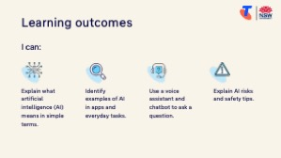 | Say:  - We’ve covered some key information and skills in using AI. Let’s take a moment to celebrate what you’ve learned and record it so you can refer back to it later.  Say:  - Let’s revisit your Learning Canvas - tick the skills you can do.  Ask:  - What’s your key takeaway from today’s session?  Learners note reflections on their Learning Canvas. Invite responses.  - What three things will you try in the next week?  E.g. share what you learned with someone, use voice assistant to make a call/send a text/check the weather, use ChatGPT to write a letter/answer a question/ask for recommendations.  Learners note actions on their Learning Canvas. Invite responses.
Support  10 min   | Explain:  - Where learners can go for support (e.g. 1:1 help at the library, tech groups, or other programs).  Learners note support on Learning Canvas.  - Show Tech Savvy Seniors program and provide the schedule for upcoming sessions.  Say:  - Well done! You’ve all achieved something new today. Keep practising little and often. We look forward to seeing you at another session.

