Tech Savvy Seniors
Module 11
Shop and bank online safely
Session plan

Table of contents
Session overview 3
Learning architecture 3
Learning outcomes 3
Resources checklist 4
Session summary 5
Session plan 6
1. Welcome (10 min) 6
2. Shopping online (40 min) 7
3. Recognise safe payments and scam signs (20 min) 10
4. Online banking (25 min) 13
5. Built in flexibility (25 min) 16
6. Wrap up (20 min) 17

Session overview
This 2–2.5-hour session introduces safe, practical ways to shop and bank online. Learners will practise searching for items on shopping websites, spotting secure payment methods, and recognising scams or fake stores.
The session also includes a guided walkthrough of online banking (view only), showing how to access an account, check balances and use security features — without needing to log in themselves.
The focus is on building digital confidence and helping learners feel in control when handling money online.

Learning architecture
This module forms part of a 12-module series.
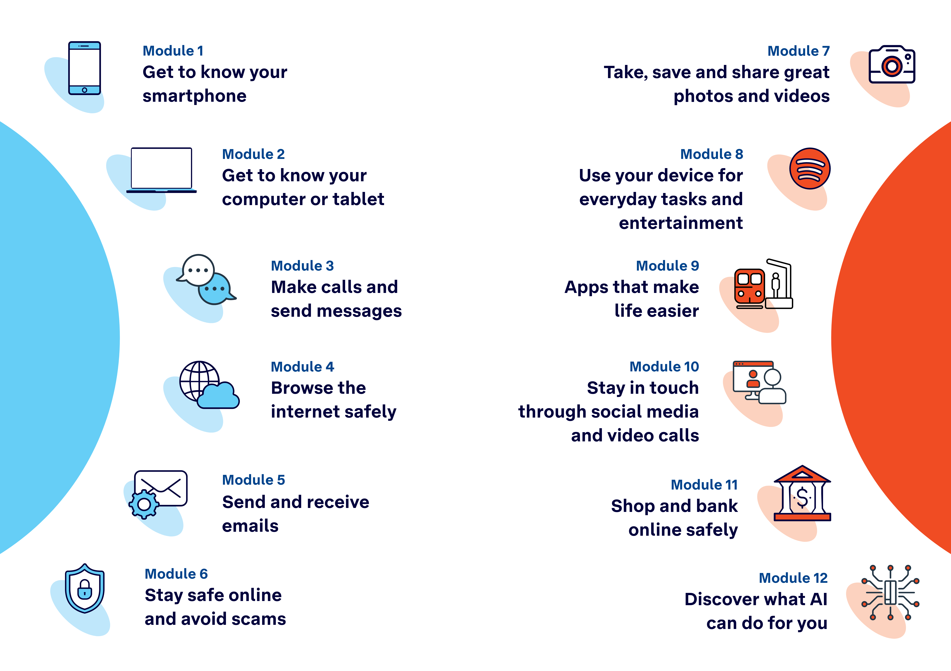

Learning outcomes
At the end of this session, learners will be able to:
- Navigate online shops and search for items.
- Explain what makes a payment method or page secure.
- Recognise signs of a scam or fake store.
- Access online banking safely (view only).

Resources checklist
This session requires the following resources:
☐ | Session plan (this document)
☐ | PowerPoint presentation
☐ | Learning Canvas - printed (one per learner)
☐ | Pens for learners (one per learner)
☐ | Butchers paper/markers or a whiteboard/markers may be useful to assist with capturing ‘learning goals’ which will be touched on throughout the session
☐ | Library’s Wi-Fi password
☐ | Tech Savvy Seniors program schedule - printed (one per learner)
☐ | Learners’ own device (smartphone, tablet or computer)
☐ | Internet-connected smartphones, tablets or computers (as available)
☐ | Facilitator’s computer for demonstrations
☐ | Projector and screen (optional)

Session summary
This session summary provides an overview of topics, the activities relevant to each topic and the duration.

Duration | Topic | Useful links
10 min | 1. Welcome
40 min | 2. Shopping online
10 min | Break
20 min | 3. Recognise safe payments and scam signs
25 min | 4. Online banking | https://demo.bendigobank.com.au/banking/accounts
10 min | Break
25 min | 5. Built in flexibility
20 min | 6. Wrap up | - iPhone: Scan a QR code with your iPhone or iPad  - Android: How do you scan QR codes on Android?
Total duration: 2.5 hours

Session plan

1. Welcome (10 min)
Overview
Purpose:
- Introduce Module 11: Shop and bank online safely (short demos + practice)
- Set a safe, calm tone; reduce anxiety about ‘pressing the wrong thing’
- Introduce the Learning Canvas as a personal guide they can use during the session and take home
- Gather learner goals to tailor the ‘Built‑in flexibility’ section later
Timing breakdown | Content
Session overview  10 min    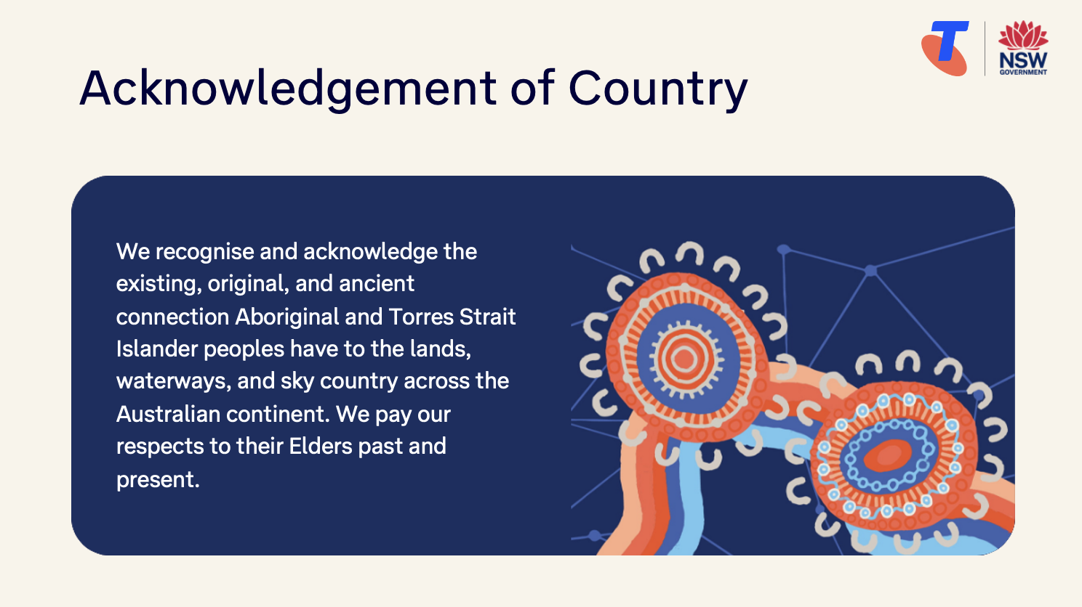  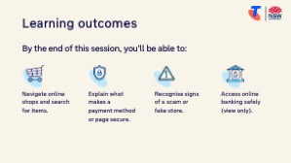  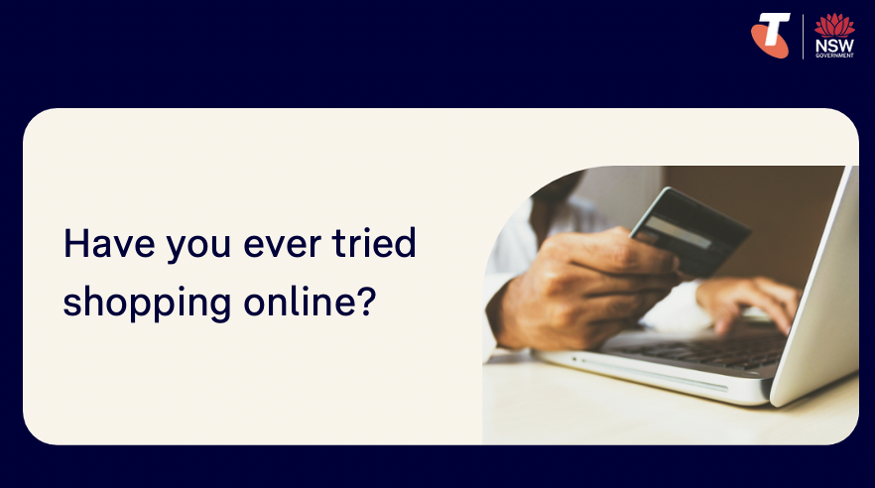     | On arrival, ensure each learner has a device, printed Learning Canvas and pen. Group learners by device so they can support each other.  Deliver: An Acknowledgement of Country.  Say:  - Welcome! Today we’re going to talk about how to shop and bank safely online.  - We’ll look at how to find trusted websites, search for products, and recognise when a payment page is secure. We’ll also learn how online banking works — things like checking your balance or viewing past transactions — but don’t worry, you won’t need to log in to your own account today.  - Our goal is to help you feel more confident and in control when using the internet for shopping or banking.  - Before we touch anything, let’s agree: it’s fine to make mistakes. That’s how we learn.  - By the end of this session, you’ll be able to:  - Navigate online shops and search for items.  - Explain what makes a payment method or page secure.  - Recognise signs of a scam or fake store.  - Access online banking safely (view only).  Introduce Learning Canvas:  - Use your printed Learning Canvas to write notes in your own words, tick off skills as you learn them, and highlight what feels most useful to you. Writing things down helps you remember and understand them better, and makes it easier to recall later. Take your Canvas home to keep practising. On the back, you’ll find extra tips and trusted links if you want to explore more.  Ask:  - Have you ever tried shopping online?  - Have you ever used internet banking — even just to check a balance?  - What’s one thing you’d like to feel more confident about by the end of today?  (Write answers on a whiteboard or butchers paper. These will help shape the ‘Built-in Flexibility’ section later in the session.)  Confirm everyone has a device; pair anyone without.  Transition:  - Let’s begin by learning what email is.

2. Shopping online (40 min)
Overview
Purpose:
- Explain what online shopping means in clear, practical terms.
- Show learners how to find and browse a trusted online shop.
- Practise searching for an item, viewing product details, and comparing options.
- Explain click and collect, delivery, and secure checkout basics (no purchases made).
Timing breakdown | Content
What is online shopping?  5 min  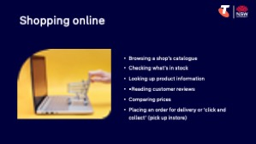  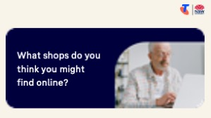  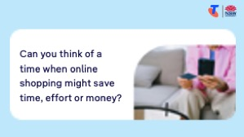 | Say:  - Let’s start with the basics. Today we’re going to explore two useful everyday activities you can do online — shopping and banking.  - These aren’t new ideas, but the way we do them has changed a bit over time. Using the internet, you can now check prices, order groceries, or pay a bill — all from home, if you want to.  - Even if you prefer going into a shop or branch, it’s helpful to know what your options are, so you can choose what suits you best.  Explain online shopping:  - Online shopping means using a website or app to look for or buy items. This might include:  - Browsing a shop’s catalogue  - Checking what’s in stock  - Looking up product information  - Reading customer reviews  - Comparing prices  - Placing an order for delivery or click and collect (pick up instore)  - Most shops have online stores on their website. You can shop online for:  - Groceries  - Household items  - Clothing and gifts  - Pharmacy items  - Some people place orders online for home delivery, or to ‘click and collect’ (buy online and pick up in-store).  - Others use websites to compare prices, check stock, or read product details before going into the physical store.  Ask:  - What shops do you think you might find online? (Brainstorm - Woolworths, Target, Chemist Warehouse, Bunnings, Harvey Norman, PetBarn, etc.)  - Can you think of a time when online shopping might save time, effort or money?

Timing breakdown | Content
Shopping online  35 min | Say:  - Let’s now take a closer look at how online shopping works. We’ll practise searching for a product on a trusted website and looking at the information that’s shown — like product details, reviews, and prices.  - We’re not going to buy anything — we’re just practising how it works.  Explain:  - If you want to shop from a particular store, you can go directly to their website or download their app.  Demonstrate how to browse via the shop’s website:  - Open the website in a browser (e.g. www.chemistwarehouse.com.au)  - Use the search bar to type in a common item (e.g. “sunscreen”)  - Scroll through the results  - Tap on a product to view details — price, size, reviews, click and collect availability, shipping price, how to find store availability  Explain: Online shops work a bit like supermarkets — you can add things to a cart as you go, and then check out at the end.  Demonstrate how to add to cart:  - Tap Add to Cart (or “Add to Bag”) on a product  - Tap the Cart icon (often top right of the screen)  - Show what appears in the cart:  - Product name and size  - Quantity  - Price  - Total so far  - Point out that no login or payment is required just to browse - only when you check out  Demonstrate how to check out (view only – do not enter real info):  - From the cart, tap Checkout or Proceed to Checkout  - Show typical steps:  - Delivery or collection option  - Shipping fees (note: these often appear here, not earlier)  - Payment section (explain common options: card, PayPal, gift card, discount code)  Try it:  - Guide learners to browse shops online.  Explain:  - If you’re unsure what store has the product you’re looking for, or you want to compare prices, you can search for the it using a search engine like Google.

Timing breakdown | Content
Demonstrate how to shop using Google’s Shopping tab:
- Open Google
- Type the product name into the search bar (e.g. “La Roche Posay Anthelios Invisible Fluid SPF 50+ 50ml”)
- Tap the Shopping tab near the top
- Compare results from multiple stores, noting to check the product size and consider shipping costs
- Tap a result to view the item on that store’s website
Try it:
- Guide learners to compare products online.
Extension activities:
- Use filters – Explore how to narrow search results by brand, price range, size or customer rating
- Check in-store availability – Where available, use the postcode or store selector to see if an item is available locally
- Compare delivery options – Review differences between standard, express, and click & collect shipping
- Read and compare reviews – Look at 2–3 different customer reviews for the same product. What do people like or complain about?
- Use the “Save for later” or “Wishlist” feature – If the shop allows it, try saving an item for easy access later (you’ll need to create an account first)
- Look for return or refund policies – Scroll down and find the shop’s return policy
Transition:
- Now let’s learn about how to check a shop is safe.
10 min | Break

3. Recognise safe payments and scam signs (20 min)
Overview
Purpose:
- Show learners how to tell if a payment page or method is secure.
- Explain common red flags that suggest a scam or fake website.
- Teach practical tips for staying safe when entering payment or personal information.
Timing breakdown | Content
Recognise safe payments and scam signs  10 min  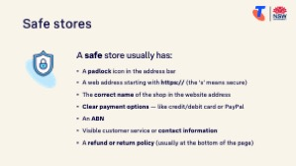  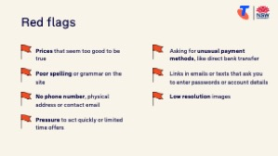 | Say:  - Earlier, we looked at how the checkout process works when shopping online. You may remember we stopped at the point where the website asked for delivery details and payment options.  - Now, let’s take a closer look at what makes a payment page safe, and how to spot the warning signs of a scam.  Demonstrate how to check if the site is trustworthy before entering your payment details:  - A padlock icon in the address bar  - A web address starting with https:// (the ‘s’ means secure)  - The correct name of the shop in the website address  - An ABN (check it on ABN look up: ABN Lookup (business.gov.au))  - Clear payment options — like credit/debit card, PayPal, or gift card  - Visible customer service or contact information  - A refund or return policy (usually at the bottom of the page)  Say:  - If you're ever unsure, don’t continue. It's always okay to stop, ask someone for help, or double-check before paying. You’re in control.  Explain common signs of scams or unsafe sites:  - Prices that seem too good to be true  - Poor spelling or grammar on the site  - No phone number, physical address or contact email  - Pressure to act quickly or limited time offers  - Asking for unusual payment methods, like direct bank transfer  - Links in emails or texts that ask you to enter passwords or account details  - Low resolution images

Timing breakdown | Content
How to stay safe  10 min  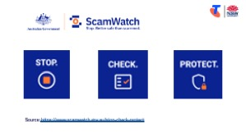  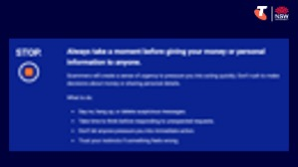  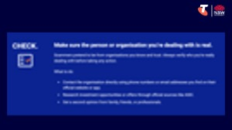  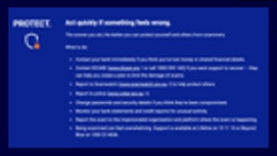 | Ask:  - So, how might we stay safe?  Encourage Reponses, then explain safe actions (below).  Explain Scamwatch’s Stop, Check, Protect method - relevant to scams in general:  Facilitator note: Scamwatch’s Stop, Check, Protect method is also introduced in Module 6: Stay safe online and avoid scams.  - Stop – Always take a moment before giving your money or personal information to anyone.  - Scammers will typically create a sense of urgency to pressure you into acting quickly. Don’t rush to make decisions about money or sharing personal details.  - What to do:  - Say no, hang up, or delete suspicious messages.  - Take time to think before responding to unexpected requests.  - Don’t let anyone pressure you into immediate action.  - Trust your instincts if something feels wrong.  - Check – Make sure the person or organisation you’re dealing with is real.  - Scammers pretend to be from organisations you know and trust. Always verify who you’re really dealing with before taking any action.  - What to do:  - Contact the organisation directly using phone numbers or email addresses you find on their official website or app.  - Research investment opportunities or offers through official sources like ASIC.  - Get a second opinion from family, friends, or professionals.  - Protect – Act quickly if something feels wrong.  - The sooner you act, the better you can protect yourself and others from scammers.  - What to do:  - Contact your bank immediately if you think you’ve lost money or shared financial details.  - Contact IDCARE (www.idcare.org or call 1800 595 160) if you want support to recover — they can help you create a plan to limit the damage of scams.  - Report to Scamwatch (www.scamwatch.gov.au) to help protect others.  - Report to police (www.cyber.gov.au).  - Change passwords and security details if you think they’ve been compromised.  - Monitor your bank statements and credit reports for unusual activity.  - Report the scam to the impersonated organisation and platform where the scam is happening.  - Being scammed can feel overwhelming. Support is available at Lifeline on 13 11 14 or Beyond Blue on 1300 22 4636.  Say:  - If something doesn’t feel right — it probably isn’t. Scams can look very convincing, so it’s always better to pause and check before clicking or entering information.  Transition:  - Now, we’ll take a look at how online banking works — through a safe, guided demonstration. You won’t need to log in — we’ll show what it looks like and how to keep your account secure.

4. Online banking (25 min)
Overview
Purpose:
- Explain what online banking means in clear, practical terms.
- Demonstrate online banking without needing to log in.
- Reassure learners that they can choose how they bank — in person, online, or both.
Timing breakdown | Content
What is online banking?  5 min  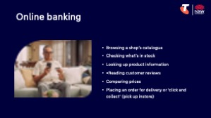 | Explain online banking:  - Online banking means using your bank’s website or app to manage your money, instead of visiting a branch.  - You can do things like:  - Check your balance  - View recent transactions  - Pay a bill  - Transfer money between accounts or to someone you know  - Change card settings  - Many banks also allow you to set up alerts, pay securely with a card linked to your account, and even block your card temporarily if it’s lost.  - You can bank online using:  - A bank’s official website  - A banking app (on your smartphone or tablet)  Ask:  - Have you ever used internet banking?  - What might feel helpful or convenient about banking from home?
Online banking  20 min | Say:  - Let’s now look at how online banking works, and what it looks like to use your bank’s website or app.  - You don’t need to log into your own account today — this is a demonstration only, so you can see how it works and ask questions.  Explain:  - Before using online banking, you’ll need to register with your bank. This often involves calling or visiting your branch, or signing up on the bank’s website. There are QR codes to Australia’s ‘big four’ banks on your Learning Canvas where you can register for an online account.  - You’ll be given a Customer ID and asked to create a secure password.  - Your bank may also ask for your mobile number, so they can send you a security code when you log in.  - Let’s learn how to bank online using Bendigo Bank’s e-banking demo. Your bank’s online system might be slightly different, but the overall layout and functionalities will be similar.

Timing breakdown | Content
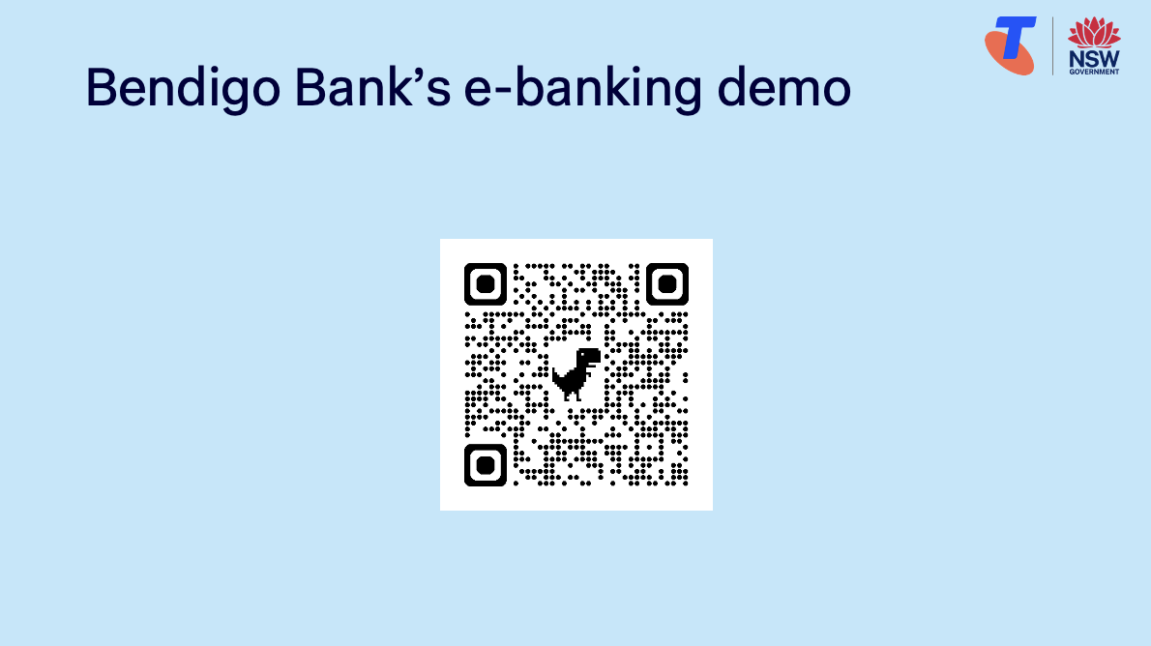 | Demonstrate how to bank online using Bendigo Bank’s e-banking demo and performing tasks, e.g.:  - Select the accounts icon (top left/landing page) and highlight account type/name, BSB and account numbers, balances, available amount in each account. Highlight the notifications in purple at the top (‘Did you know’ and ‘Activate your card’)  - Select an account to view transactions, then select the tabs ‘Upcoming’, ‘Details’, ‘Statements’ and ‘Regular Payments’  - Select Transfer to transfer money from one account to another (highlight that you can change the ‘When’ setting to delay payment or make regular payments  - Select Pay Anyone to transfer money to someone.  - Select an existing payee  - Create a new payee  - Explain PayID - a faster and easier way to make a receive payments using your mobile number, email address or business’ ABN (you need to register for a PayID account with your bank)  - Select Pay Bill to show how to BPAY:  - An existing BPAY biller  - A new BPAY biller  - Explore the icons in the left-hand menu, and highlight the red dots that mean there’s a notification attached to that section  - Select the cards icon, then:  - Follow the prompts to activate the card  - Show how to temporarily block the card, change the pin and report the card lost/stolen  - Explain the card settings - most banks will provide an option to set daily withdrawal limits, and credit cards will offer limits per transaction and spending caps  - Select the Support icon to view contact information and previous messages  - Select the Settings icon and highlight options, highlighting that you can choose to show/hide accounts  Explain:  - These activities have been generalised using Bendigo Bank’s Demo. You can access how-to guides on your bank’s website (or via the QR codes on the Learning Canvas for Australia’s ‘big four’ banks).  Try it:  - Guide learners to explore Bendigo Bank’s e-banking demo (QR code on PowerPoint and Learning Canvas)

Timing breakdown | Content
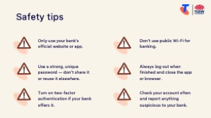 | Explain safety tips:  - Only use your bank’s official website or app  - Use a strong, unique password — don’t share it or reuse it elsewhere  - Turn on two-factor authentication if your bank offers it  - Don’t use public Wi-Fi for banking (like at cafés or shopping centres)  - Always log out when finished and close the app or browser  - Check your account often and report anything suspicious to your bank  Say:  - Great work! Next, let’s spend some time on the questions and goals you raised at the start of today’s session.
10 min | Break

5. Built in flexibility (25 min)
Overview
Purpose:
- To address the questions and skills learners were hoping this session covers
- To practice skills
- If time and learner confidence allow, introduce one or more extension activities from earlier sections
Timing breakdown | Content
Flexible time  25 min   | Facilitator note:  - If learners identified additional questions or topics in the Welcome section:  - Refer to the list you captured  - Say: “Let’s go through the things you said you most wanted to learn today. I’ll demonstrate each one, and then you’ll have a go.”  - If some learners would prefer to focus on practicing instead, divide the group accordingly  - If there are no further learner questions, recap key skills  - If time and learner confidence allow, introduce extension activities covered earlier in the session  Transition:  - Let’s wrap up by reflecting on what you’ve learned today and planning your next steps.
  Extension activities:
  Shopping online
  - Use filters – Explore how to narrow search results by brand, price range, size or customer rating
  - Check in-store availability – Where available, use the postcode or store selector to see if an item is available locally
  - Compare delivery options – Review differences between standard, express, and click & collect shipping
  - Read and compare reviews – Look at 2–3 different customer reviews for the same product. What do people like or complain about?
  - Use the “Save for later” or “Wishlist” feature – If the shop allows it, try saving an item for easy access later (you’ll need to create an account first)
  - Look for return or refund policies – Scroll down and find the shop’s return policy

6. Wrap up (20 min)
Overview
Purpose:
- Consolidate learning and celebrate progress.
- Demonstrate scanning QR codes on the Learning Canvas for trusted follow‑up resources.
- Set a simple action for the week and signpost support.
Timing breakdown | Content
Reflection  10 min  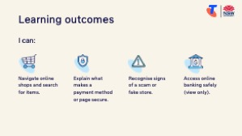  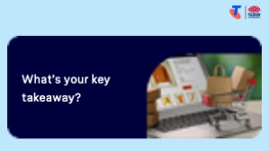  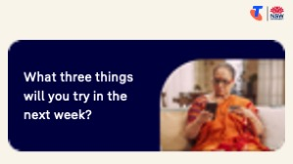 | Say:  - We’ve covered some key information and skills to shop and bank online. Let’s take a moment to celebrate what you’ve learned and record it so you can refer back to it later.  Say:  - Let’s revisit your Learning Canvas - tick the skills you can do.  Ask:  - What’s your key takeaway from today’s session?  Learners note reflections on their Learning Canvas. Invite responses.  - What three things will you try in the next week?  E.g. share what you learned with someone, search for a product at a specific shop, compare prices at different shops, complete the BeConnected courses.  Learners note actions on their Learning Canvas. Invite responses.
Support  10 min   | Say:  - There are QR codes on the back of your Learning Canvas that provides more information online.  - There’s a lot of information online, so don't feel you need to access it. We’ll cover lots more in our Tech Savvy Seniors program.  - But being able to scan a QR code is a handy skill. A QR code is a visual link to a website. It saves you from needing to type the URL/web address into your browser. So, let’s practice today’s final skill!  Demonstrate how to:  - Scan QR code (Open the Camera > point at QR code on Canvas > tap the link)  Try it:  - Guide learners to scan the QR codes on the back of the Learning Canvas.  Explain:  - Where learners can go for support (e.g. 1:1 help at the library, tech groups, or other programs).  Learners note support on Learning Canvas.  - Show Tech Savvy Seniors program and provide the schedule for upcoming sessions.  Say:  - Well done! You’ve all achieved something new today. Keep practising little and often. We look forward to seeing you at another session.

