Tech Savvy Seniors
Module 10
Stay in touch through social media and video calls
Session plan

Table of contents
Session overview 3
Learning architecture 3
Learning outcomes 3
Resources checklist 4
Session summary 5
Session plan 6
1. Welcome (10 min) 6
2. What is a video call and how does it work? (15 min) 7
3. Make a video call (20 min) 9
4. What is social media? (5 min) 11
5. Explore Facebook (40 min) 12
6. Built in flexibility (20 min) 16
7. Wrap up (20 min) 17

Session overview
This relaxed 2–2.5-hour session helps older Australians feel confident using video calling apps and social media to stay connected. It’s hands-on and paced to reduce anxiety, with time to practise calls and explore social platforms like Facebook in a safe, supportive environment.
Each topic includes short demos and guided practice.

Learning architecture
This module forms part of a 12-module series.
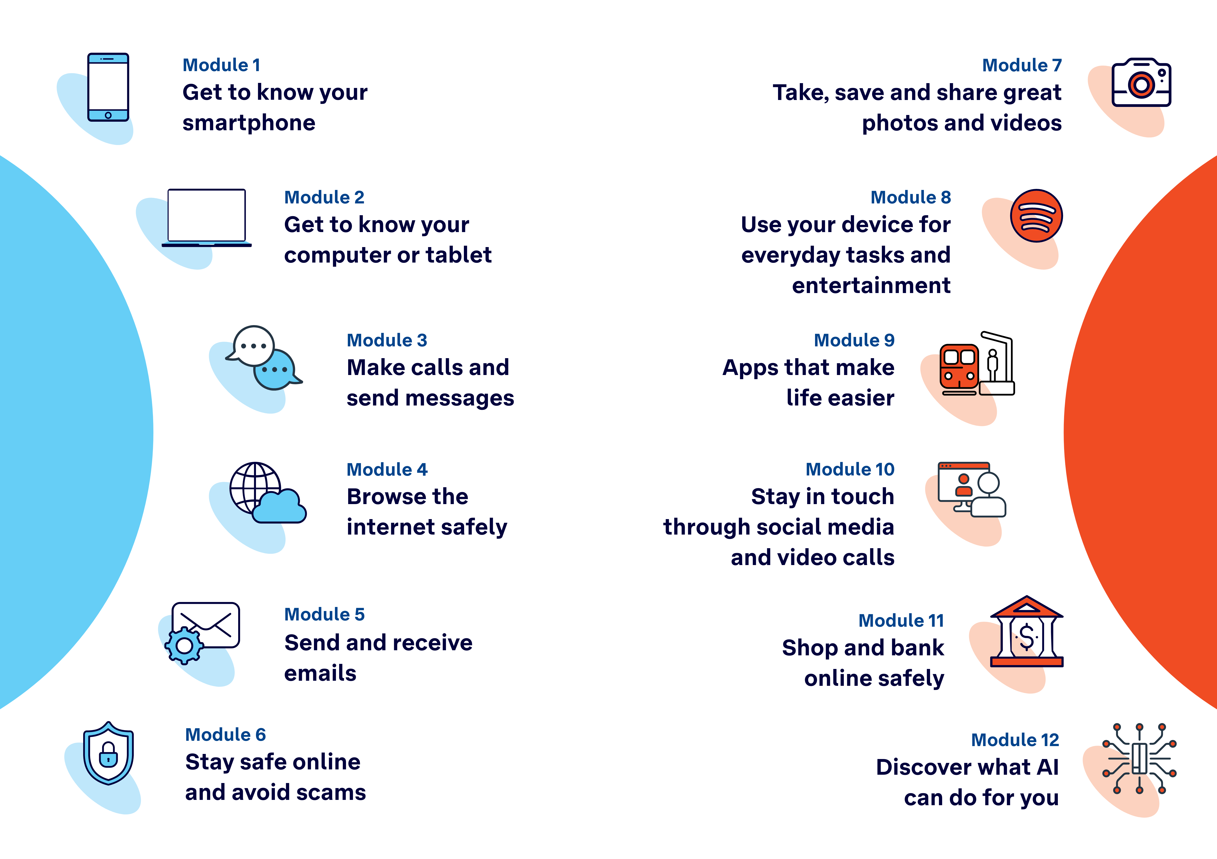

Learning outcomes
At the end of this session, learners will be able to:
- Make a video call.
- Check and use their camera and microphone during a call.
- Browse a social media feed and react to a post.
- Post a simple update or photo (optional).

Resources checklist
This session requires the following resources:
☐ | Session plan (this document)
☐ | PowerPoint presentation
☐ | Learning Canvas - printed (one per learner)
☐ | Pens for learners (one per learner)
☐ | Butchers paper/markers or a whiteboard/markers may be useful to assist with capturing ‘learning goals’ which will be touched on throughout the session
☐ | Library’s Wi-Fi password
☐ | Tech Savvy Seniors program schedule - printed (one per learner)
☐ | Learners’ own device (smartphone, tablet or computer)
☐ | Internet-connected smartphones, tablets or computers (as available)
☐ | Facilitator’s computer for demonstrations and PowerPoint presentation
☐ | Projector and screen (optional)

Session summary
This session summary provides an overview of topics, the activities relevant to each topic and the duration.

Duration | Topic | Useful links
10 min | 1. Welcome
15 min | 2. What is a video call and how does it work?
20 min | 3. Make or join a video call
10 min | Break
5 min | 4. What is social media?
40 min | 5. Explore Facebook | - https://www.facebook.com/help
10 min | Break
20 min | 6. Built in flexibility
20 min | 7. Wrap up | - iPhone: Scan a QR code with your iPhone or iPad  - Android: How do you scan QR codes on Android?
Total duration: 2.5 hours

Session plan

1. Welcome (10 min)
Overview
Purpose:
- Introduce Module 10: Stay in touch through social media and video calls, including the flow (short demos + practice)
- Set a safe, calm tone; reduce anxiety about ‘pressing the wrong thing’
- Introduce the Learning Canvas as a personal guide they can use during the session and take home
- Gather learner goals to tailor the ‘Built‑in flexibility’ section later
Timing breakdown | Content
Session overview  10 min    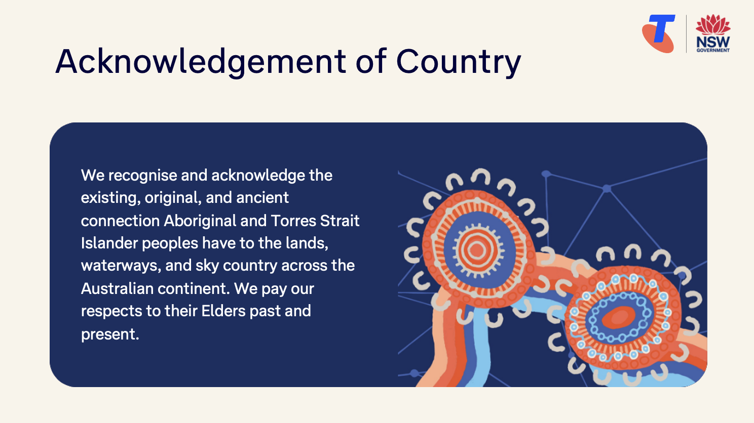  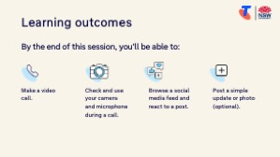  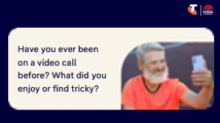  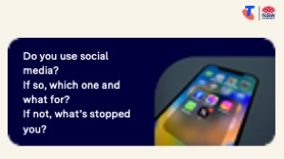   | On arrival, ensure each learner has a device, printed Learning Canvas and pen. Group learners by device so they can support each other.  Deliver: An Acknowledgement of Country.  Say:  - Welcome! Today we’re going to explore two powerful ways to stay connected with people you care about — video calls and social media. Whether you’re keeping in touch with family across the country or checking in with friends nearby, these tools can help you feel more connected.  - This is a safe space to learn and try things. There’s no such thing as a silly question. We’ll take it step by step. Before we touch anything, let’s agree: it’s fine to make mistakes. That’s how we learn.  - By the end of this session, you’ll be able to:  - Make a video call.  - Check and use your camera and microphone during a call.  - Browse a social media feed and react to a post.  - Post a simple update or photo (optional).  Introduce Learning Canvas:  - Use your printed Learning Canvas to write notes in your own words, tick off skills as you learn them, and highlight what feels most useful to you. Writing things down helps you remember and understand them better, and makes it easier to recall later. Take your Canvas home to keep practising. On the back, you’ll find extra tips and trusted links if you want to explore more.  Ask:  - Have you ever been on a video call before? What did you enjoy or find tricky?  - Do you use social media? If so, which one and what for? If not, what’s stopped you?  - What’s one thing you’d like to feel more confident about by the end of today?  (Write answers on a whiteboard or butchers paper. These will help shape the ‘Built-in Flexibility’ section later in the session.)  Confirm everyone has a device; pair anyone without.  Transition:  - Let’s begin by understanding what video calling is and why it’s become such a popular way to stay in touch.

2. What is a video call and how does it work? (15 min)
Overview
Purpose:
- Explain video calling in plain English.
- Help learners understand why and how it’s used.
- Introduce popular video call apps and what they do.
Timing breakdown | Content
What is a video call and how does it work?  15 min    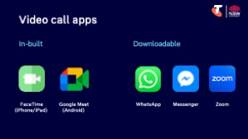 | Say:  - Have you ever wished you could see the person you’re talking to — not just hear their voice? That’s what a video call lets you do. It’s like a regular phone call, but with video. You can wave, smile, show the grandkids your garden, or even attend a doctor’s appointment — and the best part is, you can do it from anywhere. All you need is your device and an internet connection.  - Many people use video calls to:  - Stay connected with family and friends  - Attend telehealth appointments  - Join hobby groups or classes from home  Ask:  - Who would you most like to connect with over video if it were easy?  Explain:  - There are lots of apps you can use for video calls.  - There are two main ways to make a video call:  1. Use a built-in app (already on your phone)  These apps are often the easiest to use, because they come with your phone and work with your contacts.  - FaceTime: is already installed on iPhones and iPads, and works best between Apple users. If an Apple user is trying to video call an Android user, they are better using a different app like Google Meet.  - Google Meet: is already on most Android phones, but can be downloaded on Apple devices.  2. Use a downloadable app  These apps work across different phone types, but both people need to have the same app installed and be signed in.  - WhatsApp: Free, great for calls, and draws on your contacts saved in your phone.  - Messenger: Connected to your Facebook account, used to call Facebook friends.  - Zoom: Typically for professional use (e.g. classes or events).

Timing breakdown | Content
Ask:
- Have you heard of any of these apps before?
- Which ones are already on your phone?
Guide learners to search for the apps already on your phone:
- Apple: Swipe left from the home screen or swipe down and type in the app name to search.
- Android: Swipe up from the bottom of the home screen to view all apps, or use the search bar at the top.
Say:
- Today, we’ll practise using one app together — I’ll show you what to tap, how to check your sound and camera, and how to feel confident during the call.
Facilitator note: Choose one app for the demo that suits your group’s devices. E.g.:
- FaceTime for iPhone groups
- Google Meet for Android groups
- WhatsApp for mixed groups (download from App Store (iPhone)/Google Play Store (Android)
Transition:
- Next, let’s walk through how to join a video call. You’ll have a go yourself and practise using the camera and microphone.

3. Make a video call (20 min)
Overview
Purpose:
- Help learners practise opening a video calling app and starting/joining a call.
- Support learners to check and adjust their camera and sound.
Timing breakdown | Content
Make a video call  20 min  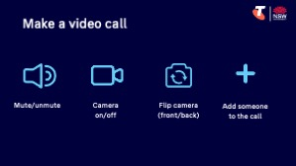 | Say:  - Now we’re going to practise making or joining a short video call.  - You’ll learn how to:  - Open the video call app  - Join or start a call  - Check your camera and sound  - See what you look like on the call  - End the call confidently  Facilitator note: Choose one app for this activity based on your group (e.g. FaceTime, Google Meet or WhatsApp). Demonstrate to the whole class first, then allow paired practice, pairing learners according to their devices.  Demonstrate how to:  - Open the selected app  - Select a contact  - Tap the video button to start a video call  - Show how to:  - Turn camera on/off  - Ensure what you want to show to the camera is in frame  Tip: Hold your phone at eye level, with light on your face — not behind you — so others can see you clearly.  - Switch between front and back camera (to show self and object)  - Mute/unmute microphone  - Adjust the volume  - End the call  Try it:  - Guide learners to practice tasks. They might want to disperse into different locations.  - Walk around and prompt: ‘Can you see yourself clearly on the screen? Try turning camera on/flipping camera/adjusting angle to fit in the frame.’  - Encourage repetition — let them try twice if time allows.
  Extension activities:
  - Join a group call with 2+ people (if devices and internet allow)

Timing breakdown | Content
Ask:
- What did you find easy?
- What would you like more practice with?
Say:
- Well done! Just having a go is something to be proud of. Video calls can take practice — the more you do them, the easier they feel.
- Even if the call didn’t go perfectly today, now you know where to tap and what to expect next time.
Transition:
- Next, let’s explore another way many people stay connected — using social media, like Facebook.
10 min | Break

4. What is social media? (5 min)
Overview
Purpose:
- Introduce social media and how it’s used to stay in touch.
- Focus on Facebook as the most common and trusted platform for older Australians.
Timing breakdown | Content
What is social media?  5 min  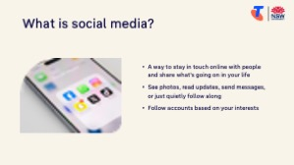  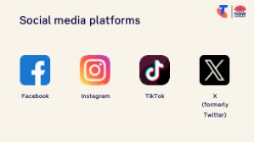 | Say:  - Social media is a way to stay in touch with people and share what's going on in your life, online.  - You can see photos, read updates, send messages, or just quietly follow along with what friends and family are doing. It’s like reading a friendly noticeboard — with photos and comments — that’s always being updated.  - You can also follow accounts based on your interests — like gardening, local community news, history, travel, recipes or even your local bowls club or book club. It’s a great way to stay involved and feel connected.  - There are lots of social media platforms out there, and each one is a little different:  - Facebook – The most popular platform for older Australians; used to stay in touch, share photos, and join interest groups or local community pages  - Instagram – Used mostly for sharing and viewing photos or short videos; common with younger people  - TikTok – Shows fast, funny, or music-based short videos; popular with teens and younger adults  - X (formerly Twitter) – Used for news, opinions and public posts; less focused on personal sharing  Ask:  - Have you ever used any of these, or seen someone else use them?  Say:  - We’ll focus on Facebook today, because it’s the most useful starting point. You can:  - Scroll through updates from people you know  - React to a post (eg like, laugh)  - Leave a short comment  - Share your own photo or update (if you want to)  - Join groups based on hobbies, interests or your local area  Transition:  - Next, we’ll open Facebook together and try it for ourselves.

5. Explore Facebook (40 min)
Overview
Purpose:
- Support learners to open the Facebook app and log in or create an account.
- Introduce Facebook’s layout and support learners to explore their profile and news feed.
- Practise scrolling, liking, and commenting on a post.
- Practise posting a simple update or photo.
- Introduce additional Facebook features to build curiosity and confidence.
Timing breakdown | Content
Download Facebook and create an account 10 min   | Say:  - Now we’re going to open Facebook and explore what it looks like. If you don’t have the app yet, let’s install it. If you don’t have an account, let’s create one so you can follow along.  Guide learners to download Facebook:  - Navigate to the App Store (Apple) or Google Play Store (Android)  - Search for and install Facebook  - Once installed, tap to open  Guide learners to either:  - Log in with an existing account, or  - Create a new account using their email or phone number, following the prompts
News feed  10 min | Say:  - Let’s continue exploring Facebook together. You’ll follow along while I show you how to move around, see what others are posting, and, if you’re ready, try posting something yourself.  - Don’t worry if your feed is still empty. That’s normal for new accounts. We’ll focus on what you can do today to get started and feel comfortable.  Explain basic terms visually and demonstrate using them:  - News Feed – This is where posts from your friends, groups and pages appear. You scroll up and down to see updates. (If yours is empty, that’s okay — it will fill up as you add friends or follow groups.) You’ll also see sponsored posts (ads) and recommended posts based on your algorithm.  - Post – A message, photo or video someone shares. You’ll see their name, the post, and a few buttons below it:  - Like – Tap the thumbs-up icon to show you enjoyed the post.  - Comment – Tap the speech bubble to write a short reply.  - Share – Tap this if you want to share a post to your own profile or send it to someone privately.  Tip: Be mindful - everyone that can see the post will be able to see your like/comment.  Try it: Guide learners to practise:  - Scrolling through their feed, liking and commenting on posts.  - Encourage learners to take their time and ask questions.

Timing breakdown | Content
Make a post  5 min | Say:  - Now let’s try posting something. This could be a short message like “Hello from my first Facebook session!” or a photo from your phone.  - Be mindful that your Facebook friends will see this!  Demonstrate:  - Tap the “What’s on your mind?” box or “+ Post” on your profile  - Write a message, or tap to add a photo  - Tap Post to share it  - You can control who sees your posts — just you, your friends, or everyone. Tap the little icon next to “Post” (e.g. a globe or friends icon) to check your privacy setting.  Try it:  - Support learners to post a short message or image (optional — they can skip this if they’re not ready).
Features  10 min | Say:  - Now let’s explore some other parts of Facebook that help you connect, learn, and enjoy your time online.  - Start with the Search bar at the top — this lets you look up people, pages, topics or groups.  - Then explore the menu tabs — depending on your version of Facebook, you’ll see:  - Friends/People: Find and add friends you know  - Groups: Join communities based on hobbies, location or support  - Pages: Follow organisations, public figures, services or topics  - Events: Browse upcoming local or online events you can join  - Marketplace: View local items for sale or list something yourself  - Reels: Watch short, fun videos shared by others  Demonstrate how to:  - Tap the Search icon (magnifying glass), type in “Gardening Australia”  - Join a group or follow a page  - Explore a tab they’re curious about  Try it:  - Guide learners to explore.  Tip: If you just created an account, try finding a friend or a page to follow — like Gardening Australia, ABC News, or your local council.

Timing breakdown | Content
Explore other key features:
- Profile – Tap your profile picture or name to view your own timeline, posts, and edit your details
- Messenger – Tap the speech bubble icon to send private messages or start a chat with a friend (note: Messenger is both integrated within the Facebook app (as a feature) and available as a separate, standalone app)
- Notifications – Tap the bell icon to see if someone has liked your post, commented, or tagged you
- Friends – Tap the friends icon to search for someone and send a friend request
Try it:
- Give learners time to explore.
Extension activities:
- Marketplace – Buy and sell items in your local area.
Tap Menu (☰) and choose Marketplace to browse or post something for sale.
- Events – Discover local or online events like markets, talks or community meetups.
Tap Menu, then tap Events to explore what’s on.
- Birthdays – Get reminders about friends’ birthdays.
Tap the bell icon (Notifications) or Menu > Birthdays to write a message.
- Pages – Follow businesses, services or topics you enjoy.
Tap Menu > Pages or use the Search bar to look up a page like “Gardening Australia” and tap Follow.
- Reels – Watch short, fun or informative videos.
Tap Reels from the bottom menu or Menu > Reels, then swipe up to view more.
- Saved – Save posts, videos or links to look at later.
Tap the three dots (...) on any post, then choose Save Post. Access saved items in Menu > Saved.
Ask:
- Did you find something new or interesting today?
- What’s one feature you're most excited about exploring further?

Timing breakdown | Content
Privacy settings  5 min  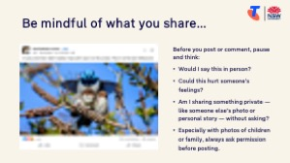  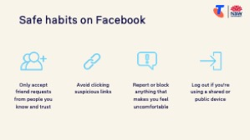 | Say:  - Facebook is a great way to stay connected — but it’s important to feel safe and in control of what you see, share and receive.  - Here are a few key things to remember:  Settings & Privacy  - Tap the Menu (☰ or the three lines)  - Scroll down and tap Settings & Privacy  - From there, you can:  - Control who can see your posts  - Choose who can send you friend requests  - Review what’s visible on your public profile  Tip: If you’re not sure, start with sharing only with Friends (not Public). You can always change it later.  Be mindful of what you share  Before you post or comment, pause and think:  - Would I say this in person?  - Could this hurt someone’s feelings?  - Am I sharing something private — like someone else’s photo or personal story — without asking?  Especially with photos of children or family, always ask permission before posting.  Safe habits on Facebook  - Only accept friend requests from people you know and trust  - Avoid clicking suspicious links — especially in messages or unfamiliar posts  - Report or block anything that makes you feel uncomfortable  - Log out if you're using a shared or public device  Transition:  - Great work! Next, let’s spend some time on the questions and goals you raised at the start of today’s session.
10 min | Break

6. Built in flexibility (20 min)
Overview
Purpose:
- To address the questions and skills learners were hoping this session covers
- To practice skills
- If time and learner confidence allow, introduce one or more extension activities from earlier sections
Timing breakdown | Content
Flexible time  20 min   | Facilitator note:  - If learners identified additional questions or topics in the Welcome section:  - Refer to the list you captured  - Say: “Let’s go through the things you said you most wanted to learn today. I’ll demonstrate each one, and then you’ll have a go.”  - If some learners would prefer to focus on practicing instead, divide the group accordingly  - If there are no further learner questions, recap key skills  - If time and learner confidence allow, introduce extension activities covered earlier in the session  Transition:  - Let’s wrap up by reflecting on what you’ve learned today and planning your next steps.
  Extension activities:
  Video calls:
  - Join a group call with 2+ people (if devices and internet allow)
  Facebook features:
  - Marketplace – Buy and sell items in your local area.
  Tap Menu (☰) and choose Marketplace to browse or post something for sale.
  - Events – Discover local or online events like markets, talks or community meetups.
  Tap Menu, then tap Events to explore what’s on.
  - Birthdays – Get reminders about friends’ birthdays.
  Tap the bell icon (Notifications) or Menu > Birthdays to write a message.
  - Pages – Follow businesses, services or topics you enjoy.
  Tap Menu > Pages or use the Search bar to look up a page like “Gardening Australia” and tap Follow.
  - Reels – Watch short, fun or informative videos.
  Tap Reels from the bottom menu or Menu > Reels, then swipe up to view more.
  - Saved – Save posts, videos or links to look at later.
  Tap the three dots (...) on any post, then choose Save Post. Access saved items in Menu > Saved.

7. Wrap up (20 min)
Overview
Purpose:
- Consolidate learning and celebrate progress.
- Demonstrate scanning QR codes on the Learning Canvas for trusted follow‑up resources.
- Set a simple action for the week and signpost support.
Timing breakdown | Content
Reflection  10 min  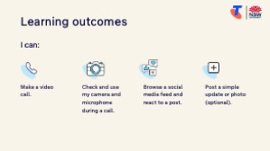     | Say:  - We’ve covered some key information and skills for video calls and using Facebook to stay in touch. Let’s take a moment to celebrate what you’ve learned and record it so you can refer back to it later.  Say:  - Let’s revisit your Learning Canvas - tick the skills you can do.  Ask:  - What’s your key takeaway from today’s session?  Learners note reflections on their Learning Canvas. Invite responses.  - What three things will you try in the next week?  E.g. share what you learned with someone, make a video call, send friend request on Facebook, make a Facebook post with a photo attached.  Learners note actions on their Learning Canvas. Invite responses.
Support  10 min     | Say:  - There are QR codes on the back of your Learning Canvas that provide more information online.  - There’s a lot of information online, so don't feel you need to access it. We’ll cover lots more in our Tech Savvy Seniors program.  - But being able to scan a QR code is a handy skill. A QR code is a visual link to a website. It saves you from needing to type the URL/web address into your browser. So, let’s practice today’s final skill!  Demonstrate how to:  - Scan QR code (Open the Camera > point at QR code on Canvas > tap the link)  Try it:  - Guide learners to scan the QR codes on the back of the Learning Canvas.  Explain:  - Where learners can go for support (e.g. 1:1 help at the library, tech groups, or other programs).  Learners note support on Learning Canvas.  - Show Tech Savvy Seniors program and provide the schedule for upcoming sessions.  Say:  - Well done! You’ve all achieved something new today. Keep practising little and often. We look forward to seeing you at another session.

