Tech Savvy Seniors
Module 1
Get to know your smartphone
Session plan

Table of contents
Session overview 3
Learning architecture 3
Learning outcomes 3
Resources checklist 4
Session summary 5
Session plan 7
1. Welcome (10 min) 7
2. What is a smartphone? (10 min) 8
3. Key physical features (10 min) 10
4. Turn phone off/on and unlock it (15 min) 11
5. Navigate (20 min) 12
6. Adjust settings (20 min) 14
7. Built in flexibility (25 min) 15
8. Wrap up (20 min) 16

Session overview
This relaxed 2-2.5-hour session is all about helping older Australians build confidence with their smartphones.
We’re keeping it simple, practical, and paced to help everyone feel at ease. Each topic includes a short demo followed by a hands-on activity. Learners will leave feeling proud of what they tried and ready to explore more.

Learning architecture
This module forms part of a 12-module series.
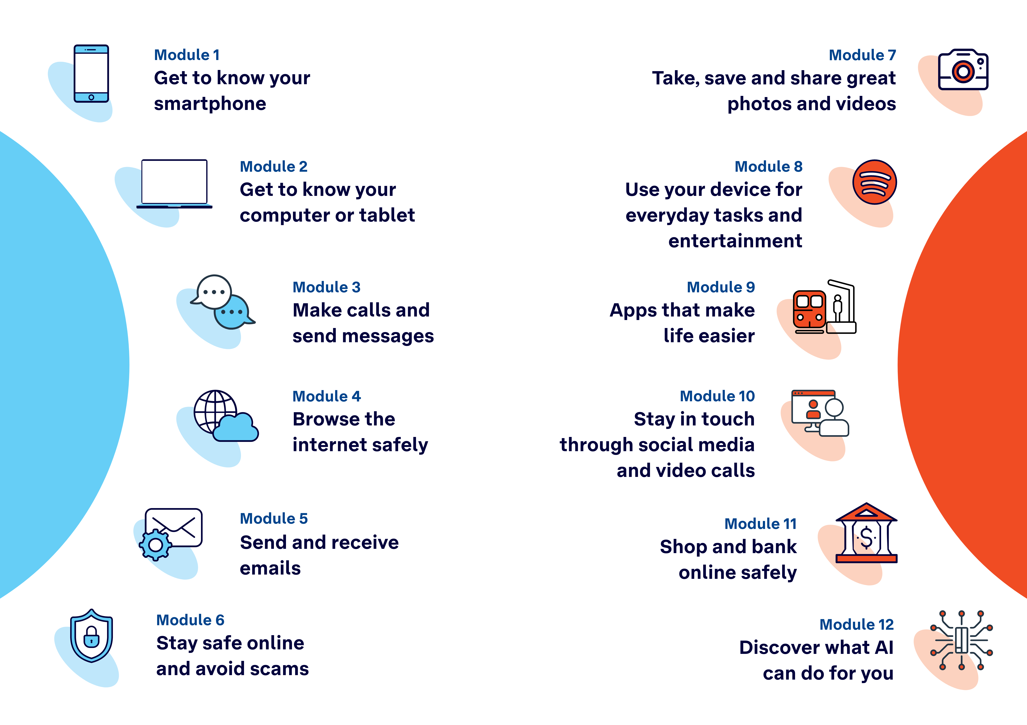

Learning outcomes
At the end of this session, learners will be able to:
- Explain what a smartphone is and list common things it can do.
- Identify key physical features (screen, buttons, charging port, cameras).
- Turn the phone on/off and unlock it.
- Navigate the home screen, open apps, and find Settings, Messages and Contacts.
- Adjust basic settings like brightness, text size and volume to suit their needs.

Resources checklist
This session requires the following resources:
☐ | Session plan (this document)
☐ | PowerPoint presentation
☐ | Learning Canvas - printed (one per learner)
☐ | Pens for learners (one per learner)
☐ | Butchers paper/markers or a whiteboard/markers may be useful to assist with capturing ‘learning goals’ which will be touched on throughout the session
☐ | Tech Savvy Seniors program schedule - printed (one per learner)
☐ | Smartphones (for learners who don't have their own)
☐ | Projector and screen (optional)
☐ | Computer (facilitator’s)

Session summary
This session summary provides an overview of topics, the activities relevant to each topic and the duration.

Duration | Topic | Useful links
10 min | 1. Welcome
10 min | 2. What’s a smartphone?
10 min | 3. Key physical features
10 min | Break
15 min | 4. Turn phone off/on and unlock it | iPhone:  - Wake, unlock, and lock  Android:  - Samsung example: What lock methods can I use on my Samsung Galaxy device?
20 min | 5. Navigate | iPhone:  - Learn basic gestures to interact with iPhone  Android:  - Get around on your Android phone  iPhone (extension activity):  - Learn gestures for iPhone models with Face ID  Android (extension activity):  - Samsung example: Use motions and gestures to control your Galaxy phone or tablet
20 min | 6. Adjust basic settings | iPhone:  - Adjust the screen brightness and color on iPhone  - Customize the text size and zoom setting on iPhone  - Adjust the volume on iPhone  Android:  - Samsung example: Changing Screen Brightness on Your Samsung Phone  - Samsung example: How to change the font or text size on your phone  iPhone (extension activities):  - Get started with accessibility features on iPhone  - Change iPhone sounds and vibrations  - Set a passcode on iPhone  - Keep the iPhone display on longer  Android (extension activities):  - Use the Accessibility Menu  - Use accessibility features on Android  - Change volume, sound, & vibrate settings  - Samsung example: What lock methods can I use on my Samsung Galaxy device?
10 min | Break
25 min | 7. Built in flexibility
20 min | 8. Wrap up | - iPhone: Scan a QR code with your iPhone or iPad  - Android: How do you scan QR codes on Android?
Total duration: 2.5 hours

Session plan

1. Welcome (10 min)
Overview
Purpose:
- Introduce Module 1: Get to know your smartphone, including the flow (short demos + practice)
- Set a safe, calm tone; reduce anxiety about ‘pressing the wrong thing’
- Introduce the Learning Canvas
- Gather learner goals to tailor the ‘Built‑in flexibility’ section later
Timing breakdown | Content
Session overview  10 min  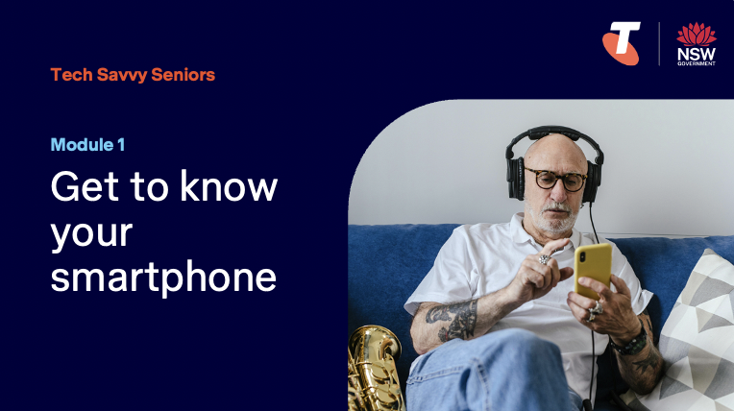  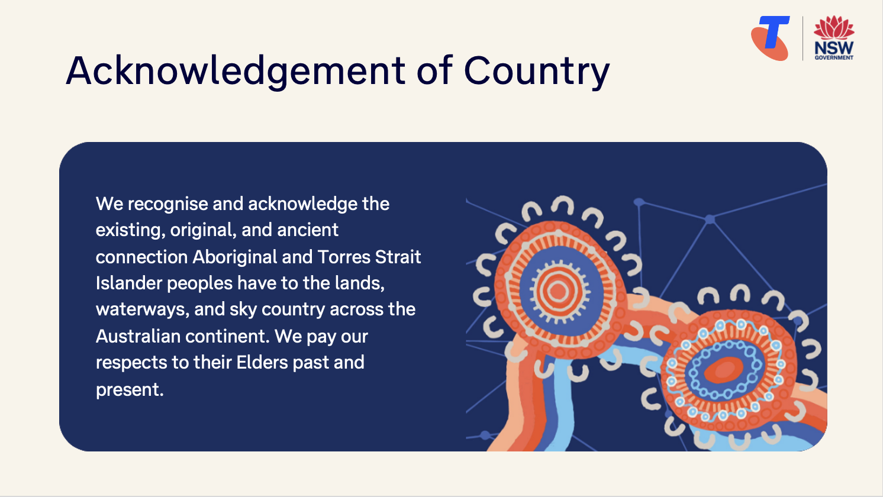  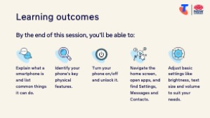  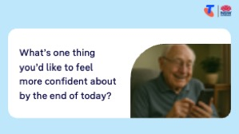 | On arrival, ensure each learner has a smartphone, printed Learning Canvas and pen.  Deliver: An Acknowledgement of Country.  Say:  - Welcome! Today is all about getting to know your smartphone. Whether you’re brand new to smartphones or have dabbled before, this is a safe space to try things out without pressure. We’ll take it step by step. There are no silly questions.  - Before we touch anything, let’s agree: it’s fine to make mistakes. That’s how we learn.  - By the end of this session, you’ll be able to:  - Explain what a smartphone is and list common things it can do  - Identify key physical features (screen, volume, charging port, cameras, speaker)  - Turn the phone on/off and unlock it  - Navigate the home screen, open apps, and find Settings, Messages and Contacts  - Adjust basic settings like brightness, font size and volume to suit your needs  Introduce Learning Canvas:  - Use your printed Learning Canvas to write notes in your own words, tick off skills as you learn them, and highlight what feels most useful to you. Writing things down helps you remember and understand them better, and makes it easier to recall later. Take your Canvas home to keep practising. On the back, you’ll find extra tips and trusted links if you want to explore more.  Ask:  - Who here is brand new to smartphones? Who’s used one a bit?  (Gauge pace.)  - What’s one thing you’d like to feel more confident about by the end of today?  (Capture responses. These will feed into the ‘7. Built-in Flexibility’.)  Confirm everyone has a device; pair anyone without.  Transition:  - Let’s start with what a smartphone actually is.

2. What is a smartphone? (10 min)
Overview
Purpose:
- Build a shared language for makes/models and operating systems (Apple iOS vs Android)
- Recognise smartphones functions
- Explain phone/data plans enable features that use the internet.
Timing breakdown | Content
What is a smartphone?  8 min  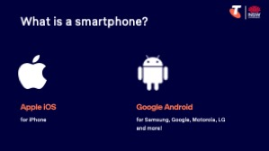  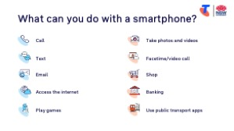  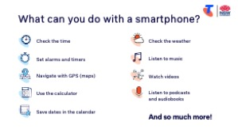  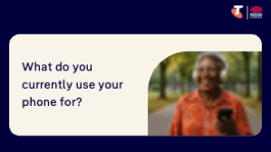 | Say:  - A smartphone is like a little computer you can carry in your pocket. They all work in similar ways, but each make and model can have its own features.  - There are two main operating systems: Apple iOS for iPhones, and Google Android for most other brands like Samsung, Motorola, and Google Pixel. They can do the same things but might look a bit different.  - Just like different makes of car – both get you where you want to go, but the controls may be in different places.  Ask:  - What make smartphone do you have?  - What operating system do you have?  Do:  - Pair learners according to the make of their phone, to support one another.  Say:  - In the past, mobile phones were mostly used for making phone calls. Now they offer so much more!  Ask:  - What can you do with a smartphone?  Brainstorm. Prompt for:  - What do you currently use your phone for?  Discuss in pairs/small groups.
  - Call  - Text  - Email  - Facetime/video call  - Take photos/videos  - Access internet | - Use apps (eg banking, games, YouTube)  - Set alarms  - Calendar  - Navigate with GPS (maps)  - Check weather  - Calculator

Timing breakdown | Content
Phone plans  2 min  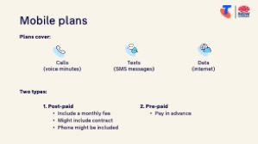 | Say:  - A phone plan is like your fuel. Without it, you can still use some features – such as the camera or saved music – but you won’t be able to make calls, send texts, or use the internet when you’re out and about. Plans usually cover three things: calls (your voice minutes), texts (SMS messages), and data (internet use).  - Data is what you use when you send emails, browse websites, download apps, use maps, or watch videos. If you’re connected to Wi-Fi – for example at home, at the library, or in a café – you can do these things without using up your data allowance.  - You purchase a phone plan from a phone provider (e.g. Telstra).  - There are two main types of plans:  - Post-paid plans include a monthly fee. They might require you to sign a 2-3-year contract, and a phone might be included in the cost.  - Pre-paid is when pay in advance for a set amount of calls, texts, and data. It’s like topping up a petrol tank – when it’s gone, you refill it.  Transition:  - Now we’ll look at the outside of the phone—the buttons and ports.

3. Key physical features (10 min)
Overview
Purpose:
- Identify physical features
Timing breakdown | Content
Physical features  10 min  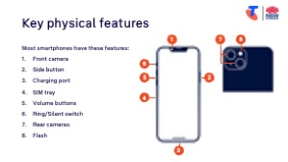 | Say:  - Most actions happen on the touchscreen, however you will see there are a few physical features.  Demonstrate where to find:  - Touchscreen  - Power button  - Volume buttons  - Charging port  - Front/rear cameras  - Home button or swipe bar  Try it:  - Guide learners to identify each of the physical features. Refer them to the labelled graphic on the Learning Canvas for support.  Transition:  - Great – now that we know where everything is, let’s learn how to turn your phone on and unlock it.
10 min | Break

4. Turn phone off/on and unlock it (15 min)
Overview
Purpose:
- Teach learners how to safely power their phone off and on, wake it from sleep, lock it, and unlock it.
- Introduce different unlocking methods (passcode, fingerprint, face recognition) and when each is used.
- Help learners understand when powering off is useful (e.g., conserving battery during travel, troubleshooting a frozen phone).
Timing breakdown | Content
Turn phone off/on and unlock it  15 min  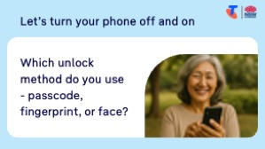 | Say:  - Phones are designed to stay on. They go to sleep when not in use to save battery, and lock to keep your information safe.  - Unlocking lets you use your phone. Depending on your settings, you may use a passcode, a fingerprint, or face recognition.  - You might turn your phone off to conserve battery, avoid making noise (e.g. at the cinema) or troubleshoot a frozen phone.  - If you ever see an emergency call screen pop up by accident, press ‘Cancel.’  Demonstrate how to:  - Power off using side/power button and on-screen slider (if present)  - Power on (hold side/power until logo appears)  - Wake from sleep (tap screen or press a button)  - Unlock with passcode, fingerprint, or face (iPhone: Wake, unlock, and lock)(Android example)  Try it:  - Guide learners to perform tasks.  Ask:  - Which unlock method do you use - passcode, fingerprint, or face?  Say:  - If you use a passcode, make sure it’s hard to guess. Avoid simple choices like your birthday or 1234 — choose something that others won’t know.  - You’ll have an option to change your unlock method/passcode later in the session.  Transition:  - Unlocked? Brilliant. Now let’s learn the touch gestures to get around.

5. Navigate (20 min)
Overview
Purpose:
- Use basic touchscreen gestures
- Navigate the home screen, open apps, and find Settings, Messages and Contacts
Timing breakdown | Content
Gestures  5 min  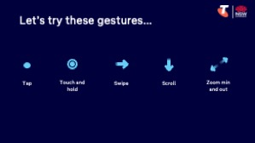 | Say:  - Your phone’s touchscreen is a sheet of glass that reacts to your fingers.  - Tapping is like clicking a mouse – it selects something. Swiping moves you around. Pinching zooms in or out. And tipping your phone to the side changes its orientation (most of the time).  - Let’s try each gesture together, nice and slowly. Don’t worry if you get it wrong – you can’t break anything.  Demonstrate basic touchscreen gestures (iPhone example)(Android example):  - Tap  - Touch and hold  - Swipe  - Scroll  - Zoom in and out  - Change orientation  Try it:  - Guide learners to perform tasks.
  Extension activities
  - Advanced gestures: (iPhone: Learn gestures for iPhone models with Face ID)(Android (Samsung): Use motions and gestures to control your Galaxy phone or tablet)
Opening apps  5 min  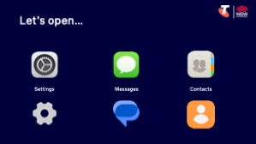 | Say:  - Apps are like small programs on your phone, each with a specific job – like sending messages, taking photos, or finding directions.  - Your home screen is where you find your app icons. The icon picture gives you a clue about what it does.  Demonstrate:  - Identify apps on the home screen (including internet)  - Tap to open, swipe to move, return to home  - Open Settings, then return to home screen  - Open Messages, then return to home screen  - Open Contacts  - Add a contact  Try it:  - Guide learners to perform tasks.

Timing breakdown | Content
Search apps  5 min | Say:  - If you can’t find an app, you can use the search function instead of swiping through every screen.  Demonstrate where to find the search function:  - iPhone: Swipe to last screen for app search bar and list.  - Android: Swipe up from the bottom of the screen to open the app drawer. At the top, you’ll see a search bar. (Applies to most androids.)
Virtual assistants  5 min  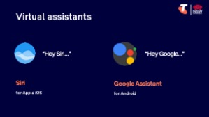 | Say:  - Your phone may have a virtual assistant – Apple calls theirs Siri, and Android uses Google Assistant.  - These assistants can help you do things using just your voice – for example, send a message, check the weather, or set a timer.  Demonstrate how to use virtual assistants, either:  - Siri (say ‘Hey Siri’ or long-press the side button), or  - Google Assistant (say ‘Hey Google’ or long-press the home button)  Note: Siri may need to be set up in Settings > Siri.  Try it:  - Guide learners to use Siri/Google Assistant.  Transition:  - You’re now moving around your phone with confidence. Let’s make it even easier to see and hear by adjusting some settings.

6. Adjust settings (20 min)
Overview
Purpose:
- Adjust basic settings like brightness, text size and volume to suit their needs
Timing breakdown | Content
Adjust settings  20 min  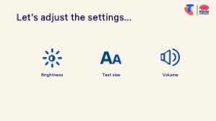   | Say:  - You phone comes with default settings. Let’s adjust them to fit you best.  Demonstrate how to navigate to Settings and change:  - Brightness:  - iPhone: Settings > Display & Brightness.  - Android: Settings > Display > Brightness Level.  - Text size:  - iPhone: Settings > Display & Brightness > Text Size.  - Android: Settings > Display > Font and screen zoom > Apply.  - Volume: Use side volume buttons and Settings > Sounds.  Try it:  - Guide learners to perform tasks.  Ask:  - What setting did you change?  Transition:  - You’ve now tailored your phone. Next, we’ll spend time on your questions from the start of the session.
  Extension activities:
  - Turn on accessibility menu (Android: Use the Accessibility Menu)
  - Change accessibility features (iPhone: Get started with accessibility features on iPhone)(Android: Use accessibility features on Android)
  - Change ringtone (iPhone: Change iPhone sounds and vibrations)(Android: Change volume, sound, & vibrate settings)
  - Change your unlock method (Android (Samsung): What lock methods can I use on my Samsung Galaxy device?)(iPhone: Set a passcode on iPhone)
  - Change auto-lock timing (iPhone: Keep the iPhone display on longer)
10 min | Break

7. Built in flexibility (25 min)
Overview
Purpose:
- To address the questions and skills learners were hoping this session covers
- To practice skills
- If time and learner confidence allow, introduce one or more extension activities from earlier sections
Timing breakdown | Content
Flexible time  25 min   | Facilitator note:  - If learners identified additional questions or topics in the Welcome section:  - Refer to the list you captured  - Say: “Let’s go through the things you said you most wanted to learn today. I’ll demonstrate each one, and then you’ll have a go.”  - If some learners would prefer to focus on practicing instead, divide the group accordingly  - If there are no further learner questions, recap key skills:  - Turning the phone on/off, and unlocking  - Navigating using gestures  - Using the search function  - Adjusting settings - brightness, text size, and volume  - If time and learner confidence allow, introduce extension activities covered earlier in the session  Transition:  - Let’s wrap up by reflecting on what you’ve learned today and planning your next steps.
  Extension activities:
  - Advanced iPhone gestures: Learn gestures for iPhone models with Face ID
  - Change accessibility features (iPhone: Get started with accessibility features on iPhone)
  - Change ringtone (iPhone: Change iPhone sounds and vibrations)
  - Change auto-lock timing (iPhone: Keep the iPhone display on longer)

8. Wrap up (20 min)
Overview
Purpose:
- Consolidate learning and celebrate progress.
- Demonstrate scanning QR codes on the Learning Canvas for trusted follow‑up resources.
- Set a simple action for the week and signpost support.
Timing breakdown | Content
Reflection  10 min  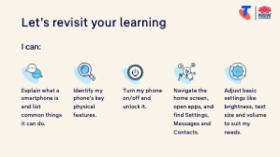     | Say:  - We’ve covered some key information and skills in using your smartphone. Let’s take a moment to celebrate what you’ve learned and record it so you can refer back to it later.  Say:  - Let’s revisit your Learning Canvas - tick the skills you can do.  Ask:  - What’s your key takeaway from today’s session?  Learners note reflections on their Learning Canvas. Invite responses.  - What three things will you try in the next week?  E.g. share what you learned with someone, add more contacts, change settings, open and close apps.  Learners note actions on their Learning Canvas. Invite responses.
Support  10 min   | Say:  - There are two QR codes on the back of your Learning Canvas that provide more information online.  - There’s a lot of information online, so don't feel you need to access it. We’ll cover lots more in our Tech Savvy Seniors program.  - But being able to scan a QR code is a handy skill. A QR code is a visual link to a website. It saves you from needing to type the URL/web address into your browser. So, let’s practice today’s final skill!  Demonstrate how to:  - Scan QR code (Open the Camera > point at QR code on Canvas > tap the link)  Try it:  - Guide learners scan the QR codes on the back of the Learning Canvas.  Explain:  - Where learners can go for support (e.g. 1:1 help at the library, tech groups, or other programs)  Learners note support on Learning Canvas.  - Show Tech Savvy Seniors program and provide the schedule for upcoming sessions.  Say:  - Well done! You’ve all achieved something new today. Keep practising little and often. We look forward to seeing you at another session.

