Tech Savvy Seniors
Facilitator guide

Program overview
To support older Australians in feeling more confident with digital technology, this practical, community-based learning program focuses on everyday skills - not technical expertise. It gives learners a friendly, low-pressure starting point.
It’s designed around what we know many older learners want: clear steps, hands-on support, and someone who will take the time to explain things. Each module brings digital learning to life through relatable tasks, peer support and real-world tools.

Learning architecture
Tech Savvy Seniors consists of 12 modules. They are not codependent - learners can pick and choose which ones they’d like to attend. Modules can be delivered in any order based on local need and learner interest.
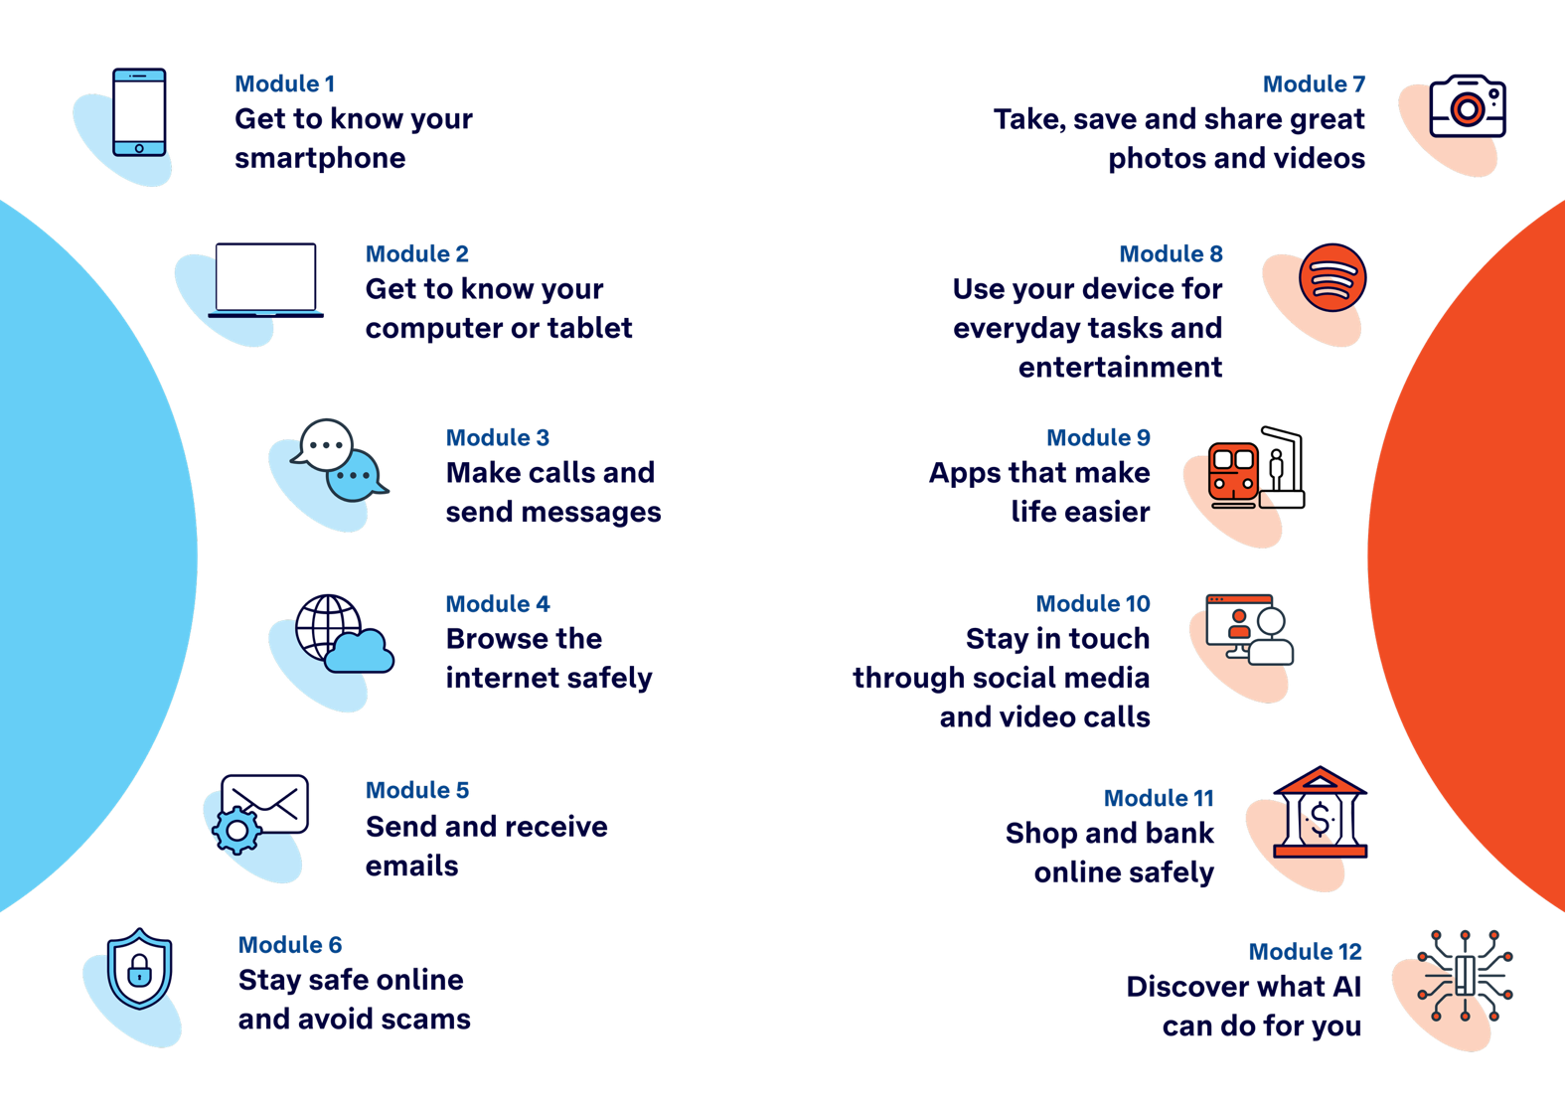

Duration
Each session runs for 2 to 2.5 hours (with two short breaks).

Class size
Sessions are designed for class sizes of 1 to 20+.

Your role
You’re here to encourage, explain, and make digital learning feel achievable. These sessions aren’t about cramming in content — they’re about growing confidence, one small step at a time.
You aren't expected to be a tech expert. With simple session plans, learning canvases, PowerPoint Presentations and QR codes/links, you can guide the group with confidence. The materials are designed to support real learning, not overwhelm - and can flex to suit different devices and skill levels.
Always tailor the session to the learners in front of you. Focus on the devices in the room and adjust the pace to suit learners’ confidence.
You are not expected to fix personal device problems, provide technical support beyond the session topic, or know every answer. If something unexpected comes up, it’s perfectly fine to say, “I’m not sure — let’s find out together” or suggest follow-up support.
The tone stays warm, clear and encouraging - so participants leave feeling proud, not overloaded.
Success in this program is measured by confidence, not completion. If learners leave feeling more capable and less afraid to try, the session has achieved its goal.

Facilitation tips
- Go slowly, pause regularly, and check for understanding.
- Use plain language and avoid unnecessary jargon.
- Always encourage learners to try things themselves — even if they make mistakes.
- Acknowledge that everyone learns at a different pace.
- Pair learners when helpful — peer learning builds confidence.
- Use the session plan to guide your timing and explanations.
- If a device doesn’t work, pair learners or offer a loan device if available.
- Remind learners not to share passwords or private information during group activities. Encourage them to enter sensitive information privately.

Resources
Each session consists of the following learning materials:
- Session plan
- Learning canvas
- PowerPoint Presentation (optional, but recommended for engagement and visual support)
Some sessions will include printed handouts.
Additional resources include:
- Facilitator laptop (fully charged, with internet access)
- Projector or large display (optional but recommended for PowerPoint use and demonstrations)
- Learners’ devices (relevant to the session), and spares for learner use
- Whiteboard or butcher’s paper and markers
- Access to Wi-Fi

Session plan

Structure
Each module follows a similar structure designed to support confidence-building, skill development, and reflection:
Welcome
- Introduce the session’s focus and set a calm, inclusive tone.
- Learners are asked: “What’s one thing you’d like to feel more confident about by the end of today?” Record responses on a whiteboard or butcher’s paper — these will be revisited later.
Topic introduction
- Introduce the topic with relatable, everyday examples.
Demonstration and skill practice
- Demonstrate each skill step-by-step, using your device and visual support from the PowerPoint.
- Learners practise the skill on their own devices.
- Support learners individually or in small groups, encouraging peer support and questions.
- Welcome questions throughout — interaction is encouraged.
- Use the extension activities at your discretion for learners who are more confident and ready for a challenge.
Built-in flexibility
- Address learners’ questions from the Welcome section.
- Allow time for revisiting activities or extending practice.
- Extension activities can be introduced to challenge more confident learners.
Wrap up
- Summarise what was learned.
- Learners revisit their Learning Canvas, reflect on key takeaways, and tick off what they can now do.
- Learners set a simple action goal for the coming week.

Flexibility and adaptability
Tech Savvy Seniors is designed with flexibility in mind:
- Device flexibility: Instructions and demonstrations are designed for various devices, including both Android and Apple devices. Where differences exist, guidance is provided for both platforms. You only need to focus on the devices in the room — there’s no expectation to cover everything if it isn’t relevant to your group.
- Timing flexibility: The ‘Built-in flexibility’ section gives you time to slow down, revisit activities, or extend the session as needed.
- Learner needs: Some learners may move quickly through content; others may need more time. Use peer support and pacing cues to adjust your approach. Capturing what learners want to get out of the session at the start (on butcher's paper or whiteboard) helps personalise delivery — revisit their goals to ensure key questions and interests are addressed before the session ends.
- Local relevance: Some sessions include multiple apps. Facilitators should select the most relevant options based on their region and learners’ needs (e.g. Opal app may not be useful in regional areas — alternatives may be more appropriate).

Learning canvas
Each learner receives a printed Learning Canvas to support learning and track progress.
- Learners use it during the session to take notes, tick off skills, and highlight what’s most useful.
- Encourage learners to use their own words — writing helps memory and builds independence.
- At the end of the session, learners reflect and tick off the skills they now feel confident doing.
- Take it home: The back includes trusted resources, tips, and QR codes for further information and practice.

PowerPoint Presentations
Each session comes with a simple PowerPoint.
- Use it to guide the session, highlight steps, and give visual cues.
- It’s optional but recommended to support diverse learning styles.
- Slides are clear and minimal to keep the focus on hands-on activity.

