IPND Data User and Data Provider Access to the IPND Web Portal
Document Release History:
Date | Section | Detail of Change
Feb 2023 | All | Document created - Penny Waite
Apr 2023 | Initial Setup | Document reviewed & Updated - Penny Waite
Jun 2023 | All | General update - Penny Waite
Oct 2023 | All | General update - Penny Waite

Table of Contents
Document Purpose: 1
Web Portal Access Availability: 1
Web Portal Functionality: 2
Web Portal Access Management: 2
Web Portal Security: 3
Web Portal User Requirements: 3
Web Portal User Access: 3
Web Portal User Registration: 3
Web Portal Troubleshooting: 6

Document Purpose:
This document is to provide IPND Data Providers and Data Users an overview of the Web Portal, as well as the process for requesting access and completing Web Portal registration.

Web Portal Access Availability:
- Web Portal access is available to:
  - Organisations which are registered by the IPND Manager as IPND Data Providers or IPND Data Users. These organisations must have an active File Source Code and have completed the IPND Onboarding process allowing them to transact with the IPND User Test and IPND Production environments.
Please refer to the IPND Data Users & Data Providers Access to Internet Interface Service (IIS) documentation for information re user setup for transacting with the IPND.
- Note: CSPs who are not registered IPND Data Providers to transact directly with the IPND are unable to access the IPND Web Portal at this time (Change Requests pending).

Web Portal Functionality:
The below functionality is available in the Web Portal for registered IPND Data Providers, Data Users/Consumers, the Regulator and the IPND Manager:
- Self-service functionality:
  - Schedule data extracts / data refresh and view request history / status (Data Provider & Data User/Data Consumer)
  - Perform Public Number query and view results (Data Provider & IPND Manager)
- Perform queries for specific errors (Data Provider)
- Register to receive Error Notifications / Subscriptions via email or sms (Data Provider)
  - Create User Query’s to report an error with a specific Public Number (Data Provider & Data User/Data Consumer)
  - Access Management: add new Organisation Admin and General User (Data Provider & Data User/Data Consumer Organisation Admins & IPND Manager)
  - Access Management: create new Organisations and Organisation Admins (IPND Manager)
- View Customer Record Upload File status and errors (Data Provider & IPND Manager)
- View Download File status for the various files that the IPND produces for Download to Data Providers, Data Users/Consumers, the Regulator and the IPND Manager (Data Provider & Data User/Data Consumer Organisation Admins & IPND Manager)
- View Error File Status (Data Provider & IPND Manager)
- View & Download Error Summary / Trends for further analysis (Data Provider)
- View & Download Management Reports (IPND Manager & Regulator)

Web Portal Access Management:
The Web Portal includes functionality to allocate access based on individual access type and role.
The breakdown of access types and roles are as follows:
Access Type | Role/s
IPND Manager | - Super Admin
IPND Data Provider | - Organisation Admin  - General User
IPND Data User/Data Consumer | - Organisation Admin  - General User
Regulator | - Organisation Admin  - General User
Role details: | Access Management Functionality
Super Admin:  The Super Admin role is allocated to the IPND Manager / IPND Manager Support | - Create Organisations and allocate filesource to each Organisation;  - Create / authorise Organisation Admins within all Organisations;  - Create / allocate General Users within all Organisations.
Organisation Admin:  Organisation Admin/s can be allocated to each Organisation that has been given access to the IPND | - Create / authorise Organisation Admins within their Organisation;  - Create General Users and allocate access to specific filesource within their Organisation
General User:  General Users can be allocated to each Organisation that has been given access to the IPND.  General Users’ can be allocated access to specific filesource within their Organisation | - Access Management Functionality is not enabled for General Users:  - General Users cannot create or allocate access to others within their Organisation

Web Portal Security:
To protect the security of the IPND, the following measures have been created to allow users access to the IPND Web Portal:
- VPN Tunnel via OpenVPN
- 2 Party Authentication via Google Authenticator
- User configuration in the IPND Web Portal by The IPND Manager

Note: Users with restrictions applied to their PC / workspaces should engage their Organisations’ IT / Tech Support for assistance for user setup. See Web Portal Troubleshooting for more information.

Web Portal User Requirements:
To access the IPND Web Portal, users will require:
- Google Authenticator smartphone app for 2 step authentication:
- OpenVPN Client installed:
  - The OpenVPN Client is available for download from: https://openvpn.net/vpn-client/ or from the IPND IIS landing page using OpenVPN credentials provided by the IPND Support team: https://gw1.ipnd.com.au/

Web Portal User Access:
To obtain access to the Web Portal, engage the IPND Manager via email IPND.Manager@team.telstra.com to request:
- IPND Web Portal User Access
- OpenVPN Credentials (if required) or to request an additional OpenVPN profile/s.

The IPND Manager will require the below information for each user requiring access:
Web Portal Access Details
First Name | Last Name | Phone No | Email address | Role: Org Admin / General User | Filesource (General User)
Once the IPND Manager provisions access in the Web Portal, users will be required to complete registration to log in.

Web Portal User Registration:
Once the IPND Manager has configured a users’ details in the Web Portal, an email will be sent to their email address: ‘Account Access Invite: IPND Web Portal’. To complete Web Portal registration and log in, the user will be required to carry out the following:

- Establish a VPN tunnel via the OpenVPN Client.
- On the ‘Account Access Invite: IPND Web Portal’ email, click the hyperlink = To Accept the invite and please click here
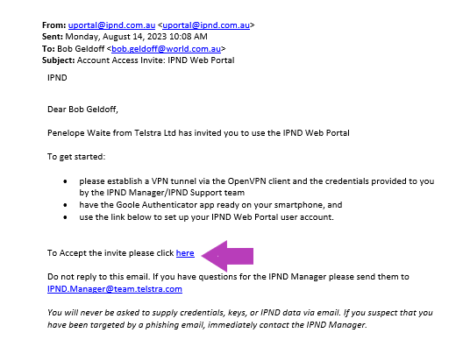
- Complete Web Portal registration via the screen pop which contains the pre-populated email address as provided to the IPND Manager:
  - In the ‘Enter your password’ field, create a new password using the Google password rules provided. (Tip: do not use a # in the password);
  - Access the Google Authenticator smartphone app;
  - press (+) to add the token and select ‘time based’;
  - scan the QR code;
  - enter the 6 digit token/secret key provided from the Google Authenticator app into ‘Generated Token’ field;
  - click ‘Register’:
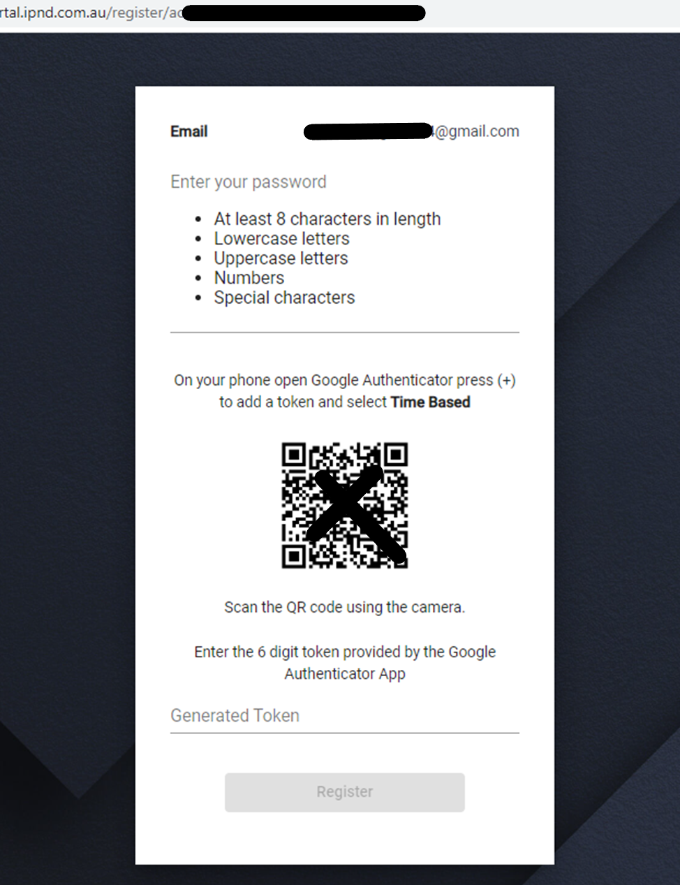
- The Web Portal login screen will appear:
  - Complete the ‘Email’ and ‘Password’ fields using the registered email address and newly created password from the previous step.
  - Access the Google Authenticator smartphone app and enter the refreshed 6 digit token/secret key provided.
Note: users may have multiple tokens/secret keys.
Google Authenticator will allow users to assign an account name to each for the relevant application.
  - Click ‘LOGIN’
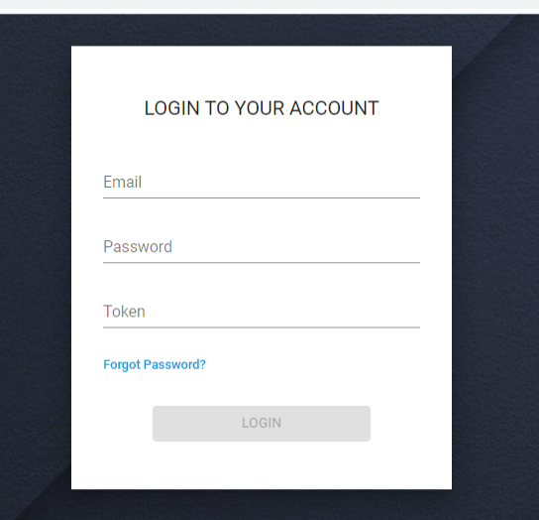
- Read and Accept the Terms and Conditions.
- Once successfully logged in, users will be presented the IPND Web Portal Dashboard.
- Save the below URLs to favourites for later use:
Environment | URL | IP Address
User Test | https://uportal.ipnd.com.au | https://10.11.110.31
Production | https://portal.ipnd.com.au | https://10.10.110.31

Web Portal Troubleshooting:

Due to the security measures applied to protect the IPND Web Portal, some people may require assistance resolve their workplace IT restrictions.

Restrictions may apply to employee workspaces by organisations’ IT to prevent the installation of non-standard applications and access to unknown sites in browsers, thereby ensuring the safety and security of the organisations IT network and data.

We strongly recommend that you consult with your organisation’s IT services and obtain technical support to permit access to the IPND Web Portal.

Telstra IT carried out the below to enable their IPND Ops team access to the Web Portal:
- Enable OpenVPN Client install on user PC (Client install maybe blocked as non-SOE);
- Configure OpenVPN Client with proxy/proxies to enable the user to establish an OpenVPN tunnel;
- Update to organisation Web Proxies PAC files (Proxy Auto Config);
- Update to user PC local hosts file: adding Web Portal details:

IPND Web Portal Environment | Content for hosts file
User Test | 10.11.110.31 uportal.ipnd.com.au  10.11.110.31 uportal-help.ipnd.com.au
Production | 10.10.110.31 portal.ipnd.com.au  10.10.110.31 portal-help.ipnd.com.au

If further support is required, please contact the IPND Manager via email: IPND.Manager@team.telstra.com

